Page left blank for notes.

16
Schedule for for Different Tours. Please note it may be necessary to modify the itinerary slightly depending on traffic conditions.
Visit | Half Day |  |  |  |  | Whole Day |  |  |  | Multi-day
 | A | B |  | C | D | E | F | G | H | J
Solar Power, Berrington Road  Stop approx 5 mins | √ | √ |  | √ | √ | √ | √ | √ | √
Itteringham Mill – stop approx 20 – 30 mins |  | √ |  |  |  | √ | √
Morph Bioethanol Plant | Tours D, G and H – only if device is in Norwich. Visit may be at start or end of Tour
Coastal Erosion - Overstrand |  |  |  |  |  |  |  |  | √
Bacton Gas Terminal  stop for 5 mins |  |  |  | √ |  | √ |  | √ | √
Sea Palling: Coastal Erosion |  |  |  |  |  | √ | √ | √ | √ | Day 2 if time permits
Horsey Wind Pump. Stop for 10 mins or up to 45 mins depending on tour and time | √ |  | √ | √ | √ | √ | √ | √ | √ | Day 2
West Somerton Wind turbine | √ |  | √ | √ | √ | √ | √ | √ | √ | Day 2
Blood Hill Wind turbines | √ |  | √ | √ | √ | √ | √ | √ | √ | Day 2
Above two visits might be separate or joint – total time ~10 mins
Scroby Sands Offshore wind turbines. ~ 10 mins | √ |  | √ | √ | √ | √ | √ | √ | √ | Day 1 or 2
Gt Yarmouth Power Station  Short stop outside | √ |  | √ | √ | √ |  | √
Gt Yarmouth Power Station Full Visit 2 hours |  |  |  |  |  | √ |  | √ | √ | Day 1
If time permits.  Gulliver –. Stop for 5 mins |  |  |  |  | √ |  |  | √ | √ | Day 2
Ren Energy: Heat Pumps; solar PV biomass etc etc | √ |  |  |  |  | √ |  | √ | √ | Day 1
Adnams Distribution Centre and Brewery |  |  |  |  |  |  |  |  |  | Day 2
On whole day tours lunch as a bar lunch and will be arranged at one of the following restaurants: a) the Imperial Hotel, Great Yarmouth. (b) Green’s Restaurant, Aylsham, c) Acle Bridge. These will be pre-booked and choices phoned through. On multi-day tours lunch will be scheduled as appropriate.
1
Contents

Visit | Tours | Page
Solar Power, Berrington Road | A - H | 3
Itteringham Mill – stop approx 20 – 30 mins | B, E, F | 3
Coastal Erosion - Overstrand | H | 4
Bacton Gas Terminal: stop outside | C, E, G, H | 5
Sea Palling: Coastal Erosion | E – H & J? | 7
Horsey Wind Pump. | All Tours | 7
Somerton Wind turbine | All Tours | 8
Blood Hill Wind turbines | All Tours | 8
Scroby Sands Offshore wind turbines. | All Tours | 8
Gt Yarmouth Power Station – brief stop outside | A – D, F | 9
Gt Yarmouth Power Station Full Visit 2+ hours | E, G, H, J | 9
Gulliver – largest on shore wind turbine in UK | D, G, H & J? | 13
Ren Energy: Heat Pumps; solar PV biomass etc etc | A, E, G, H, J | 14
Adnams Distribution Centre and Brewery | J
Morph Bioethanol Plant (if available) | D, G, H | 15
Sizewell Power Station |  | 14

General

For many of the tours we shall be passing through the Broadland area. The Broads themselves were constructed by man when peat was dug in the middle ages as a fuel. They now provide a unique landscape. Beneath Broadland is a major, and as yet untapped coal reserve about 500 m below the surface.

Near Horsey there is a 16 sq km of land area lying below sea level. Originally a key aspect of the water level management was the Wind Pump at Horsey (see later) which we shall be visiting. Recently there have been plans to allow a managed retreat of the shoreline to flood the area.

The coast line of Norfolk is showing significant signs of coastal erosion and on tours E – H some of the key sites will be visited.

2

Mobile Biodiesel Production Plant (MORPH).

Visits to this plant are dependent on the device being in Norwich. This visit may be scheduled either at the start or end of the visit

This is a portable device which allows production of biodiesel from a variety of feed stocks. It was designed in Norfolk and has several innovative features – including avoiding the need for any mechanical agitation of the fluids and also a very fast separation of the product from the glycerol. (This visit is subject to one of the devices being available in Norwich on the day of the tour).

The Remainder of this Page is left blank for notes.
15
Nuclear Power Stations - Sizewell.

Time does not permit us to see the power stations at Sizewell which is further down the coast. There were two stations operating. Sizewell A was commissioned in 1966 and was finally closed on 31st December 2006. This station was of the MAGNOX type and had an output capacity of 420 MW.

The newer Sizewell B station is the UKs only pressurised water reactor and was commissioned in 1994. It has a capacity of 1188 MW and a typical load factor of 80%+. This station can provide the electrical equivalent of 55 times the output of Scroby Sands or sufficient for 2 million houses. The efficiency of this power station is around 33% or only 60% that of the CCGT Station at Great Yarmouth.

Ren Energy: Tours A, E, G, H, J
– on some days an alternative site at Hemblington may be visited as an alternative or in addition to the standard visit.

RenEnergy is a company which was established in 2006 with four people. It now has a workforce of around 35 people and is constantly expanding. It originally specialised in ground based neat pumps but has expanded to cover many renewable energy sources including air-source heat pumps, solar, PV, solar thermal, micro wind, biomass.

A heat pump is a device which works with thermodynamics and for each unit of energy put in will provide three to four times as much heat. The additional energy comes from the ground. A heat pump operates like a refrigerator. The ground coil represents the cold box, while the grill at the back of the refrigerator where heat is rejected is equivalent to the coil supplying the heat in the under floor heating. A series of ground coils have been laid under the area at a depth of about 1m and what is significant about this installation is that the actual extent and number of coils can be varied and this should provide valuable experience for the future.

Much of the current business of RenEnergy is focussed on Solar PV and indeed following an Strategic Carbon Management Consultancy Project in 2009, the company has developed a novel funding method and is trialling it in the village of Blofield as a community project.
14

Solar Thermal: Broadsol Project: 39 Berrington Road Hellesdon.

This house is fitted with Solar Thermal Panels and was part of the Broadsol Community Solar Scheme launched in 2003. In this residents of Broadland District Council were asked to sign up in advance and pay a 50% deposit for the installation of the panels and associated plumbing. As a result the price per installation was reduced from bulk buying of components. The scheme was over subscribed within 22 minutes of its launch. The number of panels installed, the size of the hot water tank, and whether it was a combination tank or pre-heat tank varied between installations and depended on the size of the family, space available for the additional tank etc. The panels at Berrington Road were installed in early 2004, and have been providing around 800 – 900 kWh of energy each year.

Itteringham Mill Tours B, E and F only

This mill has an innovative hydro scheme which provides much of the electricity for the old mill. The owners of the mill are also planning to install under floor heating powered by a heat pump which will use the water in the mill pond as the external heat source.

The hydro scheme is unusual as it works on the principle of a siphon. This has many advantages as if a fault occurs, or the inlet becomes blocked the siphon is realised with the machine stopping almost immediately. Further more by having the device above water it makes for much easier servicing. A photograph of the device is shown below.

At start up, a vacuum is created in the upper part of the machine which sucks water to the top where after it falls by gravity through the turbine. Once started the water flows directly by the siphon created and will continue until air is allowed in at the top when the vacuum in the siphon will be lost and the machine stops.
3
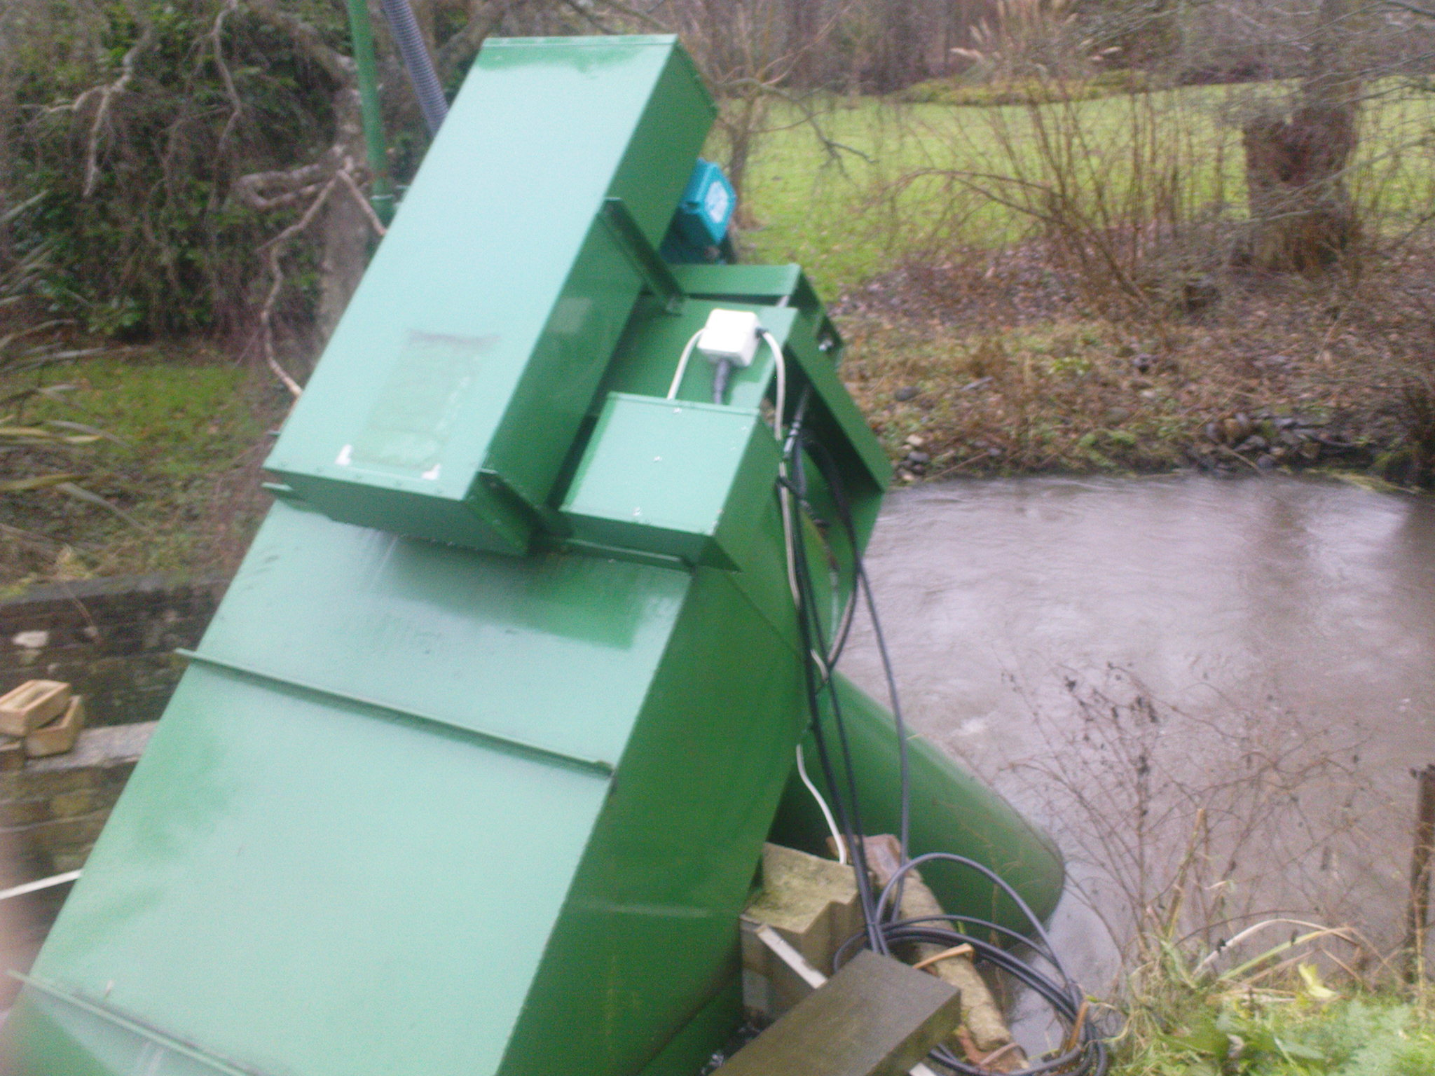
Fig. 1 The siphon hydro scheme at Itteringham Mill

Overstrand: Tour H only
This tour is included only when issues of Climate Change/Sea Level Rise form part of the theme for the day. The coast at Overstrand is eroding rapidly, the primary cause is not the sea, but high ground water levels. If following climate change, this area became wetter (as there is already evidence that it is in winter), then increased incidence of landslides in winter will occur. The visit here will look at an area where houses have already collapsed, and the many remedial measures taken following the large landslide in 1994.

4

First there is a gas turbine and secondly by a steam turbine. Gas for the power station is shipped by pipeline from the Bacton terminal. Combined Cycle Gas Turbines are significantly more efficient and as a consequence, the carbon emission per unit of electricity generated is only 40% that for a unit of coal generation. In a CCGT, gas is burnt in a gas turbine which is similar to a large aircraft engine. The temperatures here are around 1200 – 1300ºC and thus potentially more efficient because of the higher temperature. On the other hand, the exhaust from a gas turbine is high at around 600ºC which means that the efficiency of the gas turbine alone in converting gas into electricity is only around 25%. However, the exhaust gases are sufficiently hot to raise steam for a steam turbine, and the combined output makes such a combination around 50% efficient. In fact this station is one of the most efficient stations anywhere in the world at 55-56%.

There are two types of CCGT power station. Those which have separate generators for the seam and gas turbines and known as multi-shaft machines. The others like the one at Yarmouth have a single shaft with a single generator. These latter tend to be more efficient, but is less flexible in use.

Cooling water is required and unlike inland power stations, this station does not require cooling towers – instead water is taken from the river and returned to the sea where it is up to 10 ºC warmer than the surrounding water.

Some CCGT stations have separate generators on both the gas and steam turbines, but in this station they two turbines are on a common shaft driving a single generator. The maximum output from the station is 420MW. Stations such as this will typically have a load factor of 80%+ in the early years of operation.

Lowestoft “Gulliver” Wind Turbine. Tour D, G and H only

This has been named “Gulliver” and at 2.75 MW is currently jointly the largest Wind Turbine in the UK. The manufacturer of this turbine was NEG Micon It was commissioned in January 2005 and since then has had a load factor of 35.1% one of the highest in the UK and at over 40% for several months (see Fig. 3) . On average this turbine will provide electricity for 4000 houses while at peak wind speeds over 10000 homes would be supplied.

13
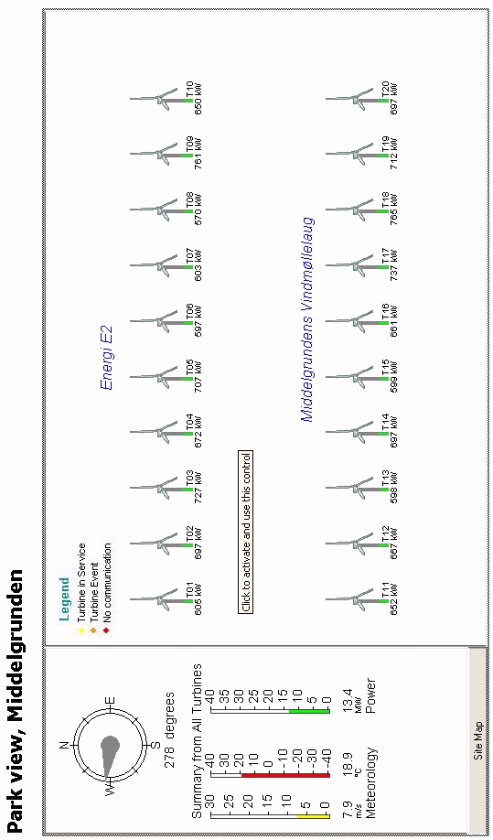
Fig. 5. Instantaneous data from Middel Grunden Wind Farm visible from Copenhagen at 09:52 on 23rd August 2006.
12

Bacton Gas Terminal. Tours C, E, G & H only

This terminal was built to receive the gas from the southern North Sea gas fields. There is also a 474 km long pipe line to the northern North Sea Gas Fields. In the mid 1990’s a 235 km inter connector gas pipeline was built between Bacton and Zeebrugge in Belgium and until 2006 was the only connection for gas with Europe. In the early years gas was mostly exported along to Europe, but since 2004, the UK overall has become a net importer of gas, although currently we are a net exporter along this particular line as supplies from the Middle East and elsewhere exceed the current demand (see Fig. 2)..

Before being exported to Belgium, the UK gas is compressed to 140 bar pressure using gas compressors which are similar to air-craft engines and which consume 0.8% of the gas transmitted.. At the Zeebrugge end, the pressure must be reduced and this causes a significant cooling which could jeopardise the integrity of the pipes and thus the gas must be heated to return it to normal temperatures.

The reverse process occurs for gas imported from Europe – i.e. compression in Zeebrugge and expansion and heating at Bacton. At Zeebrugge the compression is achieved by electrical compressors.

When initially constructed there was the capacity to export significantly more gas than could be imported. The import capability has been upgraded and there is currently the maximum flow rate from Belgium is at the rate of 25.5 bcm/year (807 GWh/day) In the reverse direction the corresponding figures are 20 bcm/year and 630 Gwh/day.

Two other inter-connector projects have been completed since 2006 One connects Bacton with Balzand in the Netherlands as is known as the BBL inter-connector and came on stream in December 2006. This will also eventually connect with the North Europe Pipe Line from Russia., This pipeline also comes ashore at Bacton.
.
5
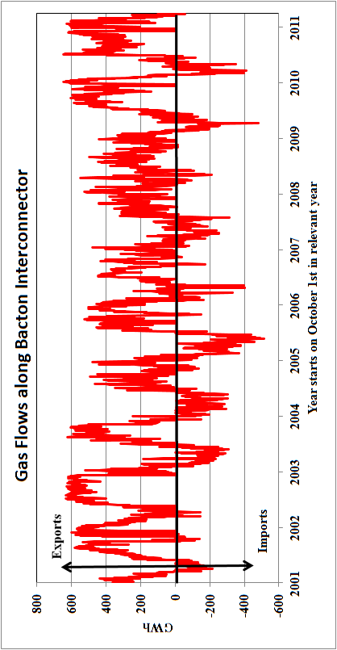
Fig. 2 Exports and Imports of gas at Bacton Terminal. 1 GWh of gas would provide all the gas needs of 50 average houses for a whole year.
6
Data from http://www.interconnector.com/onlineservices/historicflows.htm
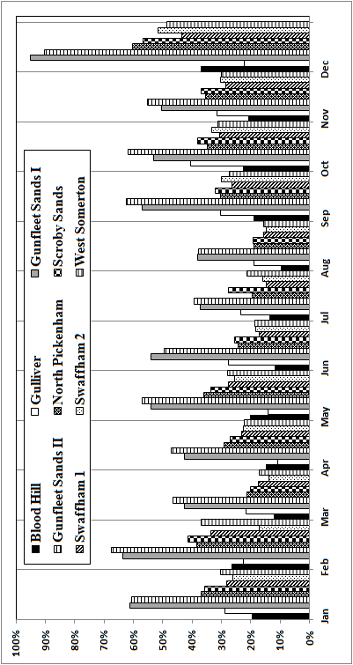
Fig. 4. Annual Load Factors for Wind Farms in Norfolk/Suffolk. Note: that in 2011, the total output at Somerton (one turbine) was 4605 GWh compared to 3232 GWh for the 10 turbines at Blood Hill
11
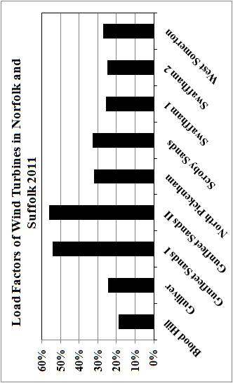
Fig. 3. Variation in load factor for the wind turbines seen today and others nearby over the year 2011. This information was derived from: https://www.renewablesandchp.ofgem.gov.uk/Default.aspx
10
A third pipeline bringing gas from Nyhamna in Norway to Easting in Lincolnshire was also completed in 2006 and is known as the Langeled Line. It is 44 inches in diameter and at 1200 km is the longest undersea pipeline anywhere in the world, and was built in two halves with a connection at the Sleipner Field in the Norwegian sector. A total of 100 000 pipes were needed to complete the line. Gas from Sleipner first came ashore in late 2006 with the remaining connection to Nyhamna operational in late 2007. The pipe will have a maximum capacity of 70 million cubic metres a day.

In recent years the UK has also been importing liquefied natural gas into terminals at Milford Haven and the Thames Esturary. Details of the flows of gas into the various terminals via LNG, pipelines from Europe and for the residue in the north Sea may be found at:
http://www.nationalgrid.com/uk/Gas/Data/EFD/

While specific information about the original interconnector may be found at: www.interconnector.com/

Sea Palling: Tours E – H (toilet stop)

In an attempt to control coastal erosion and long shore drift, several artificial reefs have been constructed offshore. These will be viewed to observe the effectiveness and consequence of such measures and provide a comparison with the protection measures at Overstrand.

Horsey Mill - All tours: on some tours it will be possible to go up windmill and walk to Horsey Mere
There will be an opportunity to use toilets

This type of wind pump was once common in Norfolk with over 600 recorded sites. They were primarily used to drain the low lying areas. At this stop it should be possible to see the modern wind turbine at Somerton as a comparison. A study has been undertaken to examine whether a windmill such as Horsey Mill could be converted to generating electricity. This machine is one of the best preserved, but even so some work is needed even to restore it to its original operating condition. The rotational speed of such machines is too low for normal electrical generation, but an independent coupling (see information in next stop) would be possible, and an output of a maximum of around 24 kW might be expected. Allowing for a load factor of around 20% this could provide sufficient electricity (averaged over the year) for about 10 houses.
7

Blood Hill and West Somerton Turbines: All Tours

- Blood Hill
These turbines are among the oldest in the UK and were installed in December 1992 and are Vestas V27 machines. Each machine has an output of 225 kW. The Load Factor of this site in 2005 – 06 was 18.2%. The maximum output of all turbines is 2.25 MW or 50% more than the single turbine at Somerton. These machines are synchronised directly to the grid with a gear box in the nacelle. They have a 12 pole generator so the rotational speed of the generator is 500 rpm and the speed of the rotor has a rotation speed of around 1 revolution each 2 seconds.

- Somerton
This turbine was installed in July 2000 and has an installed capacity of 1.8 MW. Its manufacturer is Enercon. This turbine has had an impressive capacity factor well above the UK average (29.2% as opposed to 26.96%). In the distance, the smaller and older turbines at Blood Hill can be seen. Note that the speed of rotation of this Somerton Turbine is much slower than the older machines at Blood Hill. This is for two reasons. Firstly, unlike many wind turbines this has no gear box in the nacelle and electricity is generated directly. It is then converted to DC and then synchronised back to grid frequency AC in an inverter. With no gearbox the mechanical noise arising from the machine is generally quieter than those at Blood Hill.. Secondly, the optimum performance of a turbine comes when the blade tip is moving at 6 – 7 times the wind speed and as the diameter is much larger the rotational speed will be lower.

Scroby Sands Offshore Wind Farm All Tours

This wind farm was the third offshore Wind Farm in the UK. Each turbine has an output capacity of 2MW making a total of 60 MW for the whole of the wind farm. It was constructed in late 2004, however, there have been a few technical problems and it will not be unexpected if one or two turbines are not working. The Load factor for the wind farm was low in the first few years of operation averaging around 25.8% but this has improved to 28 – 29% in the recent past. A similar wind farm at North Hoyle off the Welsh Coast which also has the same number of turbines was completed about 9 months earlier, and that now has a load factor of nearly 35%.
8

Even at 25.8% load factor Scroby Sands was providing 60% of the domestic demand from the City of Norwich. While there may be no contribution on calm days, at other times the output is twice the domestic demand of Norwich, and the 60% represents the average over the whole year.

The world’s first offshore Wind Farm at Copenhagen, part of which is visible from the Lille Havfrue (Little Mermaid), with 20 turbines each of 2MW has achieved a load factor of 22.4% for the 12 month period to 21st August 2006. This wind farm was constructed in 2000, and now has five and a half years of operational experience. Part of the reason for the lower performance is the lower wind speed in the Oresund, but also there have been technical problems with the transformers on the turbines. Actual data relating to the instantaneous and historic performance of this wind farm at Middel Grunden can be viewed at www.middelgrund.com/. An example of the real time display which was relevant for 09:52 on 23rd August 2006 is shown in Fig. 5. Though all turbines are nominally the same (i.e. 2000kW) there is an instantaneous variation in output from 598 kW to 765 kW. Though this represents a variation of over 20% between machines, the annual variation in load fact is very much less than at Scroby at –22.0% to 23.4%.

In the last two years several other offshore wind farms have been completed and the UK now has the largest installed capacity of offshore wind in the world. In fact the UK capacity exceeds the total capacity of all other countries combined.

South Denes (Great Yarmouth) Power Station Only Tours E, G, H and J will go inside Power Station. Other tours will have brief stop if time permits

Great Yarmouth Power Station is a modern gas fired power station built on the site of a former oil fired power station which was demolished in the early 1990s. The new station has an output of 420 MW and was commissioned in 2001. The generation of electricity requires motive power to turn a generator. In fossil fuelled power stations and nuclear stations this motive power is usually provided by a steam turbine, and the differences in the stations merely depend on how the steam is generated. In most modern gas stations these are of the Combined Cycle Gas Turbine (CCGT) type , and motive power is provided in two stages.
9

