ENV-2E02 ENERGY RESOURCES 2005

Handout 2

Sections 5 - 7
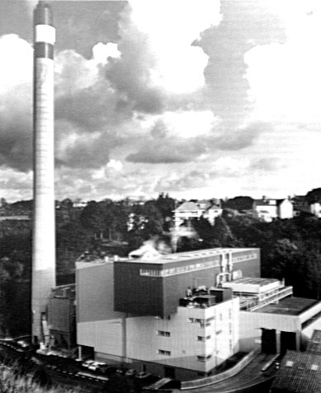

ENERGY FROM WASTE PLANT in JERSEY

Section 5 The Non Fossil Fuel Obligation: Renewables
Obligation

Section 6 Forecasting Electricity Demand

Section 7 Operation of the Pool and NETA

Last update 20th December 2004

5. Non-Fossil Fuel Obligation

5.1 Introduction

• At the time of privatisation, the NFFO was introduced which placed a levy on all energy generated from fossil fuels. The levy has then been used to subsidise the non-fossil fuels. The REC's were expected to purchase a minimum percentage of their electricity from such sources.
• The original proposal was seen as solely a subsidy for the nuclear industry
…………………………….(but needs qualification)
• This was quickly changed to a separate section for Renewables and Nuclear, and then the Renewables section was subdivided further by technology type.

• The NFFO-1 (1990) required a minimum contribution of 102 MW from new "renewables" and in fact the REC's made contracts for 152 MW. However by November 2000 the residual capacity was 144.5 MW.

- A fixed price was paid for renewable energy. The price paid per unit varied significantly with higher funding for those which were further from commercial exploitation. Wind energy had the highest guaranteed price at 11p per kWh compared to a typical consumer price of 6 – 7 p and a generating cost from fossil fuels of around 3 – 4p per kWh. This meant that there was a substantial subsidy for wind.

- Potential generators had to submit applications for the subsidy, but not all ultimately received planning permission, or alternatively the schemes ultimately failed through lack of finance.

- The subsidy was paid until 31st December 1998 – a limit initially placed by the EU

  - Summary of NFFO-2

- As with NFFO-1 a fixed price was paid to all generating capacity

- NFFO-2 (1991) was further divided the capacity by technology type and the outcome was as indicated in the table below.

- The payments under NFFO-2 also expired on 31st December 1998

Technology Group | NFFO-2 Requirement | Actual Contracts | Available November 2000 | price per kWh
 | (MW)` | (MW) | (MW)
WASTE Municipal/ industrial | 261.48 | 271.48 | 31.5 | 6.55
Other Waste | 28.15 | 30.15 | 12.5 | 5.9
Landfill | 48.0 | 48.45 | 46.4 | 5.7
Sewage | 26.86 | 26.86 | 19.1 | 5.9
Hydro | 10.36 | 10.86 | 10.4 | 6.00
Wind | 82.43 | 84.43 | 53.8 | 11.00
Total | 457.28 | 472.23 | 173.7
Details of NFFO – 2 Order

5.3 NFFO - Order 3 - January 1995

The Projects for NFFO-3 were announced at the end of January 1995 and include
TECHNOLOGY | Requirement DNC (MW) | Available (Nov: 2000) (MW)
Energy Crops Gasification | 19.056 | 46.5
Energy Crops Residues | 103.805 | 46.5
Hydro | 14.480 | 11.7
Landfill | 82.071 | 82.1
Municipal and Industrial Waste | 241.765 | 77.4
Wind - large | 146.916 | 44.7
Wind - small | 19.707 | 44.7
Total all schemes | 627.800 | 262.5

• As expected that many of the above schemes failed through planning permission etc. problems

• The Department of Trade and Industry took steps to "size cap" schemes to avoid the dominance in the market of a few large generators. Thus Eastern Electricity's proposal for a straw burning plant was rejected from inclusion in NFFO-3 as it was too large a scheme.

• The DTI also made sure that there was a sensible spread between the various Technologies.

• Clearance was given from EU for NFFO-3 to extend beyond 1998, and it is due to cover period up to 30th November 2014,
NOTE: this excludes NFF0-1 and NFFO-2 projects.

Unlike NFFO -1 and NFFO-2, the price paid for renewables was not a fixed price. Each potential supplier had to bid to supply electricity. The bid was the price they were prepared to accept for supply of electricity. As the time period of the subsidy was much greater, the subsidised price came down significantly. Within any one technology band, there were a number of different bids. There was a declared intention of 627.800 MW and the successful ones were those which required the least subsidy to provide this amount of installed capacity..

5.4 NFFO –Orders 4 and 5

NFFO orders 4 and 5 were announced in mid 1990s and came into effect in 1996 and 1998 respectively. They were very similar to NFFO-3 and both had a twenty year timescale finishing in 2016 and 2018 respectively.

The bid prices were noticeably lower than for NFFO-3.

With the extended time scale, many schemes from both orders are still being built and commissioned – see section 5.6. Indeed some NFFO-3 scheme have only recently been commissioned

5.5 General Review of NFFO tranches to date

The Government planned (1995) to have 1500 MW of renewable generating capacity installed by 2000.

But in reality only a little over half of this figure has been achieved.

UPDATE: from New Review – February 2003
As at 30th September 2002, 409 projects contracted under NFFO, the Scottish Renewables Obligation (SRO) and the Northern Ireland (NI) NFFO had been commissioned and were generating electricity, totalling nearly 1033 MW DNC (declared net capacity). These figures include those projects formerly contracted under NFFO-1 and 2, whose contracts expired on 31 December 1998. The breakdown is shown in the table:
 | Order  Note the reduction in output from Wind since 2002 | Technology Band | No. of Projects | Capacity MW (DNC)
 | NFFO-1 | Hydro | 21 | 10.001
 |  | LFG | 19 | 30.776
 |  | MIW | 4 | 40.63
 |  | Other | 4 | 45.48
 |  | SGas | 6 | 5.98
 |  | Wind | 5 | 8.138 | 11.6
 |  | Totals | 59 | 141.005 | 144.5
 | NFFO-2 | Hydro | 10 | 10.457
 |  | LFG | 26 | 46.393
 |  | MIW | 2 | 31.5
 |  | Other | 1 | 12.5
 |  | SGas | 18 | 19.059
 |  | Wind | 23 | 52.452 | 53.8
 |  | Totals | 80 | 172.361 | 173.7
 | NFFO-3  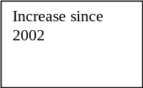 | Biomas | 2 | 69.5
 |  | Hydro | 8 | 11.738
 |  | LFG | 42 | 82.071
 |  | MIW | 6 | 77.419
 |  | Wind Large | 10 | 41.021
 |  | Wind Small | 11 | 10.835
 |  | Totals | 79 | 292.584 | 262.5

Current Status of NFFO (30th September 2002) – contd

Order | Technology Band | No. of Projects | Capacity MW (DNC)
NFFO-4 | Agricultural Waste | 1 | 1.43
 | Hydro | 8 | 2.297
 | LFG | 53 | 139.431
 | MIW | 3 | 22.48
 | Wind Large | 4 | 12.97
 | Wind Small | 4 | 2.755
 | Totals | 73 | 181.363
NFFO-5 | Hydro | 3 | 0.64
 | LFG | 55 | 110.355
 | Wind Small | 4 | 3.647
 | Totals | 61 | 113.657
NI-NFFO- 1 | Hydro | 8 | 2.325
 | Wind | 6 | 12.664
 |  | 14 | 14.989
NI-NFFO- 2 | Biomass | 2 | 0.304
 | Hydro | 1 | 0.075
 | Wind | 2 | 2.567
 | Totals | 5 | 2.946
SRO-1 | Biomass | 1 | 9.8
 | Hydro | 8 | 7.82
 | Wind | 7 | 25.13
 | WTE | 2 | 3.78
 | Totals | 18 | 46.53
SRO-2 | Hydro | 2 | 1.46
 | Wind | 5 | 31.29
 | WTE | 4 | 15
 | Totals | 11 | 47.7
SRO-3 | Wave | 1 | 0.2
 | Wind Large | 1 | 8.29
 | Wind Small | 3 | 2.47
 | WTE | 2 | 8.1
 | Totals | 8 | 19.05
 | Grand Total: | 409 | 1033.18

Government originally targetted to have 1500 MW available by 2000. At the start of 2001 there were 331 schemes with a total ouptu of 834 MW

5.6 Recently commissioned projects – November 2002
 | NOW ON-LINE - from New Review No 54
 | Schemes that have come on-line since the last update include:
 | Order | Technology Band | Site Name |  | MW (DNC)
NFFO-5 |  | Landfill Gas |  | Weldon Phase 1 |  | 4.41
NFFO-4 |  | Hydro |  | Afon Tyn y Cornel |  | 0.2
NFFO-4 |  | Landfill gas |  | Edwin Richards |  | 1.78
NFFO-5 |  | Landfill gas |  | Compton Bassett |  | 2
NFFO-5 |  | Landfill gas |  | Lidsey |  | 1.44
NFFO-5 |  | Landfill gas |  | Connon Bridge |  | 0.6
NFFO-4 |  | MIW |  | Huddersfield Incinerator |  | 7.5
NI-NFFO-1 |  | Hydro |  | Silent Valley Hydro |  | 0.44

RENEWABLES OBLIGATION

The full paper is accessible on the WEB and linked from the Energy Pages on the WEB

In 1999 the Government produced a consultative document designed to ascertain opinion on how renewables might be funded in the future.

The reasons for this may be summarised as:-

- The Government’s declared commitment to reduce CO₂ emissions by 12.5% or more by 2010. Renewables were seen as a way of achieving this. A new Climatic Change Levy (CCL) is being introduced from April 1st 2001 which will in effect place a tax on fossil fuel use by industry and business (though not domestic and transport sectors). The levy at 0.43 p per kWh will increase business and industrial energy prices by 7 – 15%.

- The proposed New Electricity Trading Arrangements (currently scheduled to come into force on 23rd March 2001 – subject to final confirmation). An aspect of these arrangements is to favour flexible generators which would thus tend to penalise electricity generated by renewables.

- The requirement to continue subsidising renewable energy – even though in many case the price of the established renewable technologies are only a little more expensive than conventional generation.

- To provide a mechanism for renewable projects which are currently not commercially viable and would not be possible without Capital Grants.

- The need to differentiate between research on renwables and commercial exploitation

The consultation paper considered three mechanisms to promote renewables:-

- Energy Taxes and emissions trading (see Appendix 6 of paper)
- Using a form of Obligation to stimulate a market for renewable trading
- Direct Grants for renewable energy projects.

Following consultation, option (2) is now favoured as it was seen that this would provide the best mechanism to drive down prices of renewable energy sources such that they would be competitive with conventional sources. Option (3) might provide an initial stimulus, but is unlikely to be sustained unless the price of electricity were to rise significantly.

Part of the background for the paper was to ensure that fuel poverty was avoided, and thus prices were to rise as little as possible. It was seen that only option (2) was likely to satisfy the diverse requirements needed for promoting renewable energy.

If an Obligation were to be in place, the paper discuss the advantages and disadvantages of placing the obligation on
  - the generators
  - the National Grid Company
  - the Distributors (i.e. Eastern Energy)
  - the Suppliers
  - the Consumers

The paper considers all of these, but ultimately the chosen option for the 2000 consultation was option (d) – the Suppliers.

5.8 RENEWABLES OBLIGATION – 2000 consultation

New and RENEWABLE ENERGY – Prospects for the 21st Century: The Renewables Obligation: Preliminary Consultation

This paper draws on responses to the 1999 consultation document. Much of the document is now confirmed for implementation following Parliamentary Legislation in October 2001 with the intention that it should run until 2026 with annual revisions of targets etc. There was then a Statutory Consultation Period, and finally the Renewables Obligation came into force on 1st April 2002..

The Renewables Obligation requires that all SUPPLIERS obtain a minimum amount of renewable energy for sale to their customers. The target amount is set to increase by a proscribed amout each year up to 2010 and presumably beyond. In the cost of generating electricity from conventional sources averaged between 1.8 and 2.5p per kWh. Further it is expected that many of the more established renewables will be able to generate electricity at a price range less than about 3p per kWh..

It is important to note that the Renewables Obligation refers to NEW Renewables, so in 2002/2003 much of the renewable generation was excluded. The total Renewable generation is around 3% with about 50% coming from the New Renewables. This means that unless substantive comissioning of new renewables takes place in next few months there will be a substantial shortfall in the 3% new reneables shceduled for the current 12 month period.

The idea behind the obligation is to ensure that renewables are used even if their price exceeds that of conventional generation. However, there is an optional buy out set at a proposed 3p per kWh limit. This limit was retained despite discussions which suggested a higher "but out" price would ensure a higher deployment of renewables. The idea behind this is that if the price of some renewables is too large than suppliers can opt out of their obligation by paying for the units at 3p per kWh.

In the first few years of operation, it is probable that the statutory limit will be significantly higher than the phsyical amount of renewable generation capacity available, and most companies will have to invoke the "Buy Out" Clause.

The scheme will be controlled by the issue of Renewable Obligation Certificates (ROC's), and these certificates will have an intrinsic value.

A supplier may thus satisfy his obligation by one of the following means.

- Purchasing sufficient RenewableEnergy which will automatically transfer to that supplier the requisite number of ROCs. These are then handed to the regulator at the end of the year.

- Purchasing ROC's from companies who have a surplus of such certificates. [ this is very unlikely to occur in the first few years, as there is a substantial shortfall in the physical capacity of renewable generation]

- Pay the "Buy Out" price for all units of non-renewable electricity purchased up to the statutory limit for the year in question. Initially the "but Out" price will be 3p per kWh..

The "Buy Out" price is significantly above the price for conventional generation, so this would mean that the price a supplier would have to pay for any shortfall in his obligation would be at least:

3p + generation cost + Climatic Change Levy

Taking 1.8p as a typical generation cost and the Climate Change Levey which applies to all Fossil Fuels of 0.43p perkWh. This would suggest that the cost to the supplier would be in excess of 5.2p.

The "Buy Out" price will be recycled to the
In this way the value of ROC's are likely to be

.
As this is significantly above the price for conventional generation, thus will automatically provide a subsidy for renewable energy.

It is intended that the 3p will not be decreased in future, but it is suggested that it should rise by the RPI.

Using this 3p it is anticipated that electricity bills in 2010 will be 3.7% higher than those in 1998.

Summary of incentives for Renewables: Table B from Consultation Document:

Source | Needed for 10% Target | Renewables Obligation | Climatic Change Levy Exemption | Capital Grants Available
Landfill Gas | √ | √ | √
Sewage Gas | √ | √ | √
Energy from Waste | √ |  | √
Large Hydro > 10 MW | √
Small hydro | √ | √ | √
On shore Wind | √ | √ | √
Offshore Wind | √ | √ | √ | √
Agricultural and Forestry Residue | √ | √ | √
Energy Crops | √ | √ | √ | √
Wave Power | √ | √ | √
Phtovoltaics | √ | √ | √

Notes

- Large Hydro generation will have to pay Climatic Change Levy
- Energy from Waste does not qualify under Renewable Obligation as it is already developed and competitive with conventional generation
- Offshore Wind and Energy Crops are likely to not get started without additional stimulus – hence a Capital Grant issued to help initial cost.

The Climatic Cgange Levy came ino force on 1st April 2001 and amounts to 0.43p kWh for all electricity purchased by industry and businesses. This increase in energy costs was offset by a reduction in the NI contributions paid by employers. Thus an organisation with a low energy use but high number of employees benefitted, while those with a large energy consumption and low number of employees had to pay more. Partly because of the exemption of the CCL levy to the University for its CHP generation, UEA benefitted from this change by several tens of thousands of pounds per year.

Table D illustrates how the Renewables Obligation will be met. Note that there are two components for Renewables: those which are classified as being within the Renewable Obligation; and those which are not (i.e. large Hydro and Energy from Waste.

Table D. Profile of Obligation to 2010 (from Consultative Document)
 | Estimated Electricity Demand | Renewable Target for 10% in 2010 | Contribution from Non-Eligible Renewables | Contribution from Eligible Renewables | Obligation as % of Sales
 | TWh | TWh | TWh | TWh | %
1999 | 350.8 |  | 6.0
2000 | 353.2 |  | 5.9
2001 | 355.7 |  | 6.3
2002 | 358.2 | 16.1 | 6.7 | 9.4 | 3.1
2003 | 360.6 | 18.0 | 7.0 | 11.0 | 3.6
2004 | 363.1 | 20.0 | 7.5 | 12.5 | 4.0
2005 | 365.6 | 21.9 | 8.0 | 13.9 | 4.5
2006 | 368.5 | 25.8 | 9.0 | 16.8 | 5.3
2007 | 371.4 | 29.7 | 10.0 | 19.7 | 6.2
2008 | 374.3 | 33.7 | 11.0 | 22.7 | 7.1
2009 | 377.3 | 35.8 | 12.0 | 23.8 | 7.4
2010 | 380.3 | 38.0 | 13.0 | 25.0 | 7.7

Note: NFFO-3,4,and 5 projects will come under Eligible Renewables, and in first year of Obligation (i.e. 2001 – 2002) it is anticipated that much of the obligation will be fulfilled by these projects or ones to come on line shortly.

The above table shows the Government’s projections but their data are incompatible with the objective to reduce CO₂. In 2001 the electricity consumption was higher than the projected figures by 9 TWh.
It is planned that 10% of electricity will be generated by renewables by 2010 amounting to 38 TWH. This means that 380.3 – 38 = 342.8 TWh will come from conventional generation. In 1999, the contribution from conventional sources was 350.8 – 6 = 344.8 and thus a reduction of only 2 TWh in conventional generation will be achieved. Since a significant amount of nuclear is planned to be closed, by then there will be an increase in fossil fuel generation, and it is difficult to see how the reduction in CO₂ can even be stabilised to 1999 levels yet alone reduced further in line with the Kyoto Protocol. Either the Government must promote renewables more widely than the 10%, or they must curtail demand, or see a replacement of nuclear generation as older stations are decommissioned.

  - Operation of Renewables Obligation

Renewable Generators can be issued with Renewable Obligation Certificates (ROCs) if they can demonstrate to OFGEM, that the electricity generated by them falls with an eligible category of Renewables. These ROCs form the basis whereby OFGEM can monitor compliance of the Obligation by the Suppliers.

The Supplier will have to demonstrate that it the proportion of eligible renewable electricity is at least the proportion shown in Table D.

They may do this in one of several ways.
- Purchase from generators the exact amount of renewable electricity verifiable by ROCs to meet the target. They will have to produce the requisite number of certificates to demonstrate this.

- Suppliers who have a deficit of ROCs could negotiate with others who have a surplus and purchase the required ROCs at an agreed price. Since there are several suppliers, this will ensure competition.

- Suppliers can opt for the BUY OUT option at the proposed level of 3p per kWh, if the price of the extra ROC’s become excessive. The proceeds from the BUY OUTs paid to OFGEM will be recycled to the suppliers in proportion to the actual number of certificates held by each supplier. Thus a supplier with no ROC’s would receive nothing, while those with a large number will receive a proportionately high amount. This is seen as a way to encourage suppliers to purchase their full obligation in the first place and to provide necessary capital for new projects in the longer term. Since the recycled BUY OUTs are proportional to certificates held, this puts a price on the certificate which in turn will be used by suppliers the price at which they are prepared to purchase or sell extra certificates.

5.10 B&B – or Banking and Borrowing

Suppliers who have access to more than their Obligation in any one year may bank the certificates for use in another year. The proposed maximum amount that can be banked is suggested at 50% of the required obligation. A supplier who in one year has negotiated a contract over and above their obligation in one year may find this attractive if they can see that in the following year they might have difficulty in making contracts – perhaps through late commissioning of suitable plant.

It is presumed from the document that those banked and not redeemed will not figure in the recycled BUY OUT funds, and thus it will be an added dimension in the pricing of ROC sales and purchases – i.e. is the value of certificates likely to rise or fall in the future.

As well as banking, suppliers may borrow certificates against redemption opportunities in the future. To avoid distortion of the markets and the avoidance of using the BUY OUT option for suppliers with a shortfall, the maximum level of borrowing is proposed at 5% of the supplier's obligation target.

5.11 Banded Prices and Capital Grants.

The Consultation document also considers the idea of banded obligation payments – i.e. each technology would have its own BUY OUT price could distort development. This would add an additional complication in that each supplier would not only have to demonstrate overall compliance, but compliance in each technology band. This could be counter productive for suppliers in different parts of the country, and also the differential setting of the BUY OUT prices may not properly reflect the technical and other developmental problems within each band. Equally, the Government is keen not to favour one form of renewable electricity over another.

There are two exceptions to the above: Offshore Wind and Energy Crops, both of which are almost certainly required for the specified targets. These are at a much earlier stage of development. It is proposed here that a one off payment of 40% of the eligible costs could be made for such projects. However, strict guidelines will apply for the submission of proposals, and furthermore this aspect will also need to be ratified by the EU before it can be implemented.

  - Concluding Remarks

While the Renewable Obligation should help to promote further development of renewables, there are serious issues which are not covered in the report.

The Renewable Obligation refers only to electricity generation, no support is indicated for other applications – e.g. solar hot water/space heating. Equally, the RO is only applicable to grid connected schemes (presumably because of the monitoring aspect). For offshore wind and wave it may make more environmental sense to generate hydrogen offshore and pump this ashore for local reconversion using a very clean fuel into electricity at the point of use. If this were done it would tend to promote “A Hydrogen Economy” and set the development for local Fuel Cell generation of electricity. This is perhaps a significant deficiency in the proposals.

The first tranche of the Obligation is due to run from 18 months from October 2001 to March 2003, and thereafter targets will be revised on an annual basis.

It will not be until March 2003 that the full implications of the Renewable Obligation can be assessed.

Space for additional notes:

6. ELECTRICITY DEMAND

6.1 TYPICAL DAILY PATTERN:-

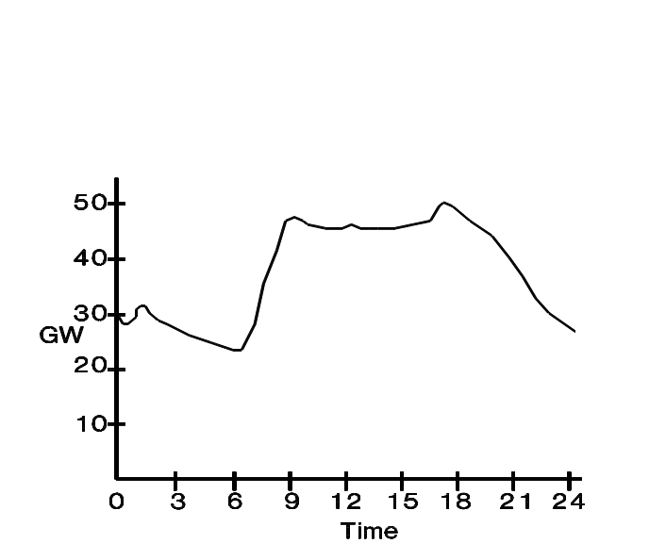
WINTER:-

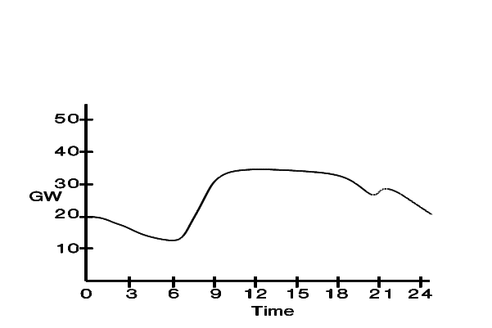

SUMMER:-

For an up to date indicaion of actual demand – consult http://www.bmreports.com which is accessible fro the Energy Web Pages. Detail s of demand as recently 30 minutes ago can be seen.

6.2 FORECASTING DEMAND:-

Except in relatively small quantities. electricity CANNOT be stored, and generating capacity at any instant must be closely matched to demand.

IMPORTANT TO FORECAST DEMAND AS ACCURATELY AS POSSIBLE.

FACTORS AFFECTING DEMAND:-

- Weekdays have generally similar demand pattern to Figures on previous sheet.

- Weekends have a different but generally consistent demand pattern.

- Minor variations occur:-
e.g. larger morning peak on Mondays, more spread out evening peak on Fridays.

- Weather affects demand by shifting curve upwards:-

*Dominant factors:-

EXTERNAL TEMPERATURE (approx. 8% increase in heating demand for every 1o C drop in temperature).

INDUSTRIAL DEMAND (these are usually constant for a given day)

- Other factors:-

* Wind chill
* Solar gain
- affect consumption by a few percent at most.

- Seasonal factors shift evening peak to late evening as daylight hours increase.

6.3 THREE LEVELS OF FORECASTING:-

MADE BY NATIONAL GRID COMPANY.

1) LONG TERM:- Strategic planning of requirements of period of years. In past CEGB used this for decisions on building of new plant. Since privatisation situation is somewhat different.

2)SHORT TERM:- (about 1 week ahead) on basis of long range weather forecasts2424 to ensure sufficient plant is going to available). It can take up to 36 hours or so to bring a power station from cold to generating status

3)24-HOUR FORECAST:- (previous afternoon) on basis of latest weather information. This forecast indirectly influences which generating plant are likely to be called upon in the coming 24 hours

On the basis of the above three, a projection is made for ch half hour period in the following day. After this, the generating companies (the Big 2 and other smaller ones) bid to supply electricity during a given period. This bidding process will be covered in detail later in the course.

SHORT TERM FLUCTUATIONS:- arising from equipment failures, television adverts etc. (i.e. periods of seconds to a few hours). These variations are dealt with by use of pumped storage schemes, use of GAS TURBINES etc.

NOTE:- A reserve of about 0.5 - 1.0% is usually provided by running generators slightly under full load. This gives scope for reasonable response in cases of emergency (e.g. failure of a 500/660MW generating set).

FORECASTS ARE VERY DIFFICULT TO DO FOR SPECIAL OCCASIONS e.g. the Royal Weddings, as these occur rarely, and the demand in the early 1980's would be different from a similar occasion now.

SPECIAL SPORTING EVENTS can cause minor problems (e.g. the CUP FINAL going to extra time), but there is generally sufficient recent historical data to make reasonable predictions possible.

6.4 MEETING DEMAND - former CEGB method

Electricity cannot be stored except in small quantities so power stations are called into use as needed.

If a station is cold it may need up to 2 days to come on line. Even when hot most will need at least 20 minutes to come up to full power.

- Cheapest marginal plant were run first (i.e. nuclear -- does not mean nuclear is cheapest, merely that marginal cost is cheapest).
- Then come base-load Coal - most efficient coal.
Above plant are run continuously for several days on end as demand is always above output (at least in short term)
- The cost for running a particular plant will depend on how warm the plant is (i.e. how long since last generation.

7. The Electricity Pool and the New Electricity Trading Arrangement

7.1 Introduction

Currently the majority of electricity supplied in England and Wales is traded in the "Pool". It is anticipated that the POOL will be replace by the New Electricity Trading Arrangement during 200 (NETA).

In Scotland the system is very different.

Organisations supplying electricity to the Pool are:-

National Power, PowerGen, Eastern group, Mission Energy, Nuclear Electric, BNFL (Magnox), "The Independents", Industry and EdF. All these are involving in the "bidding process"

Scottish Power and Scottish Hydro supply electricity to the Pool but supply in Scotland generally does not go through the POOL.
Purchasers of Electricity from the POOL include:-

• PowerGen and INNOGY [formerly National Power]
• Licensed Suppliers
• Regional Electricity Companies (e.g. MANWEB, SEEBOARD, SWALEC, YEB, NEB, EMEB, MEB, EMEB, LEB, SWEB, NWEB, Eastern Electricity, Southern Electricity).

Several of these have seen mergers in recent years – for instance Eat Midlands Electricity is now part of PowerGen, and Midlands is part of the nPower Innogy group, while NWEB has amalgamated with North West Water to form United Utilities, and Scottish and Southern have joined forces. Eastern purchased several power stations from PowerGen and National Power a few years ago and are one of the major generators.

- From 1st April 1990 any of above suppliers could supply to any customer with an average load in excess of 1 MW (UEA has a load varying from 1.8 MW to 3.9 MW).
- From 1st April 1994, the threshold was reduced to 100 kW.

But Only RECs could supply to small consumers

- From 5th September 1998 [and phased across country until June 1999], all consumers including domestic ones can now purchase electricity from any of the above irrespective of locality or indeed from any licensed supplier.

7.2 The bidding process operated by National Grid Company

Each day the NGC publish the expected demand for electricity for each half hour period during the following day, and invite bids from all generators who supply more than 100MW.

This bids must be in by mid afternoon after which NGC decide who will generate (and hence get paid).

Each generator will bid for each generating set and the bid will represent the cost for running the plant. These are then stacked with the lowest bid at the bottom and successively higher bids above. The prices which a generator will bid will also depend on how long it has been since the generating set last generated if it is not generating in the immediately preceding half hour. This is because it takes energy to warm the unit up as well as more man-power in the run up period. Consequently the bid for those units is likely to be higher.

The highest bid which provides a cumulative generation capacity equal to the projected demand is the SYSTEM MARGINAL PRICE (SMP), and all generators who bid below this price will be paid at the SMP irrespective of what their bid was.

An example of stacked bids is shown after the schematic of the POOL

Generators A - E had successful bids and would be all paid £19.31 per MWh.

Generators F and G were unsuccessful.

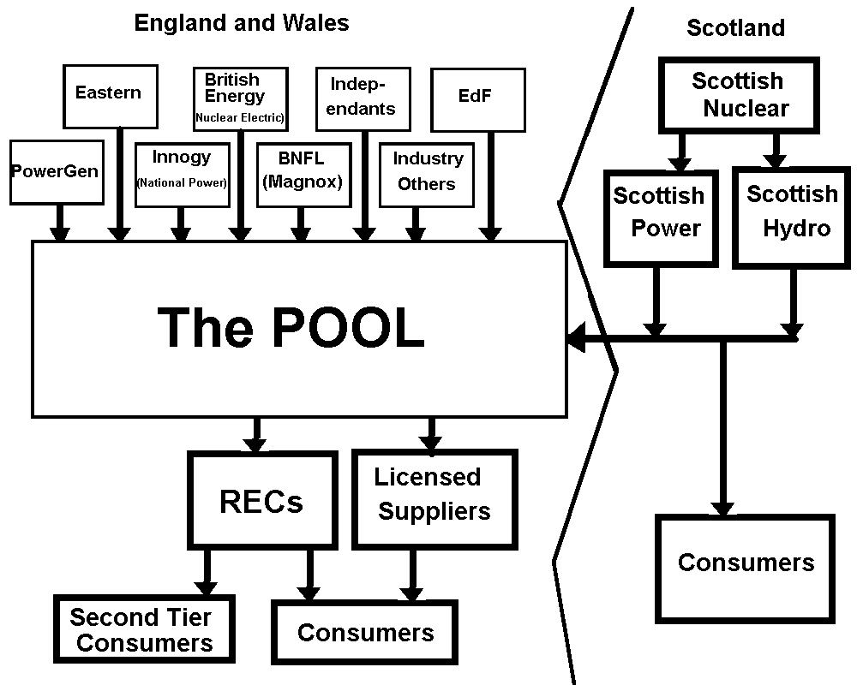
Fig. 7.1 The Electricity Pool
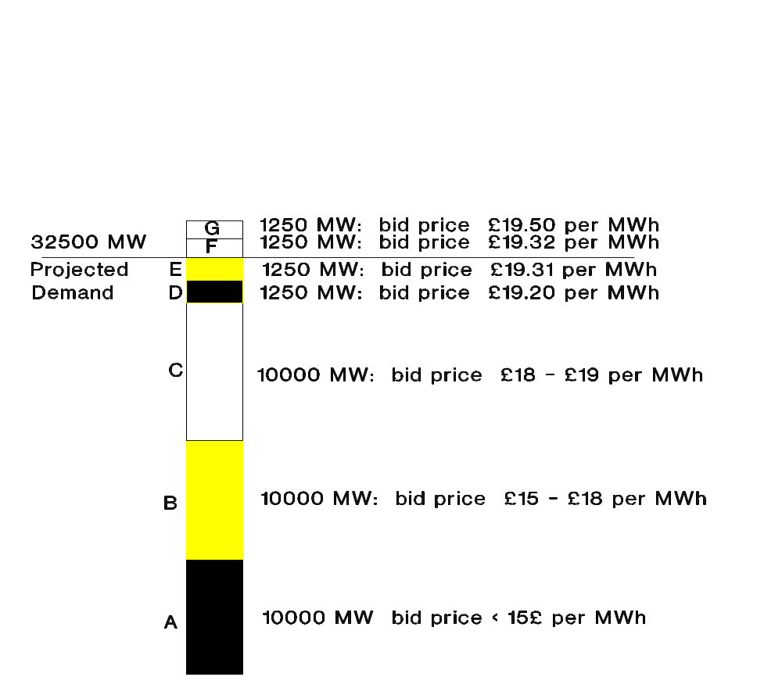
Fig. 7.2 Example of bids from different generators

Illustration of operation of the Pool: Generators A:E are successful but F and G are not. The System Marginal Price is £19.31 per MWh and will be paid for each unit generated by A – E irrespective of the bid they actually made.

There is no reason why a generator should not bid £0 – particularly if it wanted to guarantee a unit ran – i.e. it was kept running and warm to make the bid for the next half hour less. If all generators did that, then the SMP would be £0 and they would have to generate their electricity for nothing!

7.3 The Pool input Price (PIP)

The Pool input price is a combination of the SMP and a capacity charge. This latter is paid to generators who make capacity available irrespective of whether they generate any electricity or not. This capacity may be required to cope with unexpected demands.

PIP = SMP + LOLP*(VOLL - SMP)

LOLP is the loss of load probability. In summer this tends to be very small (e.g. 0.00005) or zero as usually there is plenty of capacity potentially available to deal with changes in demand. In winter it can become important (~0.001)

VOLL is the value of the loss load and is determined by OFFER and was initially about £2200 per MWh. It is now somewhat higher

If for example, the SMP is £19.31, the LOLP is 0.00005, and the VOLL is £2200, then

PIP is 19.31 + 0.00005*(2200 - 19.31)

= £19.419/MWh

If LOLP rises to 0.002,

then the PIP will be £23.67 / MWh

The generators get paid the PIP for units that are actually generating, but can receive payment for

LOLP*(VOLL-SMP)

if they are asked to have a generator on standby to cope with emergencies.

7.4 UPLIFT

The Regional Electricity Companies and Licensed Suppliers purchase electricity at the Pool Output Price (or POP).

POP = PIP + Uplift

• The Uplift is an additional cost which accounts for the fact that it is not always possible to purchase the cheapest electricity because of technical constraints (e.g. number of transmission lines).

• Some stations will be CONSTRAINED ON irrespective of their bid price as they are critical to security of supply (e.g. Didcot I nearly days).

• Others are CONSTRAINED OFF because although they bid below the system marginal price, they are unable to supply because of transmission constraints.

• Constrained Off stations are paid the full SMP even though they generate no electricity.
- Constrained on stations are paid at their bid price

7.5 Problems with the Pool

The Pool has worked fairly well since Privatisation, but both PowerGen and National Power have played silly games with the system.

1) In early days, both large generators deliberately bid high on stations they knew were likely to be CONSTRAINED ON. This raised the SMP artificially. OFFER stepped in and bids from Constrained On stations are not included in determining the SMP.

- Both big generators saw that it was to their financial advantage to deliberately make plant temporarily unavailable by additional maintenance so that LOLP increased. At one time, the capacity charges amounted to over 20% of total PIP.

7.6 OPERATION OF ELECTRICITY POOL - CONTRACTS

Generators and Large Customers can enter into ONE- or TWO - way contracts to reduce variations of POOL price which can change considerably over the day and season.

ONE-WAY CONTRACTS

There is a STRIKE price at which the generator will compensate the customer if the POP exceeds the STRIKE price.

TWO - WAY CONTRACTS

In a two way contract, there is an upper and lower STRIKE price. The generator pays the customer the balance if the POP is greater than the upper strike price.

Similarly the customer compensates the generator if the PIP is less than the STRIKE price

The reasoning behind such contracts is to make energy charges more predictable

A full worked example part of which was set as an exam question is shown in the Appendix Section 7.xx. As the POOL has now ceased operation, this type of numeric question is no longer relevant now, but is included to illustrate exactly how the process of payments worked.

7.7 Developments to the Pool

1) From April 1st 1995, the uplift charges should became the sole responsibility of NGC so that these are minimised. In return NGC received payments for undertaking this liability.

OFFER was concerned that the UPLIFT has been allowed to drift upwards under the present arrangement, and by placing it wholly under NGC this should lead to more efficient scheduling and despatching within the industry.

2) Following the fiasco of the capacity charges and bid prices, OFFER has threatened to take both National Power and PowerGen to MMC unless they dispose of 4000 and 2000MW of coal fired generating capacity respectively to Independents. The disposal was completed by 31st December 1995 and this capacity was purchased b Eastern who then became an important additional player in the POOL.

- In 1998 a major review has took place with numerous consultative documents. The POOL was replaced with the New Electricity Trading Arrangements (NETA). on 27th March 2001. Essentially NETA introduces a bidding process into the process – something that was lacking previously.

- There have been many consequences of NETA, and the current problems of Bristish Energy, the demise of TXU, the finnancial difficulties of AES, and the significant problems now encountered by embedded generators such as CHP are a direct result of NETA.

- In the last four years there have been major changes in the ownership of power stations. Thus National Power demerged into Innogy and International Power. The pumped storage schemes operated by National Grid were sold to Mission Edison Power (trading under the name of First Hydro). Fiddler’s Ferry Power station was sold by PowerGen to Mission Edison, and latterly to AEP. Etc.
7.8 DEREGULATION -

This is a fast moving subject - so watch press, and documents from OFFER.

From April 1st 1990

Customers > 1 MW could obtain supplies from second tier suppliers

From April 1st 1994

Customers > 100 kW were included

All customers in above markets have now to have meters which can assess consumption in each 30 minutes period separately.

From April 1st 1998

All customers included

Customers have three components to their bills - a distribution charge which is paid to local REC or distribution company, and a charge for electricity consumed - paid to the supplier whoever that may be, and a charge for reading the meters.

- The charge for distribution is the same whether the local REC is the supplier or not.
- The local supplier is not allowed to reduce prices more than a certain amount in the early days of Deregulation. This is to encourage other suppliers and RECs from other areas to get a foothold. Thus in most cases, the local REC is one of the most expensive suppliers in its own local area, but is likely to be one of the cheaper ones outside its area. Ultimately this restriction on local RECs will be removed.
- Metering is often still done by the local REC even if they are no longer the Supplier. Ultimately it is expected that specialist metering firms will emerge and read meters on behalf of several different suppliers.

  - Payment by Suppliers for Electricity

Electricity will ultimately be charged differentially by the half-hour.

Problem:-installation of suitable meters in short term.
Financial payments must be made between suppliers and distributors and generators on a 28 day basis - which is much shorter than normal - month billing period

solution: use an assumed profile for those customers not on half hourly meters

Each half hour:
• determine consumption from customers with half-hour meters, and
• subtract that from total consumed in the REC area. This is the net load to be profiled
• Profile load of all other customers according to one of 8 or more profiling curves to estimate what each customer has used. Compare the total of all profile customer loads with the cumulative determined above and compute a correction ratio.
• Attribute consumption to suppliers according to each of its customers multiplied by this ratio.
• This represents an initial settlement price to supplier who can now pay the POOL and the distributor.
• After three months when bills are in, the total for each customer is compared with the aggregated adjusted profile loads for that customer, and any discrepancy is compensated either way in the "RECONCILIATION PHASE"

- Metering by the half hour could lead to more effective energy conservation and is a welcome step in the right direction. i.e. electricity at certain times of day could become much more expensive, and much cheaper at others. This will encourage people to shift use from peak leading to less demand for new power stations. It is in place for large consumers, but ultimately it could well come to domestic consumers

  - The New Electricity Trading Arrangement (NETA) - Background

There are numerous very lengthy documents on this accessible on the WEB. One in particular is quite a good and concise summary of how the system will work. This is linked from the List of WEB Pages accessible from the Energy Home Page.

-Overview of New Trading Arrangements V1.0 - this is included as an Appendix to this Section

NETA was introduced on 27th March 2001, with modification in July 2002.

The introduction of NETA was a major overhaul in the way electricity is traded.

The critical differences with the POOL are

- NETA will overcome a deficiency that the prices were set largely by the generators with little input from suppliers.
- The majority of purchases/sales of electricity will be done outside NETA provisions between generators/traders/distributors/suppliers. That means that for a particular period a supplier will contract with a generator to purchase a projected amount of electricity based on expected demands. I.e. this is a form of FUTURES market.
- The projections are unlikely to be accurate and there will be imbalances arising from changes taking place after the contracts are made e.g.
- Changes in weather
- Unforeseen changes in customer demand
- Breakdowns in the system
- Etc

- NETA is concerned primarily in assessing the imbalances which occur at a particular time and provide a mechanism for charging. For instance the demand imposed by customers on the suppliers may increase or decrease above the contract position. The suppliers will then be charged for the imbalance whether it is positive or negative. Clearly, it is in their interest to minimise these imbalance payments and thus they need to predict as accurately as possible what the demand from their customers will be.

- The role of the National Grid Control will be largely to deal with the imbalances as they arise and ensure that the system remains secure and there is collectively over the whole system sufficient electricity available.

- NETA will tend to favour those generators which are flexible in the amount they can output, equally if suppliers have customers who can load shed, then these will be at an advantage. The Magnox Nuclear stations are unlikely to be that flexible and may be at a disadvantage compared to their present position under NETA. Equally, CHP and Renewable generators are likely to be at a disadvantage, particularly Wind generators as their supply is unpredictable. It is partly for this reason that the Renewable Obligation is also being introduced – although not until 6 months after the introduction of NETA.

- The main basis of NETA is the Balancing Mechanism (BM) unit. For a generator a BM unit will normally be a physical generating set or a collection of smaller sets (many power station have several sets). For a supplier the BM unit is likely to be a single large consumer or a collection of consumers. A typical size for a BM Unit (either generator or supplier) is about 50 MW or about 0.1% of peak demand.

7.11 An brief Overview of NETA – Physical Notifications

Most electricity trades will be direct contracts between generators and suppliers, although there may also be Electricity Traders operating to broker deals between the generators and suppliers.

Each supplier and generator will have to project their supply or demand requirements in advance for each 30 minute period of each day. These must be done in two stages.

- An Initial Physical Notification (IPN) of the electricity to be traded by 11:00 am on the day preceding the day in which the half hour period occurs.

- A Final Physical Notification (FPN) which is made by 3.5 hours prior to the real time. For instance if the half hour period is 17:00 – 17:30, then FPN must be made by 13:30. The time of 13:30 is known as GATE CLOSURE.

Obviously between IPN and FPN, adjustments are likely to be made on the contracted supply as more refined information on changing weather and other physical factors (e.g. sudden plant breakdown) becomes available. These amounts are the quantities of electricity which each part will be obliged to supply or generate for the given period. Financial Transactions will take place just between the parties concerned.

Both the IPN and FPN may be at a constant level, but in many cases, particularly for demand side BM units, the project demand might vary over the half hour period. Thus BM units may define a single IPN/FPN for the whole half hour period, or on a minute by minute basis. Thus from 08:30 to 09:30, the demand on many demand BM untis will increase quite rapidly as work starts for the day, and recognition of this can be included in the Physical Notifications.

No change in the contract position is possible after GATE CLOSURE irrespective of changes which may occur. At that point any trade enters the Balancing Mechanism Period and it is here that NETA fully comes into force. It is concerned about charging for electricity generated or no generated which is above / below the contract position. Equally, the difference in the supply above/below the contract position.

Since the contract position is the basis for charging, it is for this reason that the amounts contracted are notified in the Physical Notifications. One reason for the two different Physical Notifications is to allow the National Grid Company (NGC) responsible for security to check that the contract provide a secure system. Thus if all the contracted generators were in the north and the majority of the supply was in the south, then there would be system constraints which would affect the secure operation. In this way the NGC can call on generators specifically for security operation and/or provide cover for emergencies. Such generators (or even load shedding suppliers) will be paid for these services, but these represent an additional complication of NETA which will not be covered in this course.

  - NETA OVERVIEW:
Balancing Mechanism

As electricity demand is transient there will always be discrepancies between the projects made by Gate Closure and the aual electricity generated or supplied at the real time. The Balancing Mechanism provides a means whereby the NGC can ensure sufficient supply and demand.

All BM Units (whether generators or suppliers) may in addition to their statutory requirement to notify their contracted supply/demand make an OFFER or BID to change their contractual position after GATE CLOSURE. For a generating BM unit and OFFER would imply and offer to INCREASE generation, whereas from a supplying BM unit, and OFFER would represent an offer to REDUCE demand (probably through Load Shedding) - see Fig 7.3. Though the projected demand is specified on each half hour period, it is quite probable that the forecast demand might change during that period as is also shown.

A BID will be to reduce the output of a BM generating unit or increase the demand of a supplying unit.

The purpose of these OFFERS and BIDS is to permit flexibility to cope with the actual demand at the real time rather than the projected generation and demand as given at GATE CLOSURE.
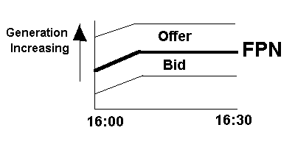

FPN
Fig. 7.3a The FPN is shown to increase and then remain steady. The diagram shows that generators can OFFER to increase their output (at an OFFER Price). Equally, they may BID to lower their output. Note that OFFERS for generators increase output, BIDS decrease output. Also that the increase is +ve
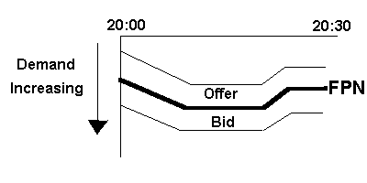Fig. 7.3b Showing a varying FPN during a 30 minute period. This diagram is for Suppliers. Once again, there is an OFFER and a BID. However, an OFFER will reduce demand and a BID will increase Demand. Thus increasing demand is plotted -ve. This allows both generator and supplier information to be plotted on same diagram.

The OFFER and BID prices from a particular BM unit will depend on the ability of the BM unit to respond and also the price the generator or supplier is prepared to see the BM unit deviate from the contractual position. Thus to increase demand will require additional fuel in a fossil fuelled station and this will tend to be reflected in the OFFER price. The OFFER price (i.e. the price the BM Unit is willing to be paid) to increase the FPN (increased generation or reduced consumption) and will in general not be the same as the BID price.

At first site it may appear odd that a Supplier could reduce demand. In fact many large customers have Load Shedding arrangements which means that at relatively short notice these customers are prepared to reduce their demand by a given amount, and in doing so get a preferential price for all the electricity they consume. The OFFER price for a supply BM unit thus reflects the discount the supplier has to pay to the Load Shedding Consumer.

NOTE: An OFFER (whether from a generating BM Unit or a Supplying BM unit) will always increase the (final Physical Notification Level) FPN level. In the case of the supply, this in effect means reducing the demand (or making the demand less –ve). It is for this reason that the two types of BM unit have opposite signs. Conversely a BID will reduce the FPN level for both generation and supply.

In many cases, a BM unit may have differential OFFER and / or BID prices depending on how much the FPN is to be raised. Thus to raise the FPN by say 50 MWh over the 30 minute period might be offered at say £30, but to raise the FPN by a further 50 MWh to 100 MWh would be offered at say £40.

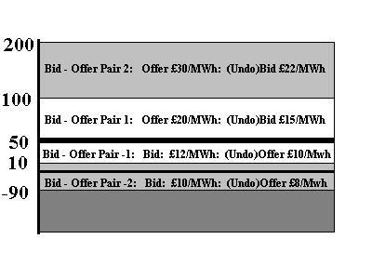This procedure is indicated in Fig. 7.4. The FPN is at 50 MW. The offer price to increase the output between the FPN and 100 MW would be £20 per MWh, but to increase to between 100 and 200, the offer would be £30 / MWh.

Fig. 7.4 illustrating multiple bids for different ranges. Also included in this diagram are the Undo Offers and bids.

Two points to note:-

- The Physical Notifications only require the volume of the generation/demand in the relevant contract.
- The Bids and Offers must also include the cost.

NOTE: The physical notification refers to the rate of production/ consumption of electricity, whereas the prices are in terms of a physical total quantity. Do remember though that we are dealing with 30 minute periods, so if a unit was called upon to run at 50 MW above the FPW – i.e. 100MW for the whole 30 minute period, it would generate

(100 – 50) * 0.5 MWh

during the period – the 0.5 referring to the half hour period.

The decision to operate at anything other than the FPN is taken by the National Grid Company who will require a company offering or bidding to make goo on their offer or bid if the system becomes out of balance after Gate Closure. Obviously the NGC will normally take up those offers and bids which are cheapest.

However:

- System constraints may dictate that higher priced offers/bids are taken up (this is a little akin to the constrained ON/ constrained OFF situation in the POOL.
- If a BM Unit fails to deliver on its offer/bid, the NGC for whatever reason, then the NGC will have to take an alternative which will almost certainly be higher and the defaulting BM unit will be penalised accordingly such neither the NGC nor the consumer is affected in terms of price.

The balancing mechanism begins immediately on Gate Closure and continues throughout the period until the end of the real time half-hour. Simultaneously, there will be balancing occurring for the following half-hour periods. Electricity supply is a very dynamic operation and supply and demand is continually changing, and hence many bids/offers may be taken up.

Once a BM unit and the NGC agree on the ACCEPTANCE of an OFFER or BID, this is then binding on both parties (see above for situation with defaulting BM units).

However,

The NGC cannot cancel an ACCEPTANCE of BID/OFFER once it has been made. This means that a problem would occur, if after accepting an offer for more electricity, the demand suddenly falls. To overcome this there are UNDO options – i.e. an UNDO BID will remove an OFFER and conversely an UNDO OFFER will remove the effects of a previous BID. Since this will incur costs on the BM unit (e.g. a generating unit may have kept on staff to start up a new unit only to have to stand down), the UNDO BIDS and UNDO OFFERS will be less than the corresponding normal OFEERS and BIDS as shown in Fig. 7.4. This means that the NGC picks up the cost for calling on a Bid/Offer only to cancel it later.

The OFFERS and associated UNDO BIDs are normally linked as a pair as shown in Fig. 7.4. These are number successively +1, +2, +3 on the normall OFFER side (i.e. increase generation/decrease consumption) and –1, -2, -3 on the normall BID side.

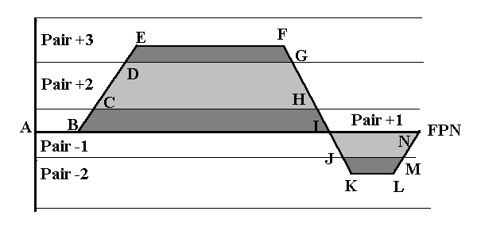7.13 Examples of Balancing Mechanism
Fig. 7.5 An example of Offers and Bids in a single half hour. Offers are accepted for the first part of the period which sees the level rise above FPN into the region covered by Pair +3. Later in the half hour, BIDS are accepted to reduce the FPN into the region covered by Pair –2. Typical prices of OFFERS/ BIDS are shown in the following table.

It is assumed that FPN is 50 MW

Bid/Offer Pair | OFFER (£/MWh) | BID (£/MWh) | Range (MW)
+3 | 50 | 35* | 200 to 400
+2 | 30 | 25* | 100 to 200
+1 | 15 | 13* | 50 to 100
-1 | 13* | 12 | 10 to 50
-2 | 11* | 10 | -90 to 10
The *items are not invoked in this example as all OFFERS and BIDS are accepted and then not changed.

The relevant Pair are in operation as follows:-

A – B | OFFER/BID No. | H – I | Pair +1
B - C | Pair +1 | I – J | Pair –1
C - D | Pair +2 | J – K – L – M | Pair -2
D – E – F - G | Pair +3 | M - N | Pair -1
G - H | Pair +2
Now suppose that the demand level changes after acceptance of the OFFERS and BIDS to that shown in Fig. 7.6

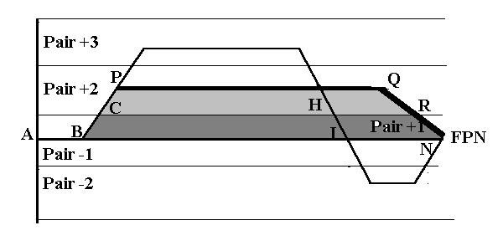Fig. 7.6 showing revised actual level relative to FPN - A – B – C – P – Q – R – N.

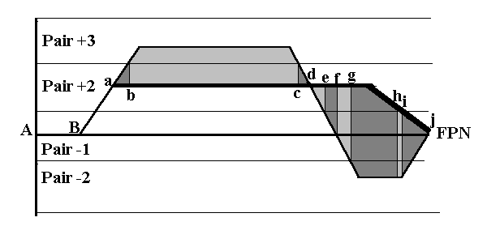
Fig. 7.7 Periods when initial Offers/Bids from Fig. 7.5 have had to be cancelled (see Fig. 7.6)

- Between a and b, part of the original offer in Pair +2 (i.e. at £30/Mwh) is cancelled at a price of £25/MWh – that means the BM unit benefits by £5/MWh).

- From b – c the original off in Pair +3 is cancelled entirely and also part of the offer in Pair +2).

- The situation for c – d is similar to a – b, while d – e would represent an additional offer in Pair +2.

- From e – f the addition would be the offer price for both Pair +1 up to its limit and the remainder from Pair +2. These are new and first time offers above the original level so there is not UNDO situation here.

- From f-g the is the UNDO offer of Pair –1 + the Offer of Pair +1 and Pair +2.

- For g – h there is full UNDER offer for Pair –1, a part undo offer for Pair – 2, a new OFFER for Pair +1 and part offer for Pair +2

- For h – I, the are the undo offers for Pair-1 and Pair –2 (part), and also a full new offer for Pair +1
- Finally for I – j there will be undo offers covering the whole range of Pair –1 and part Pair –2 and a new offer for Pair +1.

As electricity demand and supply are changing dynamically, it is expected that there may well be several changes in requirements for bids/offers or undo offers/bids. Clearly in calculating what is to be paid to, or charged from, a BM unit depends on all proceeding BID/OFFER Acceptances.

7.14 NETA Concluding Remarks

The above sections 7.10 – 7.13 refer the proposals which at present are planned to be implemented as from 23rd March 2001.

It is expected that with experience, the 3.5 hour period from Gate Closure to the start of real time.

- While the above gives an overview, the actual mechanisms also have to take note of the dynamic characteristics of each BM Unit. For instance a generating set takes some time to respond to instructions to change its output. An example is a 500 MW unit which if it is fully warm will take up to 90 minutes to synchronise and a further 90 minutes to load up to maximum load. It is partly for this reason that the gate closure is set at 3.5 hours. [ A set which is cold may well take 24 hours or more to warm up].
- Some generating units e.g. Magnox stations, cannot come back on load in less than a minimum time (usually around 24 – 48 hours once their load has been reduced.
- Some demand BM units can be changed almost instantaneously by load management. But in these cases, a finite warning of a pre-determined period (e.g. 1 hour) is needed.
- The National Grid Company cannot accept unlimited power from one part of the country because of transmission constraints.
- All the above must be considered by NGC when accepting any particular BID or OFFER. In some cases, they may not be able to accept electricity at the best price. In the past this has been referred to as NON OPTIMAL DESPATCH (NOD).

  - Implications of NETA on Renewable and CHP Generation

The New Electricity Trading Arrangements have had a significant effect on both the generation of electricity by renewables and also CHP. In the first year, the effects were generally negative, but this has been partly overcome with the introduction of the Renewable Obligation. Some of the renewable generators – e.g. large Hydro can accurately predict their output and should be able to cope with the new requirements. On the other hand Wind is very variable and could present a problem.

Many small scale CHP generation schemes and much of smaller renewable generation are what is known as embedded schemes. That means they are connected to the local distributors network and not the National Transmission Grid. Under the POOL, these have found favour with the local distributors as they do not incur the transmission losses, and thus the schemes (e.g. UEA) were able to be paid at a price which was above Pool Input Price to allow for the reduced charges the local distributor would have to pay for the “embedded” electricity.

This allowed a degree of predication on behalf of CHP operators as their contract was likely to be based as the Pool Input Price plus a proportion of the savings on the transmission. With the NETA, no distributor can yet give a definitive answer about the price to be paid to CHP operators leading to some uncertainty.

It is true that the majority of the electricity generated by small scale CHP is consumed on the premises, and that over a 24 hour period schemes such as UEA are net importers of electricity. Nevertheless NETA is making operation of CHP more difficult to predict.

7.16 Further Reading on NETA

There are hundreds of documents from OFFER about NETA, most of which are on the WEB. A key selection of these papers are directly linked from the INDEX of WEB LINKS on the Energy Home Page.

7.17 Appendix: AN EXAMPLE OF THE OPERATION OF THE ELECTRICITY POOL

NOTE: This example is mostly for historic interest only. An exam question similar to this was set in 1995. It does however, show the intricacies of the operation of the Electricity POOL up to 2001.

You are a manager of Electric Power plc which operates 6 power stations, A, B, C, D, E, and F. For station A, you have a one-way contract with a customer with a strike price of £22.00 per MWh. For station B, you have a two way contract with upper and lower strike prices of £21.50 and £21.20 per MWh respectively.

You are informed by the National Grid Company that the predicted demand for the 30 minute period (1700 - 1730) the following day is 42 500 MW. The loss of load probability is 0.0005 while the value of lost load is £2400 per MW.

Your bid prices for the six stations to supply electricity to the Pool are shown in Table 2. Following the bidding you are informed that full power will be required from stations A, B, C, and D, and that station E will be required on standby. Table 3 shows the bid prices from other generators.

What are the pool input and output prices for the half hour period, and what will be the income for your company during that period? Clearly state any assumptions you make.

[You may neglect transmission losses and assume that the UPLIFT arises solely from additional capacity charges and sub-optimal scheduling and despatch by the National Grid Company].

TABLE 2. POOL BID PRICES BY ELECTRIC POWER plc
Station | Capacity (MW) | bid price (£/MWh) | Rank
A | 470 | 10.00 | 1
B | 530 | 10.00 | 1
C | 420 | 19.68 | 14
D | 370 | 20.02 | 20
E | 470 | 19.82 | 18
F | 270 | 19.23 | 10

TABLE 3. BID PRICES FROM OTHER COMPANIES
Company | Capacity (MW) | bid price (£/MWh) | Rank
1 | 11500 | 10.00 | 1
2 | 10500 | 15.00 | 4
3 | 7500 | 17.00 | 5
4 | 1500 | 20.09 | 22
5 | 180 | 20.03
6 | 530 | 19.84
7 | 300 | 18.00
8 | 3600 | 17.50
9 | 1800 | 18.37
10 | 1600 | 17.91
11 | 900 | 19.55
12 | 900 | 19.81 | 17
13 | 850 | 19.60 | 13
14 | 450 | 19.72 | 15
15 | 1100 | 19.51 | 11
16 | 320 | 19.73 | 16
None of the stations in Table 3 are either constrained on or off. Company 6 has been informed that it will not be required as standby.

Station F is not being asked to generate but Station D is which has a higher bid, Station F must be "constrained off", so neglect this station temporarily when constructing merit order table.

The maximum bid price which matches predicted demand of 42500 is £19.81 which is the System Marginal Price. The company matching this price is company 12, but for this company the generator will be running under low load (i.e. 660 MW of the potential 900 MW). However, Electric Power D is constrained on so the actual generation required from company 12 is only 660 - 370 (i.e. 290 MW). Thus the balance of 610 MW and the 470 MW requested standby of Electric Power E are the standby capacity (since company 6 was not requested for capacity standby and neither company 5 or 4 were constrained on).

The Pool input Price (PIP)

= SMP + (VOLL - SMP)*LOLP

= £19.81 + (2400 - 19.81)*0.0005
= £21.00 / MWh

Company | Capacity (MW) | bid price (£/MWh) | Rank | Cumul-ative Capacity (MW)
Electric Power A | 470 | 10.00 | 1 | 470
Electric Power B | 530 | 10.00 | 1 | 1000
1 | 11500 | 10.00 | 1 | 12500
2 | 10500 | 15.00 | 4 | 23000
3 | 7500 | 17.00 | 5 | 30500
8 | 3600 | 17.50 | 6 | 34100
10 | 1600 | 17.91 | 7 | 35700
7 | 300 | 18.00 | 8 | 36000
9 | 1800 | 18.37 | 9 | 37800
Electric Power F | 270 cons-trained off | 19.23 | 10
15 | 1100 | 19.51 | 11 | 38900
11 | 900 | 19.55 | 12 | 39800
13 | 850 | 19.60 | 13 | 40650
Electric Power C | 420 | 19.68 | 14 | 41070
14 | 450 | 19.72 | 15
16 | 320 | 19.73 | 16
12 | 900 | 19.81 | 17
Electric Power E | 470 | 19.82 | 18
6 | 530 | 19.84 | 19
Electric Power D | 370 | 20.02 | 20
5 | 180 | 20.03 | 21
4 | 1500 | 20.09 | 22

The maximum bid price which matches predicted demand of 42500 is £19.81 which is the System Marginal Price. The company matching this price is company 12, but for this company the generator will be running under low load (i.e. 660 MW of the potential 900 MW). However, Electric Power D is constrained on so the actual generation required from company 12 is only 660 - 370 (i.e. 290 MW). Thus the balance of 610 MW and the 470 MW requested standby of Electric Power E are the standby capacity (since company 6 was not requested for capacity standby and neither company 5 or 4 were constrained on).

The Pool input Price (PIP)

= SMP + (VOLL - SMP)*LOLP
= £19.81 + (2400 - 19.81)*0.0005
= £21.00 / MWh
================

The additional capacity charges refer to the 610+470 MW noted above i.e. 1080 MW

The charge for the constrained off and constrained on stations refer only to their bid prices

So total output price for all units generated will be (remembering for half an hour!!!)

(42500-370)*SMP/2 +370*20.02/2
|
constrained on

+ 270*19.23/2 + (42500-370+1080)*2400*0.0005/2
| |
constrained off capacity payment

The factor 2 refers to half an hour

Total cost =
£417297.65 + 6299.75 + 25926 = £449523.4

Total units generated = 42500/2 = 21250 MWh

so Pool output Price

(POP) = 449523.4/21250 = £21.15 per MWh

or uplift = £0.15 per MWh

Since the POP is less than £22.00 there will be no payment by Electric Power to its customer for the one way contract. However, since the PIP is less than the lower strike price, Electric Power will be paid the difference (i.e. £21.20 - £21.00 = £0.20) for every unit generated by the two-way contract partner.

So income for electric power in half hour period will be:-

Stations A, B, and C at PIP

i.e. (470 +530 + 420)*21.00/2 = £14910.00

Station B supplementary payment from contract

(530*0.20)/2 = 53.00
Capacity payment for station E

= 470*2400*0.0005/2 = 282.000

Constrained off payment for station F

270*19.23/2 = 2596.05

Constrained on payment for stations D

370* 20.02/2 = 3703.70

TOTAL income = £21544.75
=========



31 May 2000

An Overview of the New
Electricity Trading

Arrangements
V1.0

A high-level explanation of the New
Electricity Trading Arrangements
(NETA)

Reformmated from original for ENV-2E02 Energy Resources

1. INTRODUCTION

This document provides a relatively high-level explanation of the New Electricity Trading Arrangements (NETA). It should be read in conjunction with a number of other explanatory documents that have been or will be produced by the NETA Programme.

The audience for this document is expected to include those who are not familiar with the existing electricity trading arrangements in England and Wales. This document does not, therefore, explain how the New Electricity Trading Arrangements change from those currently in place. Furthermore this document is aimed at providing a factual description of how the New Electricity Trading Arrangements will operate, rather than attempting to explain why they will operate in a particular manner. Given the intended audience, an attempt has been made to avoid using existing and
new Industry jargon and acronyms, however some basic understanding of the major processes involved in the electricity supply chain (i.e. generation, transmission, distribution, and supply) and markets in general is assumed.

2. BASIC PRINCIPLES

One of the basic principles of the New Electricity Trading Arrangements is that those wishing to buy and sell electricity should be able to enter into any freely negotiated contracts to do so. It is expected that under the new trading arrangements, bulk electricity will be traded on one or more exchanges and through a variety of bilateral and multilateral contracts. Those buying and selling electricity on exchanges and through bilateral contracts are likely to include not only generators and suppliers (who produce or consume physical quantities of electrical energy), but non-physical traders as well.

The role of the NETA Programme is not to dictate how energy will be bought and sold on these exchanges or in bilateral contracts. Instead it is to provide mechanisms for near real-time clearing and settlement of the imbalances between contractual and physical positions of those buying, selling, producing and consuming electrical energy. In practice, traders of electricity may buy more or less energy than they have sold; generators may physically generate more or less than they have sold; and the customers of suppliers may consume more or less energy that their supplier has purchased on their behalf. The central NETA systems are designed to measure these surpluses and deficits (or imbalances) and to determine the prices at which they are to be settled in order to send out invoices and payments for them.

The processes involved in calculating and settling these imbalance volumes is referred to as ‘Imbalance Settlement’. It should be reiterated that the purpose of Imbalance Settlement is not to price and settle bulk purchases and sales of electrical energy. Instead it is to price and settle the surpluses and deficits arising from the smaller
differences between the contractual and physical positions of market participants.

The process of Imbalance Settlement requires a comparison of the quantities of electrical energy that parties have purchased and sold under contract with their metered quantities of physical generation and demand. This comparison is needed in order to determine an imbalance volume (i.e. a surplus or a deficit). It is also necessary to determine a set of prices for settling the surpluses and deficits. Because metered data for generation and wholesale demand is available on a half-hourly basis (i.e. electricity meters in England and Wales are set up so that the kWh of energy generated or consumed by generators or suppliers is measured on a half-hourly integrated basis), Imbalance Settlement will also operate half-hourly under.4 NETA. Thus imbalance volumes and imbalance prices will all be calculated on a half-hourly basis, and settled on a daily basis, approximately 28 days in arrears.

In addition to Imbalance Settlement, the central elements of the new trading arrangements are designed to fulfil a second related role. This second role is to provide a mechanism for adjusting the intended operating levels of generation and demand in real time.

The requirement to provide this mechanism is twofold. First, it is likely that the aggregate level of generation that generators intend to (and/or actually) produce will not match the aggregate level of demand that customers of suppliers intend to (and/or actually) take at any given time. Second, for a number of detailed technical reasons (including the fact that the transmission network in England and Wales has only a finite capacity), it is sometimes necessary to be able to adjust the level of production or consumption of individual generators or demands away from the level at which the generator or customer would otherwise wish to operate. By adjusting the output or inputs of generators and demands in this way, localised overloading of the transmission system can be prevented.

In addition to Imbalance Settlement, the NETA arrangements therefore provide for the creation of a ‘Balancing Mechanism’. As discussed above, the Balancing Mechanism provides a means of adjusting the level of production or consumption of individual generators or demands. Under NETA, the ‘System Operator’ will determine what actions need to be taken in the Balancing Mechanism in order to maintain the required national and local balances of generation and consumption.

3. THE BALANCING AND SETTLEMENT CODE (BSC)

The central elements of the new trading arrangements provide for two basic functions: the Balancing Mechanism and Imbalance Settlement. The rules that govern how these two functions are carried out are set down in the Balancing and Settlement Code.

Those persons that are bound by the terms of the Balancing and Settlement Code are collectively referred to as parties. It is anticipated that holders of generation, transmission, distribution/PES and supply licences will be required to be parties to the Balancing and Settlement Code whilst traders and others may choose to become parties to the Code.

4. GATE CLOSURE

It is intended that bulk electricity will be traded by generators, suppliers and traders via a variety of means, including exchanges and bilateral contracts. The quantities of energy purchased and sold in these trades must be notified into the Imbalance Settlement mechanisms in order that they may be taken into account in determining the imbalance position of the parties. Furthermore, because Imbalance Settlement operates half-hourly, the traded quantities will be notified in respect of each half-hour.

It is expected that these trades may, in some cases, be made a year or more in advance of the half-hour to which they relate. Whilst trades may be notified some time in advance they cannot be notified after the event (i.e. after the half-hour to which they relate has passed). Instead, trades must be notified in advance of the half-hour to which they relate. The time limit by which information relating to trades needs to be notified into Imbalance Settlement is called ‘Gate Closure’ and is initially set at 3 ½ hours [reduced to 1 hour in July 2002] prior to the start of the half-hour to which it relates. Thus notifications of quantities of electricity purchase and sale for the settlement period 16:30 – 17:00 must be received before 13:00 on the same day. Every half-hour period has its own Gate Closure, set 3 ½ hours [1 hour after July 2002] prior to the start of the half-hour.

Because quantities of purchases and sales for a particular settlement period must be notified prior to Gate Closure, physical trading of electricity on exchanges and under bilateral contracts is effectively prevented after this time. If, for example, at 14:00, a supplier purchased energy for the period 16:30 – 17:00, it would not be possible for that purchase to be taken into account when determining the imbalance position of that supplier in Imbalance Settlement. This is because the latest time for notification of contract volumes relating to 16:30 – 17:00 is 13:00. The supplier would therefore have to buy the energy to meet its physical demand from the Imbalance Settlement mechanism.

Gate Closure also has a significance that relates to the operation of the Balancing Mechanism. This is discussed further in section 6.

5. THE BALANCING MECHANISM

5.1. Overview

Generators and suppliers differ from pure traders of electricity in that not only do they buy and sell electrical energy under contract, they produce and have customers that consume physical quantities of energy as well. Under NETA, generators will, in general, be free to determine for themselves the level at which their individual generating units will operate. Similarly suppliers will, in consultation with their customers, generally be free to specify their intended levels of demand.

It is likely (although it is not a requirement) that the proposed level of physical operation of generation or demand will be related to the overall contractual position of the associated generator or supplier. Thus, it may be expected that a generator will wish to sell a net amount of energy that is related to its intended level of physical generation. Similarly a supplier may wish to buy an amount of energy that is related to the expected level of physical demand taken by its customers. Again, whilst this may be likely, it is not a requirement, and parties can elect deliberately to be in imbalance should they wish to do so.

Once generators and suppliers have decided on the levels at which they wish to operate, they are required to notify these levels to the System Operator. In practice not all generation and demand will be required to notify these operating levels. This is discussed further in section 6.3.

When notifying their proposed operating level to the System Operator, generators and suppliers may, if they wish, also indicate a willingness to deviate from these operating levels. In exchange for payment, generators may be willing to increase or decrease the output of their generating units, and suppliers may have in place arrangements for their customers to be able to increase or decrease their demand.

To this end, generators and suppliers may submit Offers and Bids into the Balancing Mechanism. Generators and suppliers may both submit Offers and Bids. Offers indicate a willingness to increase the level of generation or reduce the level of demand. Conversely, Bids indicate a willingness to reduce the level of generation or increase the level of demand.

The System Operator may ‘accept’ particular Offers and Bids placed by generators and suppliers in order to control the national and local balance of generation and demand. This process is described in more detail in the next section.

5.2. Physical Notifications

Generators and suppliers that are required to notify the System Operator of their intended operating level do so by submitting ‘Initial Physical Notifications’ (IPNs) and ‘Final Physical Notifications’ (FPNs), in accordance with the requirements of the Grid Code.

An Initial Physical Notification relating to expected operating levels throughout the whole day must be submitted to the System Operator by 11.00am on the day before trading.

A Final Physical Notification relating to proposed operating levels in a particular half-hour must be submitted to the System Operator by Gate Closure.

This information is in addition to the contract information relating to purchases and sales of electricity to Imbalance Settlement (as described above) which must also be submitted by this time (although in the case of contracts, the information is submitted to central settlement and not to the System Operator).

Where submitted, Final Physical Notifications must normally be submitted for individual generating units and for individual demands. This is because the System
Operator needs locationally specific information in order to ensure that generation and demand is safely matched locally as well as nationally.

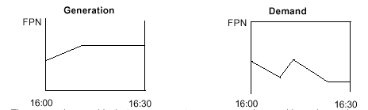Final Physical Notifications take the form of a minute-by-minute profile of the expected power output or consumption of the relevant generation or demand across each settlement period. The information is specified to the nearest MW. A graphical example of the Final Physical Notification data for a generator and a demand is given below.

Figure 1 – An example of Final Physical Notifications for Generation and Demand.

The convention used is that power exports are expressed as positive values, whereas imports are expressed as negative values. Thus it is likely that generators will have positive FPNs, and demand will have negative FPNs.

5.3. Requirement to Submit Physical Notifications

Parties responsible for wholesale electricity production and consumption will not necessarily be required to submit Physical Notifications to the System Operator for all generation and demand. In practice, the System Operator does not need information relating to smaller plant (generation and demand) in order to ensure safe operation. For this reason Physical Notifications are only needed when the ‘relevant plant’ is above a de minimis limit of 50MW.

In this context, ‘relevant plant’ means a ‘BM Unit’. The definition of a BM Unit is discussed in more detail in section 6.4.

5.4. BM Units

The term ‘BM Unit’ is used to describe collections of generation plant and ‘demand plant’ that import and/or export electricity, so that physical imports and exports can be treated appropriately under the Balancing and Settlement Code. Because of the number of different types of generation and demand that it must cover the exact definition of a BM Unit is somewhat involved. However, for generating plant, a BM Unit is typically a single generating unit. For demand the definition of a BM Unit is largely dictated by the metering information available to Imbalance Settlement. For large demands, separate metering information is available on a half-hourly basis. In this case, the associated BM Unit is essentially defined as the aggregate of a party’s demand behind a single point of connection to the transmission or distribution system. For smaller demand, half-hourly metering information is not available on a site-by-site basis for Imbalance Settlement. Instead, the metering information that is available is the aggregate of small demands supplied by a demand on individual suppliers over 12 different ‘GSP Groups’. In this case, the relevant BM Unit is the aggregate of a particular supplier’s demand in each of the GSP Groups.

Parties to the Balancing and Settlement Code are required to submit Initial Physical Notifications and Final Physical Notifications to the System Operator by Gate Closure if the associated BM Unit is larger than 50MW (i.e. the BM Unit has a maximum associated import or export in excess of 50MW).

5.5. Participation in the Balancing Mechanism

The BM Unit is the basic unit of participation in the Balancing Mechanism. In order for a BM Unit to be used to provide services to the System Operator in the Balancing Mechanism a Final Physical Notification must be submitted for that BM Unit. Consequently, some parties may also choose to submit Final Physical Notifications for BM Units that are smaller than 50MW if they wish to use these BM Units to offer services in the Balancing Mechanism.

Another pre-requisite for BM Unit participation in the Balancing Mechanism is the requirement to establish appropriate electronic communication links with the System Operator. Under NETA, these links must be electronic in order to handle the large amounts of data transfer. The links are needed for two reasons: first for a party to submit Final Physical Notifications and Bids and Offers for individual BM Units to the System Operator; and second for the System Operator to inform the party when it wishes to call off (or ‘accept’) Offers and Bids. These issues are discussed in more detail in the next section.

5.6. Offers and Bids

If a BM Unit is to be used to offer services in the Balancing Mechanism, in addition to the Final Physical Notifications, the party also submits Offers and Bids for that BM Unit.

Offers and Bids indicate a party’s willingness to operate the BM Unit at a level other than the Final Physical Notification in exchange for payment. They take the form of a set of prices and volumes. An example is given in Figure 2 below.

Figure 2 – An example of Offers and Bids

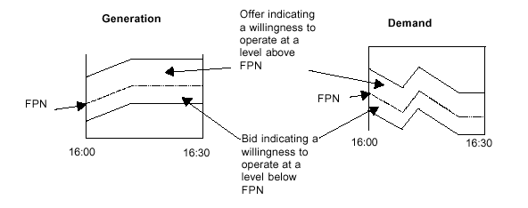Figure 2 shows a simplified set of Offers and Bids for a generation BM Unit and a demand BM Unit. Offers indicate a willingness to operate above the level of Final Physical Notification, and Bids to operate at a level below Final Physical Notification. (Note that the consumption FPN is a negative value, so ‘operating above the FPN’ actually means consuming less). If the System Operator wishes to increase the net amount of energy being delivered to the system it may accept an Offer from a BM Unit. If this is a generating BM Unit, then the BM Unit should increase its level of export. If it is a demand BM Unit, then the demand should reduce its level of import.

If the System Operator wishes to decrease the net amount of energy being delivered to the system, then it may accept a Bid from a BM Unit. If this is a generating BM Unit, then the BM Unit should decrease its level of export. If it is a demand BM Unit, then the demand should increase its level of import.

The diagrams in Figure 2 above are simplified because in practice, a party may submit several Offers and Bids for a single BM Unit for a particular settlement period. This means, for example, that the price for operating a generating BM Unit at a level up to 100MW above Final Physical Notification may be £30/MWh, whereas for operating between 100MW and 200MW above Final Physical Notification, the price may be £40/MWh.

A further feature of the Balancing Mechanism is the fact that it is ‘firm’ on the System Operator. This means, for example, that once the System Operator has informed the relevant party that it wishes to accept an Offer from a BM Unit it is committed to purchasing that Offer. If the System Operator subsequently decides that the initial decision to purchase an Offer was incorrect, then, instead of simply cancelling the original purchase, it must accept a Bid (either from the same BM Unit, or from a different BM Unit if it is economically more efficient as well as physically suitable). This means that for every Offer, there is a complementary ‘undo’ Bid. Furthermore for every Bid there is an associated ‘undo’ Offer. For this reason, Offers and Bids are submitted in pairs. These pairs are given numbers to identify them. The numbering convention is such that where the Offers and Bids are for operation above Final Physical Notification, the pair numbers are positive. If they are for operation below Final Physical Notification, the pair numbers are negative.

A more detailed example of the Offers and Bids submitted for a generating BM Unit is shown in figure 3. This highlights the pairing of Offers and Bids.

Figure 3 – More detailed example of pairs of Offers and Bids for a generating BM Unit

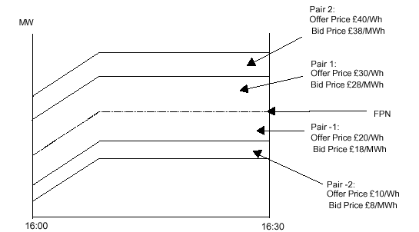

Offers and Bids therefore indicate the price for different levels of operation relative to the Final Physical Notification. As may be seen from figure 3, an initial restriction under the new electricity trading arrangements is that the level of any pair of Bids and Offers is fixed (relative to FPN) for the duration of the settlement period. In common with Final Physical Notifications, Offers and Bids for a BM Unit applying to a particular half-hour must be submitted by Gate Closure for that half-hour.

5.7. Operation of the Balancing Mechanism

The purpose of the Balancing Mechanism is to provide the System Operator with a means of undertaking several functions as follows: matching system-wide imbalances between electricity production and consumption; adjusting local and bulk power flows to ensure the security of the transmission network; placing BM Units in a position to deliver other Balancing Services. Balancing Services are technical services, purchased by the System Operator. They are required in order to maintain the reliability and security of the transmission and distribution networks. They include services to operate generation and demand plant in a manner that will support system voltage and system frequency.

The operation of the Balancing Mechanism for a particular half-hour starts after Final Physical Notifications and Offers and Bids have been submitted to the System Operator for that half-hour – i.e. after Gate Closure. The System Operator is solely responsible for determining which Offers and Bids are accepted in the Balancing Mechanism. The System Operator may accept all or part of any Offer or Bid at any time after Gate Closure up until real time.

Whilst the System Operator is generally free to accept any Offer or Bid at any time between Gate Closure and real time, the System Operator is required to ensure that
any acceptance it makes is consistent with the dynamic parameters of the associated BM Unit. The dynamic parameters of a BM Unit give information relating to the limitations on physical operation of the BM Unit. This include the rates for increasing and decreasing output and input levels, information relating to stable levels of operation, and the maximum levels of import and export that each BM Unit is capable of.

In accepting Offers and Bids, the System Operator will inform the relevant party of the absolute level at which it wishes the BM Unit to operate. In doing so, the System Operator may accept several Offers and/or Bids at once. The set of data issued by the System Operator to the party is called a Bid-Offer Acceptance. A Bid-Offer acceptance is illustrated in Figure 4.

In figure 4, a single Bid-Offer Acceptance has been issued by the System Operator that affects three of the Offers and Bids submitted for the settlement period. From this, the shaded areas in figure 5 show the quantities of Offers 1 and 2, and Bid –1 that are all accepted by the single Bid-Offer Acceptance.

Note the numbering convention for Bid-Offer Pairs is that those above FPN are given positive numbers and those below FPN are given negative numbers.

Figure 4 – Accepting Offers and Bids
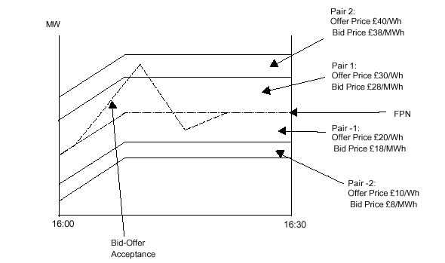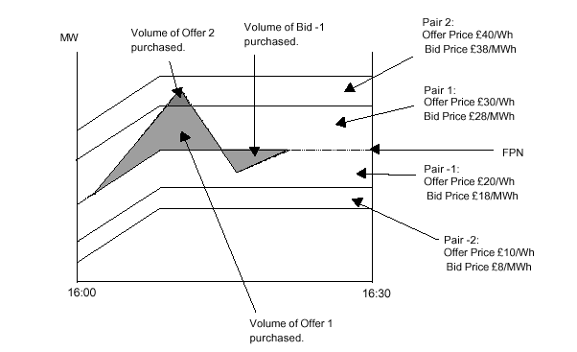 Figure 5 – Volumes of Offers and Bids Accepted

Offers are purchased where the System Operator has requested operation above the level of FPN. Bids are purchased where the requested level is below FPN. Thus in the above diagram, parts of Offers 1 and 2 are initially purchased. Later, half-way through the settlement period, when the requested operating level falls below FPN Bid number –1 is purchased.

As shown in Figure 5 above, the volume of accepted Offers or Bids determined from a single Bid-Offer Acceptance is calculated on a minute by minute basis across the half-hour.

In some extreme circumstances, (e.g. if there are insufficient Offers and/or Bids available for the System Operator to balance the system) it may be necessary for the System Operator to require certain BM Units to operate at a level other than FPN, even if no Offers or Bids have been submitted for those BM Units. In this case, the System Operator will not log an acceptance for the BM Unit in question (because there are no Offers or Bids against which the acceptance may be settled). In most situations there will be an impact on the imbalance position of a party instructed by the System Operator in this way.

The detailed operation of the Balancing Mechanism and the interface between parties and the System Operator will be set down in the Grid Code, and in the Balancing Principles. The Grid Code is a technical document describing the interfaces between those parties that connect to and use the electricity transmission network. It is anticipated that the Balancing Principles will be produced by the System Operator (as a requirement of the Transmission Licence).

5.8. Payment for Offers and Bids

The volume of an accepted Offer or Bid is determined as the volume of the shaded areas in Figure 5. Thus in the example in Figure 5, three MWh values would be
determined as a result of the single Bid-Offer Acceptance. These are the MWh of purchase of Offers 1 and 2 and the MWh of purchase of Bid –1.

Accepted Offers and Bids (adjusted to reflect transmission losses) will be settled at the relevant Offer or Bid Price. In the case of Offers, the party responsible for the BM Unit will be paid at the relevant Offer price multiplied by the losses adjusted volume of the accepted Offer.

In the case of Bids, the party responsible for the BM Unit will pay (rather than be paid) at the prevailing Bid price multiplied by the losses adjusted volume of the accepted Bid. The reason why parties are paid for Offers, but are charged for Bids is explained as follows:

A demand BM Unit from which a Bid is accepted is expected to increase its demand. The Bid price therefore simply represents the price that the party is willing to pay for an additional MWh of demand that it had not already purchased under a bilateral contract.

If a Bid is accepted from a generation BM Unit, a reduction in the generation from that unit is expected. The Bid price in this case, simply represents the price that the party is willing to pay to avoid having to actually generate a MWh of energy.

Note that it is possible for both Offer and Bid prices to be negative. If a negatively priced Offer was accepted, the party would be charged for increasing its generating
output, or for reducing its demand. If a negatively priced Bid was accepted, the party would be paid for increasing its demand, or for reducing its generation.

5.9. Arbitrage Offers and Bids

Because parties are paid for accepted Offers at Offer Price and are charged for accepted Bids at Bid price, if one BM Unit has an Offer Price that is less than the Bid
Price of another, the System Operator can in fact save money by making an ‘arbitrage’ trade. This involves simply accepting both the Offer and the Bid.

Note that both parties (i.e. from whom the Offer and the Bid were accepted) should be satisfied with the arbitrage, because they have freely submitted Offers and Bids into the Balancing Mechanism indicating the price at which they are prepared to take the balancing action.

Arbitrage Offers and Bids are treated slightly differently from other Offers and Bids
when calculating energy imbalance prices (see below).

5.10. Non-Delivery Charges

A number of Offers and Bids may be accepted from a particular BM Unit in any particular settlement period. Furthermore, as discussed above, accepted Offers and Bids may be ‘undone’ by accepting an Offer or Bid in the opposite direction. The net amount of Offers and/or Bids accepted in a particular half-hour from a BM Unit will result in a net expected profile for the operation of the BM Unit in that half-hour.

If a BM Unit has a net volume of accepted Offers (i.e. more accepted Offers than Bids), then if the BM Unit shortfalls (i.e. generates less than expected, or imports more than expected) it will be subject to non-delivered Offer charges. If a BM Unit has a net volume of accepted Bids, then it may be subject to non-delivered Bid charges.

Thus non-delivery charges are made if the meter reading for a BM Unit reveals that the BM Unit has failed to deliver its Offers or Bids on an aggregate basis across the half-hour. In the event of non-delivery, the part of any Offer or Bid that is not delivered is charged a non-delivery charge.

6. INFORMATION IMBALANCE CHARGES

Information Imbalance Charges are intended to provide an incentive for parties to operate their BM Units in accordance with their Final Physical Notification modified by any accepted Offers or Bids.

The Information Imbalance Volume for a BM Unit is simply the difference between the metered output recorded over the settlement period, and the level at which the BM Unit should have been operating in aggregate over the half-hour period, given its Final Physical Notification and any accepted Offers and Bids.

The Information Imbalance Charge is the same irrespective of whether a party generated or consumed above or below its expected level. Thus a BM Unit that ‘spills’ by 1 MWh is charged the same Information Imbalance Charge as a BM Unit that is in deficit for 1MWh.
Information Imbalance Charges are levied on the party that registers the BM Unit in the settlement system, irrespective of whether the metered output of the BM Unit has been assigned to another party (see section 7). Initially, the Information Imbalance Price will be set at zero, and consequently no charges will actually apply.

7. ENERGY IMBALANCE

7.1. Overview

In addition to the provision of a Balancing Mechanism, the Balancing and Settlement Code provides for the settlement of imbalances between the actual and contractual positions of parties in each settlement period.

As explained in section 3 above, under the new electricity trading arrangements it is expected that bulk purchases and sales of electricity will be made under the terms of bilateral contracts and via electricity trading exchanges. Generators, suppliers and electricity traders are expected to be active in this trading activity. In addition to striking contracts for purchase and sale of electricity, generators and suppliers will also be responsible for physical quantities of electricity production and consumption. Energy Imbalances settlement is needed in order to settle the differences between the net contractual and net physical position of all parties.

Thus, in order to settle Energy Imbalances, it is necessary to determine the metered production or consumption of each party and the net contractual position for each party in each settlement period. It is also necessary to determine the prices at which Energy Imbalances will be settled.

Under the new trading arrangements a two-part cashout of imbalances will be undertaken. The price paid to parties that have a net surplus of imbalance energy will be different from the price that is paid by parties that have a net deficit of imbalance energy.

A further feature of Imbalance Settlement under NETA is that for a single party, two Energy Imbalances will be calculated. Energy Imbalances for ‘Production’ related activities and ‘Consumption’ related activities are treated separately. Broadly speaking, ‘Production’ relates to generation and ‘Consumption’ relates to demand. The calculation of Energy Imbalance Prices is described in section 8.7 below.

This two-part imbalance arrangement is effected by the calculation of a ‘Production Energy Imbalance’ and a ‘Consumption Energy Imbalance’ for each party. Parties are said to hold two Energy Imbalance Accounts, a Production account and a Consumption account.
The level of the Energy Imbalance for each of a party’s accounts is calculated as the difference between the metered quantities of generation and demand allocated to each of the accounts and the contract quantities allocated to each of the accounts.

The Production Energy Imbalance will be the difference between the aggregate metered Production allocated to the party, and the net of contract volumes notified to the Production Energy Account. Similarly the Consumption Energy Imbalance will be the difference between the aggregate metered Consumption allocated to the party and the net contract volume notified to the Consumption Energy Account.

7.2. Energy Contract Volume Notification

In order to take account of the quantities of purchase and sale of electrical energy in a particular settlement period in Energy Imbalance, it is necessary for such contract quantities to be notified into central settlement.

If two parties trade electricity (either via a bilateral contract or through an exchange), it is necessary for the parties to notify central settlement of the volume of the contract (in kWh), and to identify which party has purchased the energy and which party has sold it. Note that it is not necessary for central settlement to have any information relating to the price at which energy was bought and sold under the contract in order to determine Energy Imbalance volumes.

Under the new trading arrangements, both parties to a contract must notify the relevant volumes into central settlement through a single agent. The Energy Contract
Volume Notification Agent (ECVNA) acts on behalf of the trading parties, and notifies information relating to the electricity trade into central settlement. This information includes details of the trading parties and the kWh quantities of trade (in addition to passwords etc.). Contract volumes for a particular settlement period must be notified into central settlement (specifically to the Energy Contract Volume Aggregation Agent, ECVAA) by the notification agent prior to Gate Closure for that settlement period.

A single pair of trading parties may nominate any number of Energy Contract Volume Notification Agents to act on their behalf. (One of the parties themselves could be an Energy Contract Volume Notification Agent).

In practice, the information contained in contract volume notifications needs to be slightly more specific about the parties involved in the contract trade. It is necessary to not only identify the parties involved, but the specific Energy Accounts of the parties to which the trade relates. Thus the Energy Contract Volume Notification Agent must identify both the parties and either their Production Energy Account or the Consumption Energy Account. Note that it is possible not only for the Production Energy Account of one party to sell to the Consumption Energy Account of another and vice versa, but also for a single party to notify energy ‘purchases’ and ‘sales’ between its own two Energy Accounts.

Subject to some credit monitoring, there are no restrictions on the energy contract volumes that may be notified to and from each account.

7.3. Energy Contract Volume Aggregation

Once received by central settlement, the notified contract volumes are aggregated for each of the Production and Consumption Energy Accounts of each party to determine a net contractual position for each of the accounts. These net contractual positions will be compared to the net metered quantities allocated to each of the Energy Accounts in order to determine the Energy Imbalance for each Production and Consumption Account.

7.4. Production and Consumption and Imports and Exports

In order to determine the metered quantities that need to be taken into account when calculating Energy Imbalances, it is necessary to collect metering data for each BM Unit in each settlement period. This metered data is collected in a number of different ways, but is ultimately used to establish a metered volume for each BM Unit in each settlement period.

Whether the metered volume of a BM Unit will be treated as Production or Consumption (and consequently whether it will be aggregated to the Production or Consumption energy account for imbalance purposes) depends upon the ‘Type’ of the BM Unit - i.e. whether the BM Unit itself is either a Production or Consumption BM Unit.

The Type of a BM Unit is based upon whether, over the year, the maximum level at which it is expected to be exporting over any settlement period is more or less than the maximum level at which it is expected to be importing over any settlement period. It is generally intended that BM Units that comprise generating plant will be Production BM Units and BM Units that comprise supplies will be Consumption BM Units. In practice some BM Units will also be permitted to choose their Type freely.
A further factor to be taken into account in determining the Type of a BM Unit is whether the BM Unit is to be aggregated with a number of other BM Units within a single Trading Unit. In this case, the type of all the BM Units in the Trading Unit is determined on a collective basis.

The metered quantities from the BM Unit will be allocated to the Energy Account type that matches the type of the BM Unit (i.e. Production or Consumption). Thus metered quantities for Production BM Units will be allocated to Production Energy Accounts, and metered quantities for Consumption BM Units will be allocated to Consumption Energy Accounts.

It should be recognised that Production BM Units may, in some settlement periods, import electricity and Consumption BM Units may export electricity. The difference between import and export and Production and Consumption for a BM Unit is animportant feature of the trading rules.

Whether the metered volume associated with a particular BM Unit is treated as an import or an export for settlement purposes depends upon whether its associated Trading Unit has, in aggregate, imported or exported in that particular settlement period. The classification as an import or export affects the treatment of the BM Unit Metered Volume for purposes of transmission loss factor application, and revenue surplus reallocation (see section 10 below).

7.5. Metered Volume Reallocation Notification

So as not to restrict parties’ commercial freedom, it will be possible for the energy flowing to or from an individual BM Unit to be allocated between two or more different parties for the purpose of calculating energy imbalances. (This would allow, as an example, a supplier to notify volumes relating to a share of a customer’s meter, in order to meet that customer’s requirements for partial supply).

By default, the party registering the BM Unit is responsible for the metered quantities arising from the BM Unit. Thus by default, the metered quantities from Production BM Units will be allocated to the party’s Production Energy Account, whereas the metered quantity from Consumption BM Units will be allocated to a party’s Consumption Energy Account.

It is also possible for the party responsible for a BM Unit to reallocate some or all of the metered volume for the BM Unit to another party for any given settlement period(s). As with contract volume notifications, metered volume reallocations must be notified into central settlement by Gate Closure. The information contained within a metered volume reallocation includes identification of the relevant BM Unit and the name of the party and associated Energy Account to which the metered volume is to be reallocated. The information may also contain either a fixed number of kWh to be reallocated from the BM Unit, or a percentage of the metered volume to be reallocated.

The party responsible for a BM Unit is termed the Lead Party, whereas the party receiving the metered volume reallocation is termed the Subsidiary Party.

If a metered volume fixed reallocation is made, the fixed amount is reallocated to the relevant Energy Account of the Subsidiary Party. If a percentage reallocation is made the appropriate percentage of the actual meter reading for the BM Unit is reallocated to the relevant Energy Account of the Subsidiary Party. In each case, the relevant Energy Account of the Lead party is credited with the actual metered output less the reallocated amount.

Any number of percentage reallocation notifications may be made for a particular settlement period for a given BM Unit, however the aggregate of all the percentages must not exceed 100%, nor may negative percentages be reallocated. There are no restrictions on the number or sign of fixed reallocations that may be made in relation to a single BM Unit.

7.6. Energy Imbalance Volumes

The Energy Imbalance Volume for a particular energy account is the net of all metered quantities and contract volumes allocated to that account. The Energy Imbalance Volume for an account may be positive (showing that a net surplus of energy accrued to the account), or negative (showing that a net deficit of energy accrued to the account). For the purposes of aggregation, metered exports are treated as positive values and metered imports as negative.

It is possible for a single party to have a net surplus of energy in one Energy Account and a net deficit in the other in the same settlement period. Two separate charges would be applied in this situation, as discussed further in section 8.7.

7.7. Energy Imbalance Price Calculation

Energy Imbalance Prices are the prices used to settle the Energy Imbalance surpluses or deficits. There are two Energy Imbalance Prices – the System Buy Price and the System Sell Price.

The System Buy Price is the price at which deficits are charged. It is intended to reflect the average price at which the system had to buy in order to make good the deficit on behalf of the party. Thus if an Energy Account has a negative Energy Imbalance, this is charged for at System Buy Price.

The System Sell Price is the price at which surpluses are charged. It is intended to reflect the average price at which the system had to sell in order to dispense with the surplus spill energy. If an Energy Account has a positive Energy Imbalance, this is paid for at System Sell Price.
Energy Imbalance prices are derived from the prices of Offers and Bids accepted by the System Operator in the Balancing Mechanism. System Buy Price for a particular settlement period is calculated as the volume weighted average of accepted Offers relating to that settlement period. System Sell Price for a particular settlement period is the volume weighted average of accepted Bids relating to that settlement period.

In fact, not all accepted Offers and Bids are necessarily used in the calculation of Energy Imbalance Prices. Some accepted Offers and Bids may be excluded from the weighted average calculation because they are flagged as being either ‘arbitrage’ trades or as ‘System Balancing’ trades, (as opposed to ‘Energy Balancing’ trades).

Arbitrage trades are those trades described in section 6.9. Arbitrage trades are easily identified as those accepted Bids and Offers for which the Offer Price is less than (or equal to) the Bid Price.

‘System Balancing’ trades are more complicated to identify. They exist because the Balancing Mechanism is used not just to deal with system-wide energy imbalances. It is also needed in order to provide the System Operator with a means of meeting a variety of more complex system requirements (for example to change a generator’s output so as to change power flows on the transmission system, so that voltages remain within reasonable limits).

System Balancing trades are excluded from accepted Bids and Offers prior to calculating the Energy Imbalance Prices. They are excluded by simply disregarding some of the extremely priced accepted Offers and Bids (i.e. some of the highest prices accepted Offers and some of the lowest priced accepted Bids).

There are a number of other detailed adjustments in the calculation of the prices, for example transmission losses are taken into account in the weighted averaging
calculation of Energy Imbalance Prices, and adjustments may be made if the System Operator has entered into certain contracts before Gate Closure.

Under normal circumstances, System Buy Price is expected to exceed System Sell Price.

7.8. Energy Imbalance Cashflows

The term ‘Energy Imbalance Cashflow’ is used to describe the charges or payments that arise as a result of settling Energy Imbalances. Where an Energy Account has a positive Energy Imbalance, it is paid at System Sell Price, and where it has a negative Energy Imbalance, it is charged at System Buy Price.

8. SYSTEM OPERATOR CHARGES

Whilst accepted Offers and Bids are used to determine Energy Imbalance Prices, the costs of operating the Balancing Mechanism are in fact met by the System Operator.
The System Operator is required to pay for the net cost of all accepted Offers and Bids (less any charges arising from non-delivery).

9. REVENUE SURPLUS REALLOCATION

A variety of payments and charges arise relating to various aspects of the Balancing Mechanism and Energy Imbalance settlement for every settlement period. These include payments and charges for accepted Offers and Bids and for positive and negative Energy Imbalances. Furthermore, there are charges for non-delivery of Offers and Bids and for Information Imbalance. Finally the System Operator is charged for the total cost of Balancing Mechanism action.
The net of all these charges and payments in any settlement period is not zero. In general, the net of all the charges and payments will result in an overall surplus of funds in each settlement period. This surplus is reallocated to parties, pro-rated across all metered imports and exports for which each party is responsible in each settlement period.

Note that in the case where a party reallocates metered quantities to a second party via a metered volume reallocation, then it is the second party that receives the pro-rated revenue surplus reallocation. It is anticipated that this may be taken into account when the parties agree the price for the metered volume reallocation in the first instance.

10. SUMMARY

One of the basic principles of the New Electricity Trading Arrangements is that those wishing to buy and sell electricity should be able to enter into any freely negotiated contracts to do so. It is expected that under the new trading arrangements, bulk electricity will be traded on one or more exchanges and through a variety of bilateral and multilateral contracts. Those buying and selling electricity on exchanges and through bilateral contracts are likely to include not only generators and suppliers (who produce or consume physical quantities of electrical energy), but non-physical traders as well.

The objective of the new arrangements is not to dictate how energy will be bought and sold on these exchanges or in bilateral contracts. It is to provide mechanisms for near real-time clearing and settlement of differences between contractual and physical positions of those buying, selling, producing and consuming energy. The following two mechanisms are therefore required: a mechanism by which the System Operator can change proposed operating levels of generation and demand near to real time – the Balancing Mechanism - and a mechanism for settling the differences between net physical and net contractual positions of parties – Imbalance Settlement. The detailed rules associated with these mechanisms will be contained in the Balancing and Settlement Code (BSC).

11. DISCLAIMER

Any information in this document is offered in good faith to assist interested parties in their preparation for the introduction of the New Electricity Trading Arrangements.

However, readers should be aware that some details of the Trading Arrangements may be subject to modification. Readers should also be aware that implementation of the New Arrangements is dependent on the timetable of the Utilities Bill; and that the new Balancing and Settlement Code (BSC), as well as the Implementation Scheme which will govern aspects of the transition from the current Arrangements to the BSC, will only be designated by the Secretary of State after consultation, review (and consequent amendment) of drafts of these documents. Accordingly, the information contained herein should be viewed as provisional. No warranty nor representation is given as to the accuracy of completeness of any of the information provided in this document, and none of the DGES, DTI, NGC, participants in the NETA Programme nor advisors to any of them shall be liable for error, mis-statement or omission.

This document has been produced in accordance with the terms set out in paper DISG 05/010 dated March 1 1999 and which is available from the Programme Director's Office.

