ENV-2E02 Energy Resources

Examples of Previous Examination Questions

PART 2 (questions from 1999 onwards)

for details of format of the Examination see Part 1

For these questions, there are also comments about what constitutes a good answer to a descriptive question.

CONTENTS

 | Page
- Examination Paper 1999 | 21
- Answers to Exam Paper 1999 including comments on descriptive parts of numeric questions. | 23
- Exam Paper of 2001 in Full including answers | 30
- Exam paper of 2003 in full | 36

PLEASE ALSO SEE the ENV-2E02 Web Page for additional queries which has been asked about the questions.
1. ENV-2E02 Energy Resources Examination 1999

SECTION A (25%)

1. Explain the differences between the different tranches of the Non-Fossil Fuel Obligation paying particular attention to the reasons why the later tranches have not been so effective in extending wind generation capacity in the UK
[30%]
Fig. 1 shows the rating curve for a typical 330 kW turbine. Estimate the annual output if the windspeed profile at the site during the year is as shown in Table 1.
[70%]
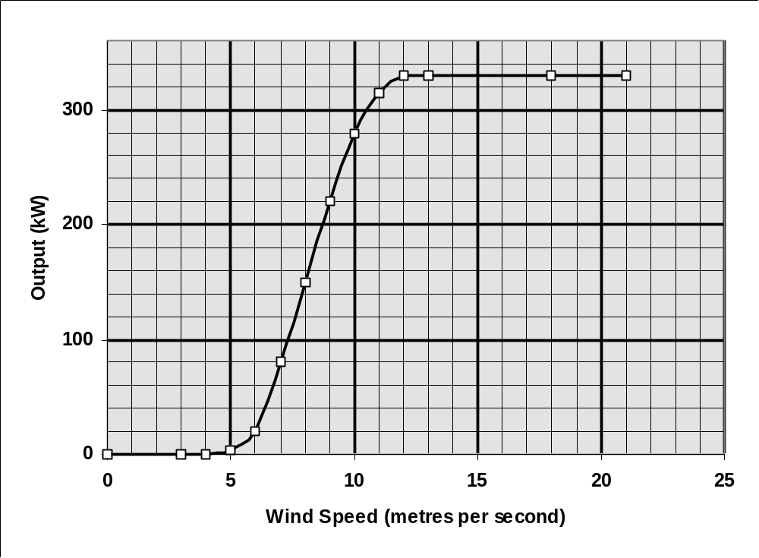
Fig 1. Rating Curve for Turbine

Wind Speed
(m S-1) | Number of days per year
<1 | 10
1 - 3 | 20
3 - 5 | 40
5 - 7 | 60
7 - 9 | 80
9 - 11 | 65
11 - 13 | 40
13 - 15 | 20
15 - 17 | 10
17 - 19 | 8
19 - 21 | 5
21 - 23 | 2
> 23 | 5

Table 1. Wind Speed Frequency during the year
2. Recent publications from the Department of Trade and Industry (e.g. Energy Papers 62, New Review etc.) indicate that biomass is likely to contribute in an major way to the generation of electricity from renewable energy sources. Discuss whether this is a sensible use of such a resource.
[30%]

It is planned to build a wood burning power station having a load factor of 70% using wood from short rotation coppicing covering an area of 20 sq km. The station will generate electricity by using a conventional steam turbine as the motive power. Relevant data for the proposed project are given in Table 1.

Estimate:
(i) the size of turbines and generators needed to exploit the resource to the full (ii) the overall efficiency of energy conversion from harvesting to the consumers premises.

Relevant data about the scheme are included in Table. 2
[70%]

inlet temperature to steam turbine | 449oC | isentropic efficiency | 75%
exhaust temperature from steam turbine | 30oC | generator efficiency | 95%
combustion efficiency | 90% | station use of electricity | 5.95%
effective energy overhead  associated with wood harvested | 11% | calorific value of wood | 20 GJ | tonne dry wood
annual growth rate of dry wood | 10 tonnes per hectare | transmission losses | 4.8%
TABLE 2.

SECTION B (25%)

3. Describe how the Electricity “Pool” operates in the UK indicating how this is used to ensure demand is met.

4. Describe the different types of geothermal energy (paying particular attention to geographic distribution), and how this difference influences its development.
[70%]
Discuss whether geothermal energy can be considered a renewable energy resource?
[30%]

5. Discuss the advantages and disadvantages of electricity generated as:

a) Direct Current
b) Alternating Current
c) Three-Phase Supply

SECTION C (50%)

6. Several different schemes have been promoted for the exploitation of tidal power from the Severn Estuary. Discuss the relative merits of the various schemes. How do they differ from the scheme currently operating at La Rance in France?
7. Describe how domestic hot water systems may be adapted to incorporate solar hot water heaters.
[30%]
Table 3 shows the radiation falling on each square metre of solar collector for the Month of March together with the number of litres of hot water at 55oC consumed in each hour. If the efficiency of the collector is 55% and the solar availability is 58%, estimate the collector area needed to ensure that the domestic hot water is entirely supplied from solar energy on a typical day.

(a) the collector area needed to ensure that domestic hot water is entirely supplied from solar energy on a typical day in March, and
(b) the minimum storage volume required.

Assume that the incoming water to the house is at 10oC.
[50%]
Hour beginning | Solar Radiation (W m-2) | litres of hot water used | Hour beginning | Solar Radiation (W m-2) | litres of hot water used
0000 |  |  | 1200 | 800
0100 |  |  | 1300 | 675 | 2
0200 |  |  | 1400 | 450
0300 |  |  | 1500 | 245
0400 |  |  | 1600 | 70
0500 |  |  | 1700 | 16
0600 | 16 |  | 1800 |  | 3
0700 | 70 | 5 | 1900
0800 | 245 |  | 2000
0900 | 450 | 5 | 2100
1000 | 675 |  | 2200 |  | 150
1100 | 800 |  | 2300
TABLE 3.

Comment critically on the assumptions made and also on the results obtained.
[20%]

8. Describe the different methods for managing the “Back-End” stages of the Nuclear Fuel Cycle. In your answer indicate the advantages and disadvantages of these methods for final disposal.

Section 2: Worked examples for 1999
Question 1:
The critical points to note about this question are:-
1. for wind speeds less than 5 ms-1 there is no output
2. for wind speeds between 12 and 21 ms-1, the output is the rated output of 330 kW
3. for wind speeds over 21 ms-1 there is no output as the turbine would be shut down.

Simple Method
Construct a table as follows
Range of Wind speeds |  | days | mean | output | kW - days
 | <1 | 10 | 0 | 0 | 0
1 | 3 | 20 | 2 | 0 | 0
3 | 5 | 40 | 4 | 0 | 0
5 | 7 | 60 | 6 | 20 | 1200
7 | 9 | 80 | 8 | 150 | 12000
9 | 11 | 65 | 10 | 280 | 18200
11 | 13 | 40 | 12 | 330 | 13200
13 | 15 | 20 | 14 | 330 | 6600
15 | 17 | 10 | 16 | 330 | 3300
17 | 19 | 8 | 18 | 330 | 2640
19 | 21 | 5 | 20 | 330 | 1650
21 | 23 | 2 | 22 | 0 | 0
 | >23 | 5 | 23 | 0 | 0
 |  |  |  | total | 58790

Converting the final value to TJ i.e. 58790 *86400/1000000000 = 5.08 TJ

The above analysis, if fully correct, is worthy of 60/70 marks. If there is a comment to the effect that the mean values would be more accurate if evaluated as the cube root of the mean of the cube of the two values in each range, then 3 additional marks are warranted. To gain full marks it would be necessary to complete the analysis using this refinement.
Range of Wind speeds | days | mean | output | kW - days
<1 | 10
1 – 3 | 20
3 – 5 | 40
5 - 7 | 60 | 6.162 | 29.734 | 1784
7 - 9 | 80 | 8.123 | 158.617 | 12689
9 -11 | 65 | 10.099 | 283.466 | 18425
11 -13 | 40 | 12.083 | 330 | 13200
13 -15 | 20 | 14 | 330 | 6600
15 -17 | 10 | 16 | 330 | 3300
17-19 | 8 | 18 | 330 | 2640
19 –21 | 5 | 20 | 330 | 1650
21 - 23 | 2 | 22 | 0
>23 | 5
 |  |  | Total | 60289
Giving an output of 5.21 TJ: difference is most noticeable at low wind speeds

Descriptive Part - points which should be covered in a good answer.

There have been 5 tranches of the Non-Fossil Fuel Obligation NFF0-1 to NFF0 - 5. Tranches 1 and 2 had a fixed time limit and ended on 31st December 1998 (EU regulations). NFF0 -3 onwards have all had a 20 year time limit. The purpose of these Obligations has been to provide a guaranteed price for generation of energy from renewables over the relevant time periods. For NFF0 - 1 and NFF0 -2 there were fixed prices for each unit generated being 11 p per kWh for wind generated electricity. From NFFO - 3 onwards, the price paid has been subject to a bidding process, and typically the mean prices paid have come down from about 5p for NFFO - 3 to less than 4p for NFFO - 5 which brings cost close to that of conventional generation. One reason for the lower bid prices has been the significantly extended timescale now permitted, but the bidding has served to lower the cost of wind generated electricity significantly. From NFFO-3 onwards, the wind energy tranche has been divided into small < 1.5 MW and large > 1.5 MW schemes.

The NFFO tranches were initially effective in promoting wind energy, but subsequently, the vast majority of schemes have not actually materialised - mainly from planning objections from a vociferous lobby, despite surveys indicating that over 70% people in favour. However, this percentage is significantly affected depending on the precise wording of the question asked. The requirements for submission to NFFO are also quite stringent needing a minimum of 12 months wind survey data actually on the site in question, and coupled with the bidding process this has also led to potentially fewer submissions. In Germany on the other hand, a published fixed subsidy is given making it more conducive to exploitation (coupled with a more receptive public). One the other hand the wind energy costs in Germany are much higher than in UK, and recent EU discussions (Spring 1999) are favouring the UK bidding process over the German model.

Question 2
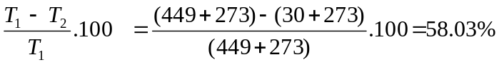
Theoretical Carnot efficiency =

But overall efficiency =

=

[30 / 70]
Now each tonne of wood harvested has an overhead of 11%, thus 1.11 tonnes must be harvested for each useful tonne. The overall conversion efficiency will be

= 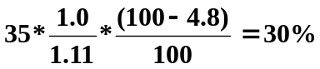 .....................answer to second part

[10 / 70]
{ if the overhead factor is omitted, then half marks, and this would give an answer of 33.32%}

Each 1 tonne of harvested wood at the power station produces 20 * 0.35 = 7 GJ of useful energy and working on an annual basis, this would give a continuous output of :-

7 / 365 / 24 / 3600 = 0.222 kW

Further each hectare produces 10 / 1.11 tonnes of wood for use = 9.009 tonnes
and thus 20 sq km will produce 20 * 100 * 9.009 = 18018 tonnes per annum leading to a continuous output of 18018 * 0.222 = 4.00 MW

Finally, since there is a load factor of 70%, the design output will be 4 / 0.7 = 5.71 MW
[30 / 70]
{if load factor aspect is omitted, then maximum mark should be 20/70}

Note: it is possible to work question differently to include load factor at an earlier stage e.g.

1 tonne produces 7 GJ of energy per year, which at a load factor of 70% could sustain a generator of 7 / 365 / 24 / 3600 / 0.7 = 0.317 kW ( as opposed to 0.222kW) which when multiplied by 18018 gives same final value as before.

Descriptive part - points which should be covered in a good answer

A good answer to the descriptive part would suggest evidence of having read Energy Paper 62.
Biomass (along with waste) it is suggested could be the major supplier of renewable energy, and could produce up to 1000 PJ over energy by 2020 which if used to generate electricity could sustain 10000 MW of generating capacity or 20% of UK electricity demand. However, the above calculation shows that to produce this would require around 10000/5.71 * 20 or around 35 000 sq km or 1/8th of total land area of UK, and this coverage solely for energy crops is probably unacceptable as it would have major environmental impact and reduce biodiversity.

The promotion of biomass through the Non-Fossil Fuel Obligation is solely for electricity generation, and this at best will have an efficiency of 30%. On the other hand direct combustion can achieve 70% and more than double the effective exploitation of the resource. Combined heat and power could improve effective utility further.

Question 7

First part: evaluate total energy required for hot water in day - i.e. sum of litres of water in column 3 multiplied by specific heat and temperature difference

from Table (below), sum of water requirements is 165 litres, so total energy requirement

=165 * 4.1868 * (55 - 10 ) / 1000 = 31.087 MJ
| | | |
litres specific heat temp. difference |
(kJ / kg) conversion (kJ --> MJ)
Hour beginning | Solar Radiation (W m-2) | litres of hot water used | Hour beginning | Solar Radiation (W m-2) | litres of hot water used
0000 |  |  | 1200 | 800
0100 |  |  | 1300 | 675 | 2
0200 |  |  | 1400 | 450
0300 |  |  | 1500 | 245
0400 |  |  | 1600 | 70
0500 |  |  | 1700 | 16
0600 | 16 |  | 1800 |  | 3
0700 | 70 | 5 | 1900
0800 | 245 |  | 2000
0900 | 450 | 5 | 2100
1000 | 675 |  | 2200 |  | 150
1100 | 800 |  | 2300
Total number of litres = 165: Sum of solar radiation = 4512 Whr m-2

Now sum radiation in each hour - 4512 Wh m-2. and bring this to MJ by multiplying by 3600. Also noting that the efficiency is 55% and availability is 58% multiply also by these factors

i.e. energy available per square metre each day = 4512 * 3600 * 0.55 * 0.58 /1000000 = 5.1815 MJ m-2

So area required = 31.087/5.1815 = 6.00 sq m

Minimum storage can be computed on assumption that there are no losses in the storage or transmission system. It is necessary to evaluate net gain and net loss in each hour. The values in the net gain column will be
radiation * area of collector * 0.55 * 0.58 * 3600 /1000000 = radiation * 0.0069 MJ

The 0.0069 is a common factor so compute once to save calculation. - enter values in Net gain column

similarly, energy used = litres * 4.1968 * (55 - 10) /1000 = 0.1884 * litres used MJ

Finally the net storage is a balance of gains and losses - starting with zero at midnight

Hour | Solar radiation | litres of hot water | Net gain | energy used as hot water | net storage
(MJ)
 | (W m-2) |  | MJ | MJ | MJ
00:00 |  |  |  |  | 0.00
01:00 |  |  |  |  | 0.00
02:00 |  |  |  |  | 0.00
03:00 |  |  |  |  | 0.00
04:00 |  |  |  |  | 0.00
05:00 |  |  |  |  | 0.00
06:00 | 16 |  | 0.11 |  | 0.11
07:00 | 70 | 5 | 0.48 | 0.94 | -0.35
08:00 | 245 |  | 1.69 |  | 1.34
09:00 | 450 | 5 | 3.10 | 0.94 | 3.50
10:00 | 675 |  | 4.65 |  | 8.15
11:00 | 800 |  | 5.51 |  | 13.66
12:00 | 800 |  | 5.51 |  | 19.17
13:00 | 675 | 2 | 4.65 | 0.38 | 23.45
14:00 | 450 |  | 3.10 |  | 26.55
15:00 | 245 |  | 1.69 |  | 28.24
16:00 | 70 |  | 0.48 |  | 28.72
17:00 | 16 |  | 0.11 |  | 28.83
18:00 |  | 3 |  | 0.57 | 28.26
19:00 |  |  |  |  | 28.26
20:00 |  |  |  |  | 28.26
21:00 |  |  |  |  | 28.26
22:00 |  | 150 |  | 28.26 | 0.00
23:00 |  |  |  |  | 0.00

Minimum storage is obtained from the maximum energy that needs to be stored - i.e. 28.83 MJ at 17:00.
so volume required = 28.83 *1000 / (55 - 10) / 4.1868 = 150 litres

[ the 1000 is need to convert the 28.83 from MJ to kJ]

Split of marks for numeric part - 20/50 for part 1 to evaluate area, 30/50 to evaluate storage

Descriptive Part

The first part can be taken from lecture notes.
There are several issues with the calculations here.

1. it is assumed that there are no losses. In reality there will be losses which will be proportional to the temperature difference between the water in the cylinder and the ambient temperature.
2. one of the net energy store values is negative, and this in fact cannot happen. What would happen in reality is that the normal central heating boiler would cut in to heat up the water and remove the deficit. That would happen on the first day, and the subsequent hourly values would all be increased by the amount supplied by the boiler i.e. 0.35 MJ, and there would be a residual amount equal to this value at the end of the day. This, in the absence of losses would be carried forward into the next day and would mean that the second day onwards would see self sufficiency.
3. the analysis here assumes that the water actually used is heated up to the correct temperature. In reality, though the top of the cylinder may be warmer than the bottom, the cylinder would not just have say 5 litres of hot water at the top and the remainder cold. The effect is less of an issue as the day progresses, but in reality, the boiler is likely to come on the first day to bring most of the water up to temperature. the problem with that is that the store will not then be able to make the best use of the solar gain later in the day as the energy store will already be full.

The consequence of the above issues is to raise the storage volume required above the minimum computed, and in reality it may well be impossible to avoid a little input of heat from other that solar.

SECTION 3: ENV-2E02 Energy Resources Examination 2001

Section A [25%]

1. What physical aspects affect the performance of wind turbines?
[20 %]
Table 1 shows simplified power rating curves for the Vestas 600 kW and ENERCON 600 kW Wind Turbines, while Table 2 gives the proportion of wind speed in each wind speed category.

Estimate the overall Load Factor for each machine at the site in question and the annual amount of electricity generated.
[80%]
TABLE 1
 | VESTAS | ENERCON
Wind speed | Power | Power
[m/s] | [kW] | [kW]
4.50 | 0.00 | 0.0
5.00 | 30.40 | 42.1
7.00 | 135.00 | 126.5
9.00 | 287.00 | 278.7
11.00 | 450.0 | 484.6
13.00 | 558.00 | 590.0
15.00 | 594.00 | 600.0
17.00 | 600.00 | 600.0
19.00 | 600.00 | 600.0
20.00 | 600.00 | 600.0
Cut out speed 20 ms⁻¹

TABLE 2
Wind Speed | Frequency
m s⁻¹ | %
0 – 2 | 7.6
2 – 4 | 11.8
4 – 6 | 22.4
6 – 8 | 18.8
8 – 10 | 11.4
10 – 12 | 9.8
12 – 14 | 7.4
14 – 16 | 5.1
16 – 18 | 2.9
18 – 20 | 2.0
> 20 | 0.8

2. Describe how a hot dry-rock (HDR) resource may be exploited.

[40%]

In an area with a geothermal gradient of 0.035ºC m⁻¹ and a surface temperature of 20ºC, estimate the amount of energy that is theoretically available per square kilometre from the region 2.5 to 3.5 km deep if the mean temperature must not be allowed to fall below 100ºC.
[30%]
The steam produced in such a scheme is used to generate electricity in a 20 MW power station in which the cooling water temperature is 25ºC. Estimate the time that the resource will last if the isentropic efficiency is 76%
[20%]
Explain why your answers are likely to significantly overestimate the true values.
[10%]
The specific heat of rock is 0.9 kJ kg⁻¹ and the density of the rock is 2600 kg m⁻³

Section B [25%]

Discuss the technical and political factors which currently hinder the greater exploitation of Renewable Energy Sources.

[Your answer should not tackle the issues specific to particular Energy Sources].

4.
- How does nuclear fusion differ from nuclear fission?
- How might nuclear fusion be harnessed?
- What are the main advantages and disadvantages of nuclear fusion over nuclear fission?

5. Describe how passive solar energy may be exploited effectively in the UK.

Section C [50%]

6. Briefly review the environmental impacts associated with the generation of electricity from tidal power.
[30%]
The Churchill Barriers between Mainland Orkney and South Ronaldsay, built as a defence measure during the last war, blocked what was a natural and strong tidal race.

There is a two hour time difference between the high tide on the two sides of the barrier, and the heights above mean level are shown in Table 3.

Table 3:
 | Time relative to high tide on east side (hrs) | Height on east side (m) | Height on west side (m)
High Tide East Side | 0 | 1.20 | 0.60
 | 1 | 1.04 | 1.04
 | 2 | 0.60 | 1.20
 | 3 | 0.00 | 1.04
 | 4 | -0.60 | 0.60
 | 5 | -1.04 | 0.00
Low Tide East Side | 6 | -1.20 | -0.60
 | 7 | -1.04 | -1.04
 | 8 | -0.60 | -1.20
 | 9 | 0.00 | -1.04
 | 10 | 0.60 | -0.60
 | 11 | 1.04 | 0.00
High Tide East Side | 12 | 1.20 | 0.60

You are asked to investigate a scheme which would insert 15 turbines, each 4.66 m diameter, into Churchill Barrier No. 1. Power can be extracted whenever the head difference is greater than 0.6 m.

Estimate the daily electricity production and the mean power produced if the efficiency of the turbines is 80%. The density of sea water may be taken as 1070 kg m⁻³. You may assume that there are exactly two tidal cycles in a day.
[70%]

- Discuss how the New Electricity Trading Arrangements, due to come into force on 27th March 2001 differ from those used previously.

- Discuss the advantages and disadvantages of the once-through and reprocessing options for the back end of the nuclear fuel cycle.
[40%]
How are the risks involved in the release of radioactive material from an underground, high level nuclear-waste repository calculated?
[60%]
SECTION 4: Worked Examples and Comments on Descriptive Questions for 2001

ENV-2B12 Question 1 - 2001.

Descriptive part:

Should include most of following key factors:-
- Output is proportional to blade diameter squared
- Output is proportional to velocity cubed
- Windspeeds have logarithmic profile above ground and thus higher hub height leads to greater output for same size of turbine
- Siting turbines on hills where velocity is higher increases output
- Turbulence effects from areas of high roughness - e.g. towns, woods should be avoided Clusters of turbines will have output reduced because of turbulent interaction between machines if they are too close.

Numeric Part

Question is best done in tabular form. The frequency column is taken from the mid-value of the histogram range. In column 5, this is the product of the power and frequency with the same situation for column 6.

The total output for each turbine will be the summation of the values in the column multiplied by the number of seconds in a year. However, we do not need to do this last multiplication as we are only interested in a load factor. This latter is defined as the actual output from a wind turbine divided by the theoretical output which would be possible if the turbine was running at its rated output continuously. Thus the load factor is simply the division of the sum by 600. Interestingly though the VESTAS machine performs better at low speeds, overall the ENERCON machine would produce the highest output.

Strictly speaking the output used to determine the relevant frequency should be the cube root of the mean of the cubes values of windspeed for each class width. However, in this example it would be complex to achieve. However, a numeric answer should recognise this fact. If it is not mentioned, then the maximum for the numeric part should be no more than 70 out of 80.

Windspeed | VESTAS Power | ENERCON Power | Frequency | VESTAS (Power * Frequency) | ENERCON (Power * Frequency)
[m/s] | [kW] | [kW] | %
4.50 | 0.00 | 0.0
5.00 | 30.40 | 42.1 | 22.40 | 6.81 | 9.43
7.00 | 135.00 | 126.5 | 18.80 | 25.38 | 23.78
9.00 | 287.00 | 278.7 | 11.40 | 32.72 | 31.77
11.00 | 450.00 | 484.6 | 9.80 | 44.10 | 47.49
13.00 | 558.00 | 590.0 | 7.40 | 41.29 | 43.66
15.00 | 594.00 | 600.0 | 5.10 | 30.29 | 30.60
17.00 | 600.00 | 600.0 | 2.90 | 17.40 | 17.40
19.00 | 600.00 | 600.0 | 2.00 | 12.00 | 12.00
cutout | 0.00 | 0.00 | 0.80 | 0.00 | 0.00
 |  |  | Summation | 209.99 | 216.14
Output at 100% load factor = 600 * 1 |  |  |  | 600 | 600
Load Factor | % |  |  | 35.00 | 36.02
Output | = load factor /100 * rated output * hours in year * 3.6 |  |  | 6.62 TJ | 6.82 TJ
Marks: 10 for identifying tables format
30 for completion of table correctly including summation
- for correct evaluation of load factor
10 for computation of annual output
10 for discussion of cube root of mean cube
20 for descriptive part
ENV-2B12 Question 2. - 2001

(a)
Assuming a linear temperature gradient, the mean temperature will be at 3000m
And will equal 3000 x 0.035 + 20 = 125^{O}C.

Useful temperature range = 125 – 100 = 25ºC

Thus theoretical energy available = volume x specific heat x temperature difference

= 1000 x 1000 x 1000 x 0.9 x 2.6 x 10⁶ kJ = 58.5 PJ
=======

Mean temperature of resource over life time = (125 – 100)/2 = 112.5ºC = 385.5 K
Mean effluent temperature = 25ºC =298 K

Overall efficiency = Carnot efficiency * isentropic efficiency = (T₁ - T₂) / T₁

where temperatures are all measured in Kelvin

= (385.5-298)/385.5 * 0.76 * 100 = 17.25%

For a 20 MW station heat input = 20/0.1725 = 115.942MW

and annual demand = 115.942 * 86400 * 365 = 3.656 PJ
|
seconds in a day

So resource will last 58.5/3.656 = 16 years

Question 3: ENV-2B12 - 2001

The critical point about this question is that it is not to look at the issues for a specific renewable resource, but more on general issues affecting more widespread deployment.

Technical issues which should be included

- Most renewables (other that large hydro and waste) are more suited to generation is DC form rather than AC as synchronism problems can be an issue - particularly for off shore wave. However, our present infra structure favours AC generation
- Many of the renewable resources are optimally located at the periphery of places where demand is leading to increased requirements for transmission lines
- Most renewables are dependant on climate and thus cannot be called upon to generate at will as is case of fossil fuel plant. Waste and geothermal are exceptions as in the former waste can be stockpiled as with fossil fuels.
- Some renewables such as onshore wind are now technically mature, but others such as marine current tidal devices, wave energy convertors are limited for technical reasons and need more research - e.g. (wave and tidal) resistance to corrosion in harsh marine environment, maintenance issues in offshore environments, mooring and foundation problems in strongly moving currents.
- Renewable generation does not always offset the need for standby fossil fuel generation when the renewable resource is unavailable - indeed fossil fired power plant in this mode would be less efficient than normal. With a large renewable component, there will be need for increased storage methods.
- Each renewable is currently treated in isolation, there would be technical advantages in integration - e.g. wind/hydro with excess wind used in a pumping mode to enhance hydro output on a more demand orientated basis.

Key Political issues are

- Planning approvals are biased towards vociferous minorities who can "kill" projects such as Wind energy even though 75% - 80% of people are in favour of wind.
- Despite intentions by Government in early 1990's for 1500 MW of new renewables by 2000 less than have that figure was achieved - the shortfall coming mostly in the latter part of the period.
- The New Electricity Trading Arrangements (NETA) which came into force on 23rd March 2001, favour flexible generators and thus discriminate against most renewable generators.
- The Renewables Obligation due to come into force in October 2001 (but is likely to be delayed because of election) aims to address this by placing an obligation of a target amount of renewable generation on all suppliers. However the low buy out price will only favour wind and others are not likely to be that financially viable (particularly tidal, geothermal etc).
- The Renewables Obligation has a lot to do with control and monitoring and thus favours electricity and not the most effective exploitation of renewable resources. In addition only grid connect electricity generation is favoured in the implied subsidies under Renewables Obligation. Generation offshore with the electrolysis of water to yield hydrogen and using this as a more efficient energy vector is not covered.

5. Describe how passive solar energy may be exploited effectively in the UK

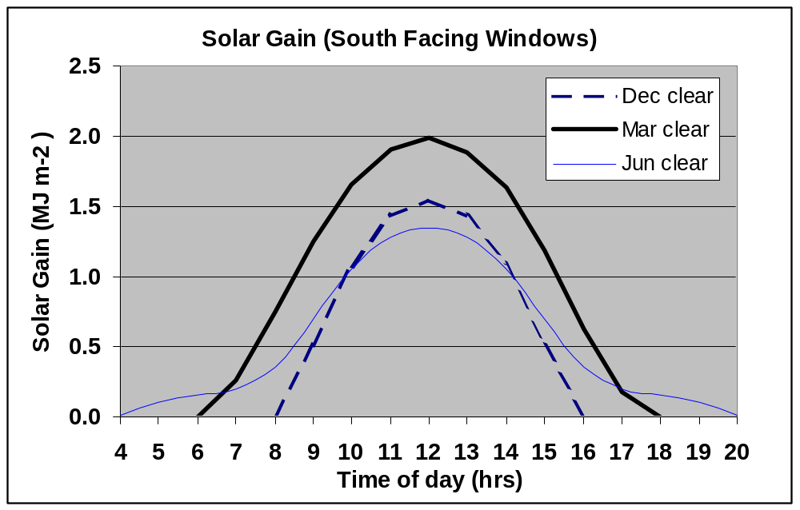A good answer would begin with a definition of Passive Solar Energy (i.e. this excludes photovoltaic and most solar hot water systems (the thermo-syphon hot water system is considered by some to be passive). Mostly passive solar energy relates to the capture of energy primarily through architectural design.

Solar energy falling on glass is transmitted, absorbed (~half of which is subsequently transmitted into the building), or reflected. The relative proportions of the transmitted to reflected energy depend on the vertical angle of the sun. When the sun is low in the sky the rays are nearly at right angles and the reflectance is low. Conversely when it is high the proportion of solar energy transmitted is less. However, a low angle sun will have a long atmospheric path which itself will absorb the energy. Consequently, for south facing windows the solar gain rises from the winter minimum as the atmospheric path length effect causes the solar energy to increase more rapidly that the reduction arising from increased reflectivity. From March to June, however, the reflectivity issue is more dominant such that the solar gain in south facing windows is less in summer than in March or September. For East and West facing windows, the net solar gain rises continuous until the middle of June and then decreases. Noticeably, the gain on East and or West facing Windows in summer is greater than on south facing windows. Energy transmitted through the glass is of a short wavelength and is absorbed by components in the room. These emit long wave radiation which is effectively trapped
The presence of a carpet in a room with mean that less heat reaches the thermal store, and although the air temperature in the day may rise quickly, there is less stored heat available for the overnight period meaning that the night time temperature fall more rapidly and overall more energy is lost than in carpets are absent. The best method for overall energy is to have solid uncarpetted timber floors.
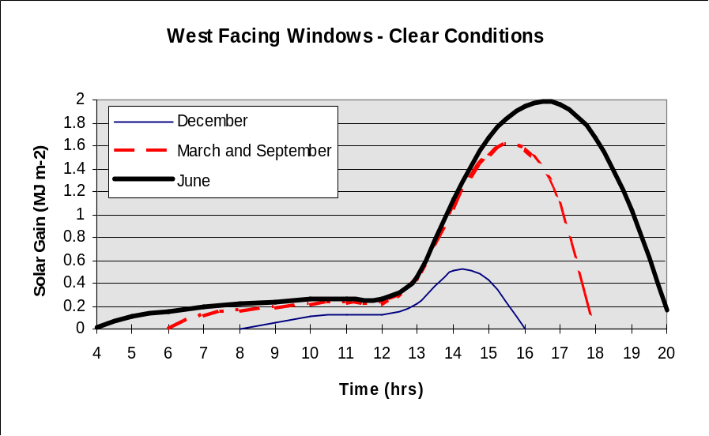
A good answer would include a diagram showing relative gain of solar energy throughout the year.

To optimise solar gain normally requires a larger proportion of glazed area in a southerly orientation, and this might have privacy issues for houses on the north side of and east west road.

With approximately 55% of glazed area pointing south, and remainder distributed evenly in other orientations (and drawing on experience from the practicals), about 8 – 10% of space heating can be satisfied in December from solar gain (or about 30 – 50% more than a house with equal glazing in all orientations). In March around 40% of heating could be provided rising to 90+% in September. The reason that September is more effective in supplying heating needs is because the mean external temperature is much higher than in March. In June the gain exceeds the losses by around 50% and overheating is likely. Thus to have an effective design, the south facing windows should be shaded by an overhang to prevent the mid-day sun from hitting the window in June, but providing no restriction during the winter months. Another effective measure is to plant deciduous trees on the south side which, when in leaf will provide an effective screen in summer, and yet in winter with no leaves the trees will cause only limited shading on the winter sun.

Trombe walls forming the south facing wall and faced with glazing provide a good way to also store heat, and this through the sensible use of air – flaps can be used to heat or cool spaces in the house. One problem with such a device is that the occupy must be sufficiently conversant with the physics of the system to ensure that the correct air-flow patterns are used – otherwise overheating or overcooling may result.
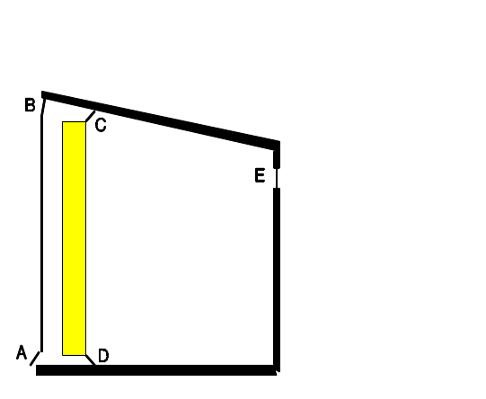
The operation of vents:

Vent | Winter | Summer
A | Open | Open
B | Closed | Open
C | Open | Closed
D | Open | Open
E | Closed | Open

Answers should have several diagrams of illustration = e.g. graphs of solar gain through year, architectural design showing overhanging balconies/trees etc, and also trombe walls.
ENV-2B12 Question 6 – 2001

Water flowing through turbine, must be consistent.
i.e potential energy of head difference = kinetic energy flowing thorugh turbines

i.e. mgh = 0.5 m V² or V = sqrt( 2 g h) where g is the acceleration due to gravity = 10 .0 m s⁻²

Values of velocity as computed in the manner outlined above in column 6 of following table. The –ve sign in these calculation is irrelevant as this merely implies two way flow.
time | Height east  (m) | Height west  (m) | Height difference  (m) | effective head  (m) | Velocity  (m s⁻¹) | cube of velocity
0 | 1.20 | 0.60 | 0.60 | 0.60 | 3.46 | 41.57
1 | 1.04 | 1.04 | 0.00 | 0.00 | 0.00 | 0.00
2 | 0.60 | 1.20 | -0.60 | -0.60 | 3.46 | 41.57
3 | 0.00 | 1.04 | -1.04 | -1.04 | 4.56 | 94.76
4 | -0.60 | 0.60 | -1.20 | -1.20 | 4.90 | 117.58
5 | -1.04 | 0.00 | -1.04 | -1.04 | 4.56 | 94.76
6 | -1.20 | -0.60 | -0.60 | -0.60 | 3.46 | 41.57
7 | -1.04 | -1.04 | 0.00 | 0.00 | 0.00 | 0.00
8 | -0.60 | -1.20 | 0.60 | 0.60 | 3.46 | 41.57
9 | 0.00 | -1.04 | 1.04 | 1.04 | 4.56 | 94.76
10 | 0.60 | -0.60 | 1.20 | 1.20 | 4.90 | 117.58
11 | 1.04 | 0.00 | 1.04 | 1.04 | 4.56 | 94.76
12 | 1.20 | 0.60 | 0.60 | 0.60 | 3.46 | 41.57
 |  |  |  |  | Total | 822.03
NOTE: The above was the model answer given, In actual practice, it is slight incorrect as the last hour (i.e. hour 12 is also the first hour of the next 12 hour period, and double counting could arise). The effect is small, and strictly speaking the information for hour 0 and 12 should be amalgamated an a single mean taken), but adds slightly to the complexity. The students were give a different example in lectures which also had this double counting in. One student correctly identified the above problem and was given extra credit for this.

Question does say students may assume g = 10 ms⁻² but if they choose to use 9.81 which is more accurate and more time consuming then they should be given full credit ( and perhaps even slight compensation)!

By continuity the mass passing per second = density x volume = density x velocity x cross section area
= ρ V π R²

and kinetic energy = 0.5 m V² multiplied by efficiency

so energy available per turbine = 0.5 η ρ V π R² V² = 0.5 η ρ π R² V³

substituting values for η, ρ, and R give the theoretical energy at any instant [R=4.66/2]

= 0.5 * 0.8 * 3.1415926 * 1070 * 2.33 *2.33 = 7299.71 V³
(remember that density of SEA water is 1070 kg m⁻³ and it is the diameter which is given not radius).

The energy available in a day will be 2 x 7299.71 x Σ V³ [the factor 2 comes from two tidal cycles per day)

Thus to find total energy work out V³ and enter values in column 7 and sum

total energy will thus be 2 * 7299.71 * 822.03 /1000/1000 MWh per day per turbine

= 12 MWh per turbine or 180 MWh for all 15turbines

The mean output power from the barrage will thus be 180/24 = 7.5 MW

Question 6 descriptive part

The key points which should be covered in descriptive part are:
- Tidal barrages enclose estuaries and thus affect tidal regimes. For EBB generation, basin is normally held at a mean level higher than natural, reverse is true for FLOOD (most common form) generation.
- In FLOOD schemes flow in basin is reduced leading to less turbulence, clearer water with many species thriving.
- Siltation behind barrage is possible, but unlike hydro, the scheme can be periodically flushed.
- Reduced sediment transmission regularly may lead to pulses of release to open sea leading to transient formation opf sand bars etc.
- Shipping would have more regular access to upstream ports by higher water levels in FLOOD schemes, albeit with the need to pass through locks.
- Some species of bird (e.g. wading ones) are likely to looses part of their habitat, although others would increase. If two way generation were used or better still a double basin system were used, these effect could be largely mitigated.
- Concerns about problems for fish to migrate seem unfounded as demonstrated by the prolific catches local fishermen at La Rance obtain from species passign through the aerated columns via the turbines.
- The barrage will reduce erosion upstream, can provide an important transport link (e.g. Dinard/St Malo) and the enclosed water can be used for recreational purposes.
- Construction involves large quantities of materials and a long time to complete - but this can enhance local employment.
- Barrage schemes can help to reduce CO₂ and related emissions by displacing fossil fired generating plant.
- Marine current devices are like underwater wind turbines, and have the advantage that they are relatively small causing limited disruption to the environment, are modular so they can avoid the large initial capital costs of barrage schemes and can be used to exploit currents where barrages would be inappropriate.

ENV-2B12 – Question 7 - 2001.

On March 27th 2001, the New Electricity Trading Arrangements (NETA) came into force and replaced the Electricity Pool which has been in force since privatisation on April 1st 1990. Prior to that date all electricity supply had been distributed by the Central Electricity Generating Board (CEGB).

ENV-2B12 – Question 8 – 2001.

Discuss the advantages and disadvantages of the once-through and reprocessing options for the back end of the nuclear fuel cycle.

The answer should begin with a definition of the back-end of the fuel cycle – i.e. that part after the fuel is used in a nuclear power plant. Both options have an initial period of 180+ days for cooling and decay of short lived radioactive daughter products of nuclear reaction (e.g. Xenon, Iodine-131, Krypton 87) etc. The answer should recognise the relative advantages and disadvantages can depend on the nuclear reactor used.

Magnox – advantageous for reprocessing – because of low initial burn up and also durability of cladding in longer term – usually considered best economic option. (many reactors in UK are of this type)

AGR - largely neutral towards advantages/disadvantages in economic terms.

PWR – slightly more expensive economically to reprocess, but political issues such as availability of uranium may become increasingly of significance (e.g. French approach).

Reprocessing – separates first the fission products from the plutonium (239 – 241) and depleted uranium, and subsequently the uranium from the plutonium. The uranium may be re-enriched for further use as somewhat controversially can the plutonium in MOX (mixed oxide fuel). Essentially the only highly radioactive waste are the fission products, and the volume of these is of the order of one tenth the volume of the spent fuel elements which need disposing in the once-through option.

However, in reprocessing, larger volumes of intermediate level radioactive waste (e.g. fuel element cladding), and low level waste (including clothing, liquid and gaseous discharges within permitted limits etc). The low and intermediate level wastes can be contained and monitored in facilities such as at ANDRA in France. The high level waste can be vitrified.

The once through option has a higher volume of high level waste and in a form which at present is less easy to vitrify. On the other hand lower volumes of intermediate and low level waste are generated.

- second part see Alan Kendalls notes
- ===============================================
SECTION 4: ENV-2E02 Exam Paper 2003

SECTION A (50%)

- Summarise the key aspects of the New Electricity Trading Arrangements.
[30%]

A generating company reports its Final Physical Notification (FPN) to the National Grid prior to Gate Closure as 300 MW and remaining constant for the half hour period starting at 15:00. The company also tenders Offers and Bids for the period as shown in Table 1.

After Gate Closure but before Real Time, the National Grid Company accept the offers and bids with the revised output requirements as show in Table 2.

Estimate the income for the generating company if the contract price associated with its Final Physical Notification is £16.81 per MWh.

[You may assume that the required output changes can take place instantaneously and are not constrained by the physical limitations of the generating units].
[45%]

After the start of Real Time, the National Grid Company requests a variation in output as shown in Table 3. Estimate the new total income for the generating company and the percentage of that income obtained from participating in the Balancing Mechanism Trading.
[25%]

Table 1
Pair | Range relative to FPN | Offer (£ / MWh) | Undo Bid (£ / MWh)
+3 | +50 to +100 MW | 50 | 40
+2 | +25 to + 50 MW | 25 | 20
+1 | + 0 to + 25 MW | 20 | 18
 |  | Bid (£ / MWh) | Undo Offer (£ / MWh)
-1 | 0 to – 50MW | 20 | 25

Table 2
Minutes from start of period | Variation requested from FPN (MW) | Minutes from start of period | Variation requested from FPN (MW)
0 - 4 | 0 | 18 - 20 | +40
4 - 6 | +20 | 20 - 22 | 0
6 - 8 | +40 | 22 - 28 | -30
8 - 18 | +60 | 28 - 30 | 0

Table 3
Minutes from start of period | Variation requested from FPN (MW)
0 - 20 | as Table 3
20 - 26 | +40
26 - 30 | 0

- If Britain decides to continue development of nuclear power discuss which type of reactor it would be best to build.

- The Energy Review (February 2002) provided a focus for discussion as to how the energy requirements of the UK could be met up to 2020. Discuss the main issues arising in the Review with particular reference to the role of renewable energy sources.

SECTION B (25%)

- Those who object to deep burial containment as a suitable method for permanently storing nuclear waste do not understand the concept of “passive engineering”. Discuss the relevance of this viewpoint.

- How far can geothermal energy be considered a renewable energy resource?

- To what extent is the present energy infrastructure in the UK a help or hindrance to the exploitation of renewable energy?

SECTION C (25%)

- To what extent could photovoltaic solar energy provide energy for the UK by 2020?
[30%]

Table 4 shows the solar irradiation fall on the south facing wall of the teaching wall at the University of East Anglia during and average day in the month of September. Assuming that day represents the average solar input for the whole year, estimate the total electricity which could be generated in a year if the efficiency of the collectors is 15%, and the total area of panels which could be attached to the wall is 300 m².

If the price paid for the electricity is 7p per unit estimate the simple pay back time if the capital cost is £150 000.
[70%]

Table 4
Time | Solar Irradiation on a vertical south facing wall (W m⁻²)
00:00 – 06:00 | 0
06:00 – 07:00 and 17:00 – 18:00 | 10
07:00 – 08:00 and 16:00 – 17:00 | 50
08:00 – 09:00 and 15:00 – 16:00 | 175
09:00 – 10:00 and 14:00 – 15:00 | 325
10:00 – 11:00 and 13:00 – 14:00 | 485
11:00 – 12:00 and 12:00 – 13:00 | 575
18:00 – 24:00 | 0

SECTION C (continued)

- Briefly review the different approaches that can be made to predict the future demand or supply or energy in the UK. Use one sector of supply or demand to illustrate the different approaches.
[25%]

Table 5 shows the Gross Domestic Product (GDP) in terms of prices in 2000 and the total UK energy use over the last 50 years. Use the data to evaluate the Energy Ratio in terms of GJ/£1000 and explain the variations in this Energy Ratio with time.

Estimate the likely energy requirement in the UK in 2006 if the economy grows by 4% per annum in real terms from 2001 and the Energy Ratio continues on its present trend.

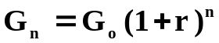The GDP in a year in the future may be estimated from:-

where G_{o} is the GDP in the current year, G_{n} is the GDP n years hence and r is the fractional annual increase.
[70%]
What problems do you forsee in using the above Energy Ratio Trend to predict energy requirements 50 years hence?
[5%]
Table 5.
YEAR | Energy (PJ) | GDP (billion pounds 2000 value)
1951 | 6214 | 277
1953 | 6364 | 290
1955 | 6674 | 313
1957 | 6691 | 322
1959 | 6720 | 335
1961 | 7181 | 363
1963 | 7445 | 383
1965 | 7934 | 416
1967 | 8001 | 433
1969 | 8521 | 464
1971 | 8780 | 479
1973 | 9341 | 532
1975 | 8625 | 521
1977 | 8923 | 548
1979 | 9211 | 581
1981 | 8320 | 560
1983 | 8269 | 592
1985 | 8504 | 629
1987 | 8793 | 683
1989 | 9119 | 734
1991 | 9270 | 730
1993 | 9324 | 750
1995 | 9467 | 807
1997 | 9777 | 857
1999 | 9877 | 901
2001 | 10179 | 949

Suggested Answers to 2003 Exam Questions

Question 1.
The New Electricity Trading Arrangements (NETA) came into force on 27th March 2001 and replaced the Electricity Pool which had been in operation since Privatisation on 1st April 1990. Unlike the Pool, NETA involves both the generators and the suppliers in the bidding process.

The system is divided into Balancing Mechanism (BM) Units which may be either units of supply or demand.
By the time of Gate Closure which was originally 3.5 hours before physical time, all BM Units had to declared the volume of their trading position to the National Grid Company (NGC). They DO NOT have to declare the price they have agreed for each MWh generated or supplied. No changes can be made by the generators or suppliers to their contractural position after Gate Closure. In July 2002, the Gate Closure was reduced to 1 hour before physical time.

At the same time they can make OFFERS to increase their output (for generators) or reduce their demand for suppliers. This is to allow for the dynamic nature of the market. Nearer the Phsyical Time when fluctuations in demand become clear, the National Grid Company will agree some of the OFFERS with some BM Units and these OFFERS will then become the required contractural position of the BM Units. The BM Units will be paid at the rate of their respective OFFERS for any options taken by NGC. In addition to the OFFERS, a generator may BID to reduce its generation and a supplier may bid to increase its demand. Some of these BIDS are also likely to be taken up by the NGC and the generators and/or suppliers will then pay for units to bring them to the new position indicated by the BID.

Once an OFFER or BID has been agreed, it cannot be undone, and the NGC is obliged to make an UNDO BID to cancel a previously agreed OFFER and an UNDO OFFER to cancel a BID.

Each OFFER is thus associated with an UNDO BID, in what is known as a PAIR. Equally each BID is associated with an UNDO OFFER, also known as a pair. The UNDO OFFERS are normally greater than the associated BID, and the UNDO BIDS are normally less than the associated OFFER.. This means that cancelling a bid or offer will be a net charge to the NGC.

Generators and Suppliers may make different OFFERS/BIDs depending on the magnitude of the departure from the FPN. Thus an OFFER/UNDO BID pair may represent an increase in FPN of up to say 50 MW for a generator, and this is known as PAIR +1. Above 50MW a different OFFER/UNDO BID may be relevant and this is known as PAIR +2 and so on. Conversely, BID/UNDO OFFER pairs are designated PAIR –1, PAIR –2 etc. BID – UNDO OFFERS and vice-versa are known as BID OFFER Acceptances (or BOAs) once they are accepted.

Generators and Suppliers who are out of balance pay penalties if they are out of balance. Too much generation, or too little demand incurs penalties at the SYSTEM SELL price. Conversely Too little generation or too much demand incurs penalties at the SYSTEM BUY price. The latter is usually much higher than the former and has been known to reach 30p+ per kWH compared to the domestic retail price of 6 – 7p.

There are further constraints that must be considered such as the physical rate of change in generation/demand that a BM Unit can experience. Equally, transmission constraints in different parts of the country may affect which OFFERS and BIDS are accepted.

Numeric Part
The income for the electricity generated at the FPN level is 300 x 16.81 x 0.5 = £2521.50
| | |
FPN price (30 mins = 0.5 hours)
Minutes | Number of minutes in period | Deviation from FPN | MW mins | MW hours | Average Price  (£ per MWh)  (see below)** | Total Income Expenditure (£)
[1] | [2] | [3] | [4] = [3] * [2] | =[4] / 60 | [5] | [6] = [4] * [5]
0 - 4 | 4 | 0 | 0 | 0 | - | -
4 - 6 | 2 | +20 | 40 | 0.6667 | 20.00 | £13.33
6 - 8 | 2 | +40 | 80 | 1.3333 | 21.875 | £29.17
8 - 18 | 10 | +60 | 600 | 10 | 27.083 | £270.83
18 - 20 | 2 | +40 | 80 | 1.3333 | 21.875 | £29.17
20 - 22 | 2 | 0 | 0 | 0 | - | -
22 - 28 | 6 | -30 | -180 | -3 | 20.00 | -£60.00
28 - 30 | 2 | 0 | 0 | 0 | - | -
 |  |  |  |  | TOTAL | £282.50

** The Average Price for the respective periods is determined as follows:

- for the periods 4 – 6 and 22 – 28, the deviations from the FPN are entirely within PAIR +1 and PAIR –1 respectively and so the average price will be the relevant OFFER/BID – i.e. £20.00 in both cases.
- for the periods 6 – 8 and 18 – 20, the deviation covers the whole of PAIR +1 and part of PAIR +2 so the average price paid for each unit during this period will be the weighted average of the prices i.e.

output in PAIR+1 balance of output in PAIR+2
| |
( 25 x 20 + 15 x 25 ) / 40 = £21.875
| |
PAIR +1 offer PAIR +2 offer

- finally for the period 8 – 18, the whole of PAIR +1 and PAIR + 2 are used and part of PAIR +3. In a similar way to above, the weighted average price is given by:

(25 x 20 + 25 x 25 + 10 x 50) / 60 = £27.083

The total income under this scenario (from figures on previous page) = £2521.50 + £282.50 = £2804
[answer to first part of numeric part of question]

after the revision, the income from the balancing mechanism upto 220 minutes will remain the same,

i.e. £222.50.

Minutes | Number of minutes in period | Deviation from FPN | MW mins | MW hours | Average Price  (£ per MWh)  (see below)** | Total Income Expenditure (£)
[1] | [2] | [3] | [4] = [3] * [2] | =[4] / 60 | [5] | [6] = [4] * [5]
0 - 20 | from previous stage |  |  |  |  | £222.50
20 - 26 | 6 | +40 | 240 | 4 | 21.875 | £87.50
22 - 28 | 6 | +30  undo offer | 180 | 3 | 25.00 | £75.00
28 - 30 | 2 | 0 | 0 | 0 | - | -
 |  |  |  |  | TOTAL | £445.00

** the price for the period of the new OFFER (20 – 26 mins) is identical with the price for the period 18 – 20 calculated earlier, while the undo offer is as shown in the data table 4.

Thus the revised total income is £2521.50 + £445.00 = £2966.50 and the percentage from balancing mechanism is 445/2966.50 x 100 = 15.0%

Question 2.

A good answer would review several of the reactors emphasizing the advantages of the different types, and then focusing on one which the student choose as being the best. Any one reactor could be finally chosen provided that the reasoning is logical. However, it is unlikely that either the Magnox or RMBK reactor would be chosen, although any of the other types might be.

The following table summarises critical information about the different types.

REACTOR | COUNTRY  of origin | FUEL | Cladding | Moderator | Coolant | BURN-UP  (TJ/tonne) | Enrichment | POWER DENSITY  MW m-3
MAGNOX | UK/  FRANCE | Uranium Metal | MAGNOX | graphite | CO2 | 400 | natural enrichment (0.7%) | 1
AGR | UK | Uranium Oxide | Stainless Steel | graphite | CO2 | 1800 | 2.5-2.7% | 4.5
PWR | USA | Uranium Oxide | Zircaloy | H2O | H2O | 2900 | 3.5-4.0% | 100
BWR | USA | Uranium Oxide | Zircaloy | H2O | H20  (water/steam) | 2600 | 3% | 50
CANDU | CANADA | Uranium Oxide | Zircaloy | Heavy Water | Heavy Water | 1000 | natural enrichment  (0.7%) | 16
RMBK | USSR | Uranium Oxide | Zirconium/  Niobium | graphite | H2O | 1800 | 1.8% | 2
FBR | several | depleted Uranium metal or oxide surrounding inner area of plutonium dioxide | Stainless Steel | none | liquid sodium | ? | - | 600

Some other points which should be mentioned.

- Gas cooled reactors (e.g. Magnox and AGR), are tolerant in fault conditions for cooling as in a coolant leak, the pressure drops gradually. This is not the case for water cooled reactors where a small leak will cause a flash of coolant to steam which has much less cooling power.
- A complete loss of water in a PWR would also remove moderator, but the decay heat is still of significance – amounting to around 6% of full load in first few hours after shut down. The FBR will cool by natural convection.
- Gas cooled reactors can be refuelled on line as can the CANDU, but the PWR and BWR cannot be and must be shut down. The PWR is designed to continue running with burst cans contaminating the fluid, whereas any offending can can removed in the case of the CANDU and Gas cooled reactors.
- CANDU reactor is modular and thus can be built at a variety of sizes,
- MAGNOX reactors cannot load follow because of Xe poisioning, AGR have moderate load following characteristics, PWR is claimed to be best
- In BWRs, the steam from actual core is passed directly through turbine. Thus any radioactivity in circuit arising from a burst can will also affect the turbine itself. All other designs have an additional fluid circuit to isolate the reactor coolant from the turbine coolant.
- Best moderator is heavy water: least suitable is ordinary water as it absorbs neutrons and becomes slightly radioactive.
- Reprocessing is required for MAGNOX – marginally cost effective for AGR’s. marginally not cost effective for PWR’s
- Enrichment uses energy, and is needed in case of PWR/BWR to combat loses as neutrons are absorbed by coolant/moderator. In case of AGR’s it is the cladding which absorbed neutrons and thus the need for enrichment.

Question 3.

A good answer will demonstrate that the student has read the Energy Review of February 2002, the associated discussions relating to the Renewables Obligation, and the Energy White Paper February 2003.

It is possible that some aspects in some answers could come in either the 80% or 20% section and a fuzzy approach to the demarcation should be given. The reason for the original demarcation was that the exam paper was written before the White Paper was published, and it was not sure if there was going to be much difference between that and the Review a year earlier.

- Some of the important points that should be mentioned – there may be many others:

- Energy Review and White Paper examine options for the Energy Scene in the UK up to 2020. In the case of the White Paper, it does also make reference to the need to reduce carbon dioxide levels by 60% by 2050.

- Both reports examine several energy supply options from a technical and economic standpoint which can be summarised in the following tables.

- Both reports put much emphasis on carbon sequestration – a technology yet to be proven except at the laboratory/small scale and questions must be raised over its likely impact on energy and carbon dioxide in the timescale involved.

- The Review indicates nuclear must be considered although its emphasis is somewhat neutral in terms of urgency. The White Paper is less committed, and although not ruling it out implies no development in foreseeable future – which means negligible new potential by 2015. All Magnox reactors will be closed by 2012 and some AGRs also by 2020. The save UK around 40 – 50 million tonnes of carbon dioxide a year. Even replacement with gas – the lowest emitting fossil fuel (gas) will see an increase in emissions.

- The Review follows the discussions on the Renewables obligation indicating that 10% of electricity will be generated by renewables in 2010. There is a little watering down of this in the White Paper implying it is the aspiration to achieve this but reading between the lines implies that this may not be achieved. A significant point not picked up in either Review or White Paper is the point raised that this 10% would help to reduce carbon dioxide emissions. In fact the Government projected growth in demand for electricity is 10%, and thus renewables at best will only be able to deal with the increase in demand, and will in no way reduce the carbon dioxide emissions from our current demand. The Review indicates a target 20% renewable generation by 2020, while the White Paper indicates a doubling of generation over the 2010 target (which itself is now rather vague).

- Both Review and White Paper discuss the issue of the buy-out price for the renewable obligation and reaffirm that this should be index linked. However, this buy out price seems inextricably intertwined with the issue of Fuel Poverty

- The White Paper introduces some new issues regarding conservation, and in particular announced its intention to bring forward the next review of the Building Regulations in respect of Energy to 2005.

- Fuel Poverty issues are an important aspect in both documents – and statements such as renewables will be pursued provided that the cost is not to great. There seems to be a considerable concern that the price of electricity will rise by the odd percentage point. It fails to recognise that the actual price as fallen by up to 20% in the last five years. It seems that the fuel poverty issues of the minority of citizens is being used as a reason for not promoting renewables further rather than tackling the issue of fuel poverty as a separate item.

- An important point raised in the white paper is that communities should take more responsibility for their own supply of energy – thus hinting at the issue of more local renewable generation.

Question 4. Please see A. C. Kendall for an answer to this

Question 5. A. C. Kendall for an answer to this

Question 6

To what extent is the present energy infrastructure in the UK a help or hindrance to the exploitation of renewable energy?

There are five aspects to consider in this answer.

- The current national energy vectors are gas and electricity, coal which was the national vector declined rapidly from the 1960s. The current focus for renewables is on the production of electricity and as such these energy sources are expected to conform to the infrastructure already in place for electricity. Little attention is being paid to non-electric forms of renewable energy e.g. direct combustion of biomass, or the use of energy vectors other than gas or electricity – e.g. hydrogen which would be more suited to renewables.

- Since the 1950s, the emphasis has been on medium and large scale centralised power plants whereas renewables are more suited to diverse localised generation for local use. The current electricity grid is designed to transmit electricity at high voltage and to successively reduce the voltage as the point of use is approached. With widespread use of renewables which could involve significant clusters is an few places (e.g. offshore wind farms), the power flows will need to be both from low voltage up to the supergrid and vice-versa which will involve changes to the operating regime of the grid.

- At present there are no grid limitations to the deployment of renewables, but if there are significant further developments in remote locations (e.g. wave off NW Scotland), then extensive strengthening of the grid will be required to service these locations. Equally, there may be the need for more pumped storage schemes such as Ffestiniog, Loch Awe and Dinorwig.

- Most renewable electricity generation is more suited to DC operation as the problems of synchronism can be avoided and output from different units can be added without problem. The current infrastructure requires AC operation. The main reason for this occurred following technology available in early 20th century. Significant losses arise from the transmission of electricity and the loss is proportional to the current squared multiplied by the voltage. Transforming the voltage to high voltage proportionally reduces the current and hence the losses. DC can not be transformed except with costly inverters which were not available in early years. If superconductivity at room temperature were available then high voltage transmission would not be needed. Most appliances run off AC so there is a further infrastructure problem. Biomass, geothermal and hydro generation are affected little and can readily mimic conventional generation in AC, but for other forms it can be a problems. More sophisticated control is thus needed for wind turbines to achieve this synchronisation. Alternatively relatively costly inverters are needed. In the case of wave power it is questionable whether direct synchronisation could ever be achieved and probably DC generation will become the norm with inversion to AC at the point of connection to the Grid.

- the political infrastucture can also be a hindrance. The current NETA arrangements favour those generators which can accurately predict output in advance, and are also flexible to vary output at short notice. Renewables such as wind suffer on both counts. On the hand, the Renewables Obligation is providing an effective subsidy even though it can be argued that currently it only really favours wind energy (and to a lesser extent biomass). The climatic change levy while not providing a subsidy allows renewable energy (other than large hydro) to be exempt – in effect partly favouring renewables.

A good answer will demonstrate that the student has a grasp of the technicalities involved and provide examples of the problem

Question 7.

To what extent could photovoltaic solar energy provide energy for the UK by 2020?

Photovoltaic cells are made by producing thin three-layer “sandwiches” of doped silicon. There are two forms of doping, one which involves replacing selected silicon atoms by an atom with a higher number of electrons, e.g. arsenic: this is known as “N” – type doping. The second or “P” – type involves layers where selected silicon atoms have been replaced with an atom with fewer electrons e.g. boron etc. Sandwiches are made as P – N – P or N – P –N. When radiation falls on the cell, electrons are excited and generate electricity. The potential for the UK is thus dependent on the efficiency of conversion (which is partly a function of manufacturing process), and the total area of collector likely to be available.

In the UK the average solar irradiation is approximately 115 W m⁻² and a typical efficiency of conversion around 15 – 20%. The latitude at which a solar collector is situated affects little the available output only to a limited extent provided that the collector is orientated perpendicular to the incoming sun. This means that in the UK with a latitude of 52ºN, on 21st March and 21st September when sun is over the equator, the optimum angle of the collector to the ground is also 52^{O}, however in winter it would be around 15º and in summer around 29º. Thus a compromise has to be struck. The major problem with the UK is not its latitude, but the amount of cloud cover which reduces the available direct sunshine. Nevertheless up to 40 W m⁻² are still available on a cloudy winters day.

A logical application is on the south face of public buildings, and with vertical orientation this will tend to enhance the availability in winter when electricity demand is highest. A typical collector will collect around 150 kWh per annum, so to provide just 5% of the UK’s demand for electricity of 365 TWH would require around 3000 sq km or about 80% of the county of Suffolk.
Extensive material are needed in construction, and the cost of around £500 per sq m even with the recent 50% grant makes solar photovoltaics economically unattractive without a higher level of subsidy or a significant rise in energy prices. There is the potential to contribute up to 20% of electricity demand, but only if the economics of photovoltaics improve.
[numeric part on next page]

Time | Number of hours | Solar Irradiation on a vertical south facing wall (W m⁻²) | Total solar irradiation in period  (W hr)
00:00 – 06:00 | 6 | 0 | 0
06:00 – 07:00 and 17:00 – 18:00 | 2 | 10 | 20
07:00 – 08:00 and 16:00 – 17:00 | 2 | 50 | 100
08:00 – 09:00 and 15:00 – 16:00 | 2 | 175 | 350
09:00 – 10:00 and 14:00 – 15:00 | 2 | 325 | 650
10:00 – 11:00 and 13:00 – 14:00 | 2 | 485 | 970
11:00 – 12:00 and 12:00 – 13:00 | 2 | 575 | 1150
18:00 – 24:00 | 6 | 0 | 0
 |  | Total in day | 3240

total useful electricity in a year = 3240 x 0.15 x 300 x 365 = 53217 kWh

equivalent annual value: - 53217 * 0.07 = £3725.19

Hence payback = 150000/3725.19 = 40.26 years or just over 40 years.

Such a scheme is not cost effective.

Question 8.

Briefly review the different approaches that can be made to predict the future demand or supply or energy in the UK. Use one sector of supply or demand to illustrate the different approaches.

The most basic approach to estimating future energy supply or demand is to plot the historic trend and to project forward along a suitable trend line often with a band of scenarios around the central trend. This approach does not allow for different factors which can affect energy in the future. Thus as a global estimation for the whole country, an improvement would come by recognising that the efficiency in creating wealth has increased significantly over the last 50 years, and a better approach would be to use this trend to predict energy supply/demand in the future once a projected economic growth has been established.

A better approach is to separate the projections by sector (e.g. domestic, industrial, etc) as some sectors are seeing an increase in supply/demand others are seeing a decrease. By separating into the component parts and make individual projects which are then aggregated at the end are more likely to lead to more accurate projections in the future. This procedure is know as Disaggregation followed by Aggregation.

On an individual sector basis, there may be several different conflicting trends which can mask the true changes likely in the future. Thus in transport in private motoring, there are at least three conflicting trends:- (i) An improvement in efficiency in vehicles which has improved over the last 40 years by around 30%, (ii) increased ownership of vehicles, and (iii) increased distance travelled per vehicle. There is evidence to suggest that the number of miles driven has saturated, although a change in motorway building may affect this. In the case of efficiency, there have been no improvements over the last 10 years, and if anything there has been a decline in efficiency as more and more cars now have air-conditioning. Thus these two components may not change much in future as improvements in efficiency could well be compensated by increased use of air-conditioning. However, it is the growth in vehicle ownership which is the dominating factor.

If projections are made for each of the components separately taking due account of issues such as saturation, the these can be reaggregated for any point in the future and will lead to more accurate estimates.

Numeric Part

Calculate the Energy Ratio in each year by dividing the Energy Consumption by the GDP .

And plot the line of Energy Ratio against year

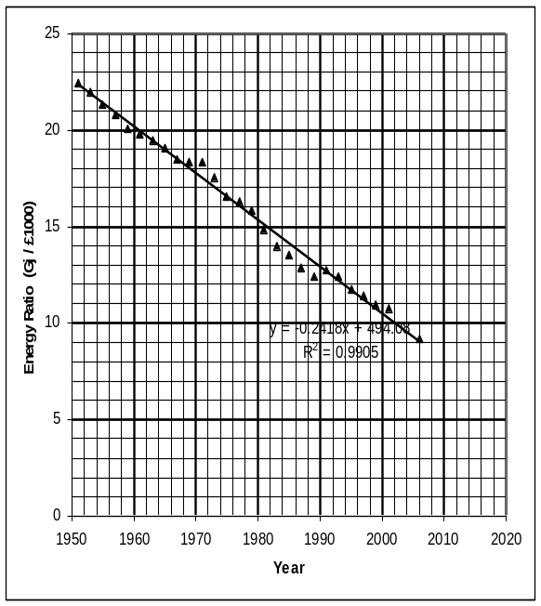YEAR | Energy (PJ) | GDP  (billion pounds 2000 value) | Energy Ratio
1951 | 6214 | 277 | 22.43
1953 | 6364 | 290 | 21.94
1955 | 6674 | 313 | 21.32
1957 | 6691 | 322 | 20.78
1959 | 6720 | 335 | 20.06
1961 | 7181 | 363 | 19.78
1963 | 7445 | 383 | 19.44
1965 | 7934 | 416 | 19.07
1967 | 8001 | 433 | 18.48
1969 | 8521 | 464 | 18.36
1971 | 8780 | 479 | 18.33
1973 | 9341 | 532 | 17.56
1975 | 8625 | 521 | 16.55
1977 | 8923 | 548 | 16.28
1979 | 9211 | 581 | 15.85
1981 | 8320 | 560 | 14.86
1983  From the 4% growth in the economy the GDP in 2006 can be estimated to be 1154.6 billion pounds and the expected energy requirement would thus be 10737 PJ. | 8269 | 592 | 13.97
1985 | 8504 | 629 | 13.52
1987 | 8793 | 683 | 12.87
1989 | 9119 | 734 | 12.42
1991 | 9270 | 730 | 12.70
1993 | 9324 | 750 | 12.43
1995 | 9467 | 807 | 11.73
1997 | 9777 | 857 | 11.41
1999 | 9877 | 901 | 10.96
2001 | 10179 | 949 | 10.73

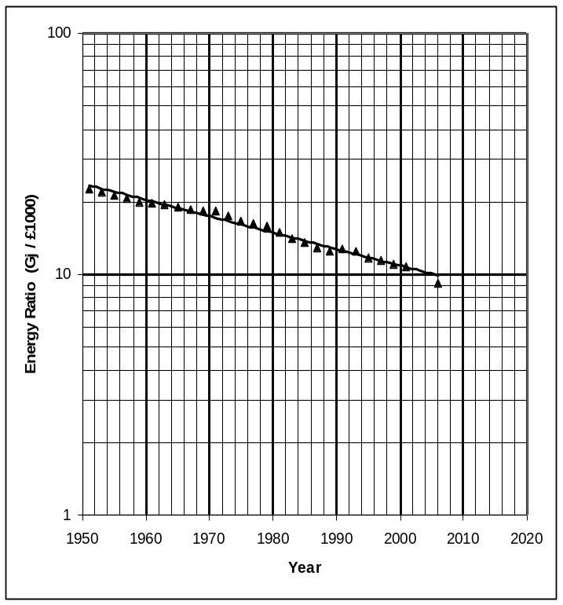
While there has been a very linear relationship with time over the last 50 years, there have been occasional blips are witnessed around 1970 (before the oil crisis) and around 1990 at the start of the recession. Clear in any one year the predictor from the past would may not have been particularly good, but overall the prediction would have been close. The problem though is that the Energy Ratio has fallen by 11 in the last fifty years, and if this relationship was indeed linear, then around 2040 – 2050 it would go negative which would give nonsensical figures. In reality, the trend should be plotted on a logarithmic scale as it is more likely to be of an exponential form. If this is done, the relationship is still very linear (in logarithmic terms) as shown in the diagram below.

In this case, the projected Energy Ratio for 2006 is likely to be closer to 9.9 giving an energy requirement of 11400 PJ

