ENV-2D02 ENERGY CONSERVATION 2006

Sections 4 – 8

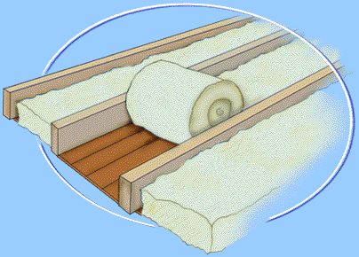
Acknowledgement: Energy Saving Trust Web Site

4) Energy Use by sector and Energy Conservation by Fuel Switching

- Energy Balance Tables

6) Heat Transfer

7) Heat Loss Calculations

8) Energy Management

CONTENTS
 | Page
4. ENERGY USE IN UK AND CONSERVATION FROM FUEL SWITCHING | 15
4.1 Summary of Consumption in UK | 15
4.2 Electricity Consumption in UK | 15
4.3 Primary Energy Ratios | 15
4.4 Useful Energy | 15
4.5 Energy Conservation by Fuel Switching | 18
5. ENERGY BALANCE TABLES | 19
5.1 Supply | 19
5.2 Demand | 20
5.3 Derived Statistics | 20
5.3.1 Efficiency of Electricity Generation | 20
5.3.2 Overall efficiency of energy conversion and transmission | 20
5.3.3 Primary Energy Ratios for Oil and Gas | 20
6. HEAT TRANSFER | 23
6.1 Definitions | 23
6.2 Conduction | 23
6.3 Radiation | 24
6.4 Convection | 25
6.5 Internal and External Surface Resistances | 25
6.6 Resistances of Air-spaces | 25
6.7 Derivation of 'U'-values for 3 types of wall | 25
6.8 Calculation of Other U - Values - and temperature distribution | 26
6.9 Problems associated with thermal bridging | 28
7. HEAT LOSS CALCULATIONS | 30
7.1 U - values | 30
7.2 Ventilation | 30
7.3 Heat Loss Calculations | 30
7.4 Notes on Sizing of Heating Appliances | 30
7.5 Annual Consumption of Energy for Heating | 30
7.5.1 Degree Day Method – Simple formula | 31
7.5.2 Degree Day Method – more exact formula | 31
7.5.3 Degree Day Tables | 31
7.5.4 Example using Degree Days | 31
7.6 Dynamic Heating | 32
7.7 Dynamic Heat Loss - a worked example. | 35
7.8 Energy issues with radiator on outside wall | 36
7.9 A Method to determine Air-exchange rate | 37
8. ENERGY MANAGEMENT | 38
8.1 Introduction | 38
8.2 Analysing Energy Demand | 38
8.3 Analysing Energy Records | 38
8.3.1 Analysis of Heating Requirements | 38
8.3.2 Degree Day Method – Case 1 | 38
8.3.3 Degree Day Method (Non-Electric Heating) | 38
8.3.4 Mean Temperature Method (non-electric Heating) | 39
8.3.5 Analysis of Lighting (Non-electrically heated) | 39
8.3.6 Analysis of Heating/Lighting in Electrically heated house | 39
8.4 Cummulative Deviation Method | 40
8.5 Advise on Energy Management | 40
8.6 Advertise Ways to Save Energy | 41
8.7 Account for Energy Use | 41
Summary of Energy Use in UK and Conservation from Fuel switching

4.1 Summary of Consumption in UK

The energy consumption may be displayed as either a per capita consumption in Watts (i.e. a rate of consuming energy) – table 4.1 , or as the total annual consumption – table 4.2.

Since 1991, the consumption in the domestic and public administration sectors has remained approximately constant (variations can be largely attributed to changes in weather). This means that though the number of houses has increased by around 1.5 million, the improved insulation standards in new houses and upgrade in older property are just keeping pace with increase in demand. Industry is continuing to become more efficient in energy terms, but transport is continuing to show an ever increasing demand.

 | 1991 | 1996 | 1998 | 2000 | 2002 | 2004
domestic | 1031 | 1093 | 1021 | 1037 | 1060 | 1078
transport | 1099 | 1196 | 1188 | 1224 | 1226 | 1271
industry | 881 | 855 | 800 | 803 | 769 | 754
Public Administration | 187 | 204 | 180 | 179 | 157 | 161
Agriculture | 30 | 33 | 30 | 27 | 27 | 20
Miscellaneous (Commercial/ Education etc.) | 259 | 276 | 266 | 271 | 256 | 278
Total consumption of delivered energy | 3487 | 3656 | 3485 | 3541 | 3495 | 3563
Conversion and distribution losses | 1592 | 1610 | 1747 | 1752 | 1701 | 1710
TOTAL ENERGY CONSUMPTION | 5079 | 5265 | 5232 | 5292 | 5196 | 5274
Non Fuel Uses | 250 | 336 | 282 | 272 | 255 | 275
TOTAL PRIMARY ENERGY | 5329 | 5601 | 5514 | 5564 | 5452 | 5549
Table 4.1. Summary of Consumption in UK - per capita consumption (Watts)

 | 1993 | 1994 | 1996 | 1998 | 2000 | 2002 | 2004
Total Industry | 1489 | 1570 | 1574 | 1443 | 1448 | 1410 | 1427
Total Transport | 2109 | 2119 | 2203 | 2248 | 2316 | 2319 | 2405
Total Domestic | 1907 | 1836 | 2013 | 1931 | 1962 | 2006 | 2040
Public Administration | 341 | 345 | 376 | 406 | 400 | 410 | 433
Commercial | 465 | 440 | 508 | 406 | 400 | 410 | 433
Miscellaneous | 465 | 440 | 508 | 57 | 51 | 50 | 39
Agriculture | 58 | 58 | 60 | 97 | 112 | 75 | 94
Total Delivered | 6367 | 6368 | 6733 | 6588 | 6690 | 6681 | 6871
UK Supply | 9846 | 10739 | 11805 | 12026 | 12088 | 11426 | 9979
Net Imports | -1354 | 11408 | -1503 | -1830 | -1936 | -1359 | 413
Stock changes | 1311 | -12382 | -15 | 0 | 118 | 56 | -42
Net Available | 9803 | 9764 | 10316 | 10196 | 10270 | 10124 | 10350
Non-Energy Use | 574 | 617 | 619 | 533 | 514 | 483 | 520
Gross Consumption | 9228 | 9147 | 9697 | 9663 | 9755 | 9641 | 9830
Losses in conversion and distribution | 2861 | 2780 | 2964 | 3140 | 3127 | 3073 | 3088
Net Consumption | 6367 | 6368 | 6733 | 6523 | 6628 | 6568 | 6742
Table 4.2 Total UK consumption in PetaJoules – figures in bold lines must be equal

4.2 Electricity use in the UK

Until 1973 there was a consistent growth of electricity demand. Then for 10 years growth was stagnant - indeed the UK had the lowest growth of electricity of any country in the period 1973 - 1986.

In the mid 1980's, growth resumed at the historic rate followed by stagnation again during the recession of the early 1990s. Since 1995 growth has resumed at almost the historic rate and is currently running at about 1.8% increase per annum.

Some points to note:
• This growth is taking place despite
i) an apparent greater awareness of energy conservation issues
ii) move to more efficient lighting etc

• Growth is partly linked to an small increae in population, but more importantly to the decline in household size leading to more dwellings.

• Though there has been a substantial increase in the deployment of renewables in the last decade, this increase is NOT keeping pace with the growth in demand.

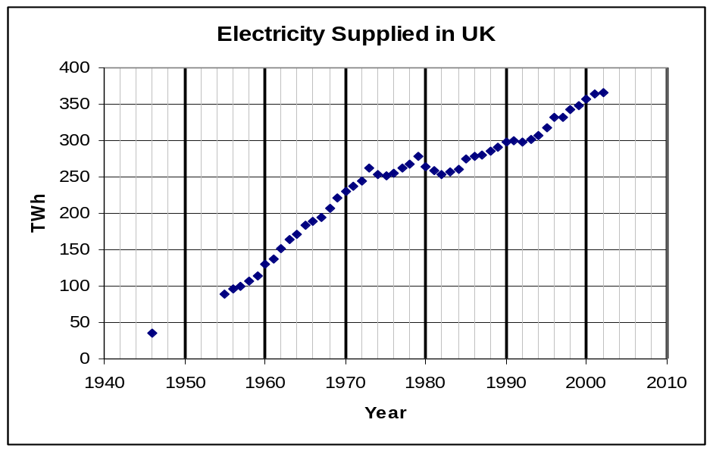Fig. 4.1 Electricity demand in UK

 | 1965 | 1973 | 1979 | 1984 | 1987 | 1991 | 1994 | 1998 | 2000 | 2002 | 2004
Solid Fuel | 1026 | 561 | 402 | 243 | 273 | 192 | 152 | 98 | 80 | 76 | 55
Gas | 197 | 508 | 867 | 942 | 1107 | 1203 | 1187 | 1281 | 1332 | 1355 | 1427
Oil | 102 | 176 | 148 | 100 | 104 | 118 | 126 | 148 | 136 | 151 | 130
Electricity | 206 | 329 | 323 | 317 | 336 | 353 | 365 | 394 | 403 | 412 | 416
Total | 1531 | 1573 | 1740 | 1602 | 1820 | 1866 | 1830 | 1922 | 1950 | 1995 | 2028
Table 4.3 ENERGY CONSUMPTION IN UK DOMESTIC SECTOR (PJ)

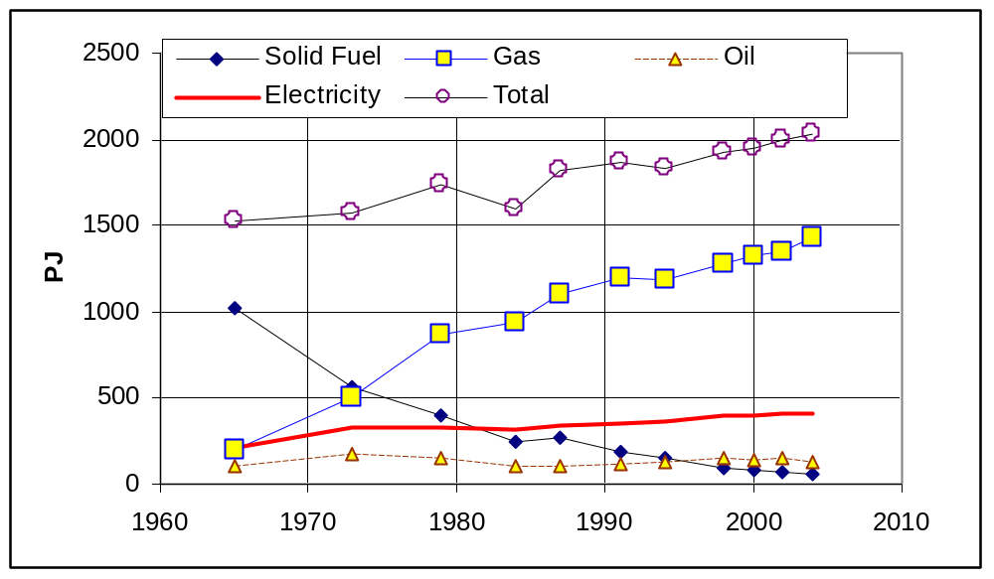

Fig. 4.2. Data from Table 4.3 plotted as a graph

Notes on Table 4.4

• Gas Appliance and Refrigeration use is small
• Figures: Estimated for Electricity use from last (pre-privatisation data from Electricity Supply Industry Statistics)
- Note: data giving a split of appliances use was not available during the 1990s. Recently data has become available from the Environmental Change Unit at Oxford but after this handout was prepared.

5GJ assumed for Electric Cooking per household and 10GJ with gas with a 50:50 split amongst 22 000 000 households.

Year 2000
 | Electricity |  | Gas |  | Oil |  | Coal
Appliances |  | 95
Lighting |  | 35
Refrigeration |  | 75
Cooking |  | 40 |  | 80
Water Heating |  | 50 |  | 200 |  | 22 |  | 13
Space Heating Normal) |  | 32
Space Heating (Off Peak) |  | 76 |  | 1052 |  | 114 |  | 67 |  | TOTAL
TOTAL |  | 403 |  | 1332 |  | 136 |  | 80 |  | 1951
Table 4.4 Distribution of Energy use in Domestic Sector (PJ)

Note: Figures are for Delivered Energy

Reliable data for split of electricity use have been generally unavailable since Privatisation of the Electricity Supply Industry in early 1990 and most electricity figures are estimates, although total electricity is correct.

4.3 Primary Energy Ratios

Gas - 1.06 (historic)
but improved to around 1.05 in last few years
Oil - 1.08
Coal - 1.02
but reduction as older inefficient pits have closed currently it is around 1.015
Electricity - varies with efficiency of generation:-

Table 4.5 Variation of Primary Energy Ratio for Electricity Generation with time.
Year | Primary Energy ratio | Year | Primary Energy ratio
1930 | 6.54 | 1991 | 3.06
1950 | 5.13 | 1994 | 2.94
1960 | 4.07 | 1998 | 2.89
1970 | 3.80 | 2000
1980 | 3.33 | 2002
1987 | 3.19
[ Note: Primary Energy Ratio does in fact vary between daytime and night-time
- most efficient stations are running at night time]

Prior to 1991, figures are for CEGB (i.e. England and Wales), from 1991 they are for whole of UK. and so figures are not entirely compatible.

There has been a significant reduction in PER arising from CCGTs coming on stream in last 7/8 years.

Total Primary Energy Requirement for Domestic Sector in 1998 was :-

electricity gas oil coal
403*2.89 + 1332*1.05 + 136*1.08 + 80*1.02

= 2796 PJ compared to 1951PJ actual demand - an overall - PER of 1.43
==========
This figure of 1.43 has remained constant since 1994

4.4 Useful Energy (Domestic Sector using 2000 data ):-

Assumptions:-
• Off Electric Heating (90% efficient because it does not respond directly to temperature.)
• 75% for gas central heating (allowing for some condensing boilers and older appliances at 60+%)
• 65% for oil
• 40% for coal

NOTE: Electricity use for Appliances/ Lighting/ Refrigeration is treated as 100% efficient in this exercise.

 |  | Useful Energy (PJ)
off-peak electricity | 0.9 * 76 | 68
remaining electricity | 1.0 * 327 | 327
Gas Cooking (50% efficient) | 0.5 * 80 | 40
Gas Water and Space Heating | 0.75 * 1201 | 939
Oil | 0.65 * 148 | 88
Coal | 0.40 * 94 | 32
TOTAL |  | 1495

This represents an increase of around 150 PJ since 1991

The reasons for this increase despite improvements in insulation are:-
• continuing reduction in household size leading to more dwellings
• increased use of appliances and particularly refrigeration and computers
• increased use of decorative lighting offsetting improvements arising from low energy lighting

2796 -------------> 1951 ----------> 1495
Primary Delivered Useful

Situation is even more dramatic if appliance inefficiencies are considered. For instance, all energy in a computer ends up as heat.

Overall only just over 50% of energy extracted is actually useful

4.5 Energy Conservation by Fuel Switching

Consider the replacement of all heating by most efficient means available (i.e. condensing Gas Boilers). We shall exclude appliances. [Data taken from Table 4.4].

All figures in PJ (include water heating)
Current Heating Method | Existing Delivered Energy | Useful Energy | Energy Required with Gas Condensing Boiler
Electricity Full Rate) | 32+52 | 84 | 93
Electricity (Off Peak) | 76 | 68 | 76
Gas | 1252 | 939 | 1043
Oil | 136 | 88 | 98
Coal | 80 | 32 | 36
 |  | TOTAL | 1346

Thus we would need 1346PJ of delivered energy in the form of Gas to satisfy our current low temperature heat demand – i.e. excluding appliance/refrigeration and cooking.

The Total low temperature demand at present i.e. hot water and space heating is 1628 PJ

So saving by fuel switching in terms of current
Delivered Energy is 1628 - 1346 = 282PJ or 17.3%
=====
New Primary Energy requirement would be

1346*1.05 + 80*1.06 + 245 *2.90 = 2207 PJ

[the 245 comes from the residual electricity demand for appliances/refrigeration/cooking]

i.e. no coal or oil, and electricity used only for appliances, lighting refrigeration and cooking

so saving in Primary Energy Terms is 598 PJ or 21%
==================

5. ENERGY BALANCE TABLES

There are two different areas to tackle with respect to Energy Conservation:-

1) The losses in conversion to and distribution of secondary fuels
2) The waste in converting energy into the form we want

- Energy Balance Tables allow us to estimate the magnitude of the former waste

- Energy Balance Tables are constructed to show the energy flows within a country. They provide a useful summary on a year basis to assess where energy losses are occurring.

- Energy Balance Tables are best constructed on a HEAT SUPPLIED BASIS (UK used to use Millions of Therms which was fairly accurate, but now uses MTOE which other countries use MTCE etc. The problem with this is that the actual values depend on the calorific values used. In the UK 1 tonne of oil is assumed to have an energy value of 41.87 GJ

When comparing one country with another:-

♦ CHECK the calorific value of fuel if MTOE or MTCE
♦ Check whether higher or lower CV is used. (UK
Energy Statistics now use Higher value)

- Primary Electricity (hydro, nuclear, renewable) creates a problem with convention. It is generally agreed that these should be treated as though electricity had been generated in a fossil-fired thermal station. The same applies in the UK's case to imports of Electricity from France.

♦ All energy extracted in primary form is +ve
♦ All energy imports are +ve
♦ All energy exports are -ve

Energy Balance Tables in recent years have been condensed into Aggregate form, which reduces space taken up, but removes distinctions between aspects such as motor spirit and diesel and fuel oil, instead lumping them all under Petroleum Products. Similarly processed solid fuels are mostly aggregated. The following explanation refers to the latest data available and is derived from the Aggregated Table 1.1 in DUKES (2001) which gives data for 2000. The data have been converted from the original units of Thousand Tonnes of Oil Equivalent into PJ.:-

Nuclear and large scale hydro are classed as primary electricity

5.1. Supply

- Line A is total supply allowing for extraction, imports, exports and stock changes. The Statistical Differences refer to the differences between the Primary Supply and Primary Demand. the reason for the differences are many fold, but include rounding errors from the many suppliers, differences in accounting periods etc.

The figure of 10220 PJ, or more correctly 10..22 EJ, is the annual UK consumption of Energy and represents an increase 4% from 9.75 EJ since 1991. A small amount of energy in the form of oil/gas is use as chemical feed stocks as shown in line K, and thus the true Energy use in the UK is 10.220 - 0.513 = 9.707EJ – a 1.29% rise since 1998..

- Line B refers to transfer and arises partly because of the aggregation of data to simplify the table. It mostly represents reclassification between the raw suppliers and the energy conversion industries. For instance some gas under pressure at the well head would be in liquid form, but at lower pressure at use would be as gas. Equally, some gas is pressurised before pumping and is received in liquid form.

- Line C indicates the energy consumed (-ve numbers) or produced in (+ve numbers) in the Energy Conversion Industries. Thus of a Primary Demand of 1594 PJ of coal 1484 PJ were directly used in producing secondary fuels such as electricity, coke etc. Similarly 4025 PJ of crude oil was converted in refineries while 3903 PJ of petroleum products were produced. 1126 PJ of gas and 72PJ of renewables (mostly as waste/biomass) were used in conversions. Finally, the whole of the residual primary electricity 822 PJ (nuclear) is converted at this stage and was used in conversion. The 2177 PJ in the final column is significant as this, being negative represents the losses incurred in converting energy.

- The lines shown by a * beneath line C show the distribution of each fuel for conversion. Thus of the 1484 PJ of coal, 1197 PJ went to the Power Stations, while 257 PJ went to coke manufacture for the Iron and Steel Industry. Equality all the crude oil went to the refineries, while all the natural gas used in conversion went to the Power Stations. The figure of 1126 PJ represent an increase from just 49PJ in 1991 i.e. a 23 fold times increase in just 9 years and reflects the so-called dash for gas. Row C is in fact the sum of the values in the * rows.

The line "Major Power Producers" refers not only to the established names such as PowerGen and National Power, but also the Independents such as Lakeland Power etc. The Autogenerators refer to generators who produce electricity for their own use - such as UEA.

- The previous section refers to the actual energy use in the conversion process - e.g. the thermodynamic conversion in the case of electricity. It does not reflect the energy use by the supply industries. Row D shows the amounts of energy used in these industries. For instance electricity is used in power station to drive pumps, grind coal, while electricity is also used in coal mine to cut coal. The aggregate amounts of each fuel used by the energy supply industries is shown in Row D.

Thus electricity generation consumes 59 PJ in station use, while the refineries use 15 PJ of crude oil, 236 PJ of gas and 2 PJ of electricity.

- Line E refers to the transmission losses between the power station and the consumer in the case of electricity or the use of gas and leakages in the case of gas distribution.

Examples of losses in supply and distribution of Gas

1) Compression of gas for storage
2) Liquefaction of gas for storage
3) heating of gas on expansion
4) Pumping

- Line F is the net amount of energy available to the consumer.

Line F = Line A + Line B + Line C - Line D - Line E

This represents the main energy balance

Below Line F the table changes from the Supply and Conversion side to the demand sectors

5.2 Demand

- Line G shows the total amount of each fuel used by industry for each fuel type, while below that line the figures are disaggregated into the separate industrial sectors.

- Line H relates to transport, and once again, this section is also disaggregated.

- Line I shows the aggregated Delivered Energy to all other sectors with a split between the different sectors in the following Rows

Line J shows the total amount of energy actually delivered for use while, as indicated above, Line K represents the Non-Energy uses.

5.3 Derived Statistics

The above raw table provides the raw statistics from which many parameters can be obtained.

We must however remember the implied definition of Primary Electricity which applies to all forms of electricity generated other than in waste or fossil fuel powered thermal stations. The terms includes renewables like hydro, wind, and also nuclear. In the tables, the figures entered in the supply sections are the equivalent thermal input i.e. the figures represent those that would have been required had the energy been produced by normal thermal generation. These thus represent grossly inflated figures of the electricity actually generated by these means.

5.3.1. Efficiency of Electricity Conversion

We need to first evaluate the efficiency of electricity conversion, and this may be done by looking at the two shaded figures in the * line below line C. These indicate that a total of 1318 PJ of electricity were generated, while losses amounted to 1981 PJ.

Thus the efficiency of conversion = 1318 / ( 1318 + 1981) * 100 = 39.95%

It represents a significant improvement over the 34.9% in 1991 and an improvement from 39.3% in 1998. The improvement arises almost entirely from the move away from coal to gas.

We can estimate thus estimate the true amount of electricity generated as primary electricity as

844 * 0.3895 or about 337 PJ representing 26% of total supply - hydro and wind represent about 2% of this. This figure of 26% represents a fall from 30% in 1998 due largely to reduced output from the nuclear stations.

We note that we have 1318 PJ of electricity generated
However we also note that 59 PJ (column 9 in line below line D) are used in the stations themselves.

This represent a station use of 59/1318 * 100 = 4.5%

Finally we note that losses in electricity transmission amount to 107 PJ and so we can estimate transmission losses as 107 / (1318-59) * 100 = 8.5%

5.3.2. Overall efficiency of energy conversion and transmission

This may be deduce from the Overall Supply at 10220PJ and the net available at 7214PJ PJ i.e there is a (10220-7214)/10220*100 = 29.4% loss in energy

Much of the losses here could be utilised in Combined Heat and Power.

5.3.3 Primary Energy Ratios for Oil and Gas

Approximate values for the Primary Energy Ratio for Oil, Gas and Coal may be obtained from an Energy Balance Table.

Thus in oil and gas extraction 15+236 = 251 PJ of crude oil and gas are consumed. In addition, 2 PJ of electricity are used, but since the primary energy ratio of electricity is 2.9, this in reality represents 5.8 PJ. [in actual practice we don’t know that 2.9 is the value and we should estimate the primary energy ratio for electricity first]. also, strictly speaking we should also apply the Primary energy ratio to Oil and Gas, but at this stage we do not know the values. In any case, the errors in these figures will be relatively small. Ideally we would estimate the PER by this method and then iterate to obtain more accurate values

Overall this represents 257 PJ.

Assuming that half of this is attributed to oil – i.e. 129 PJ

In the Oil Refineries we use 223 + 19 PJ of oil and gas respectively and 18 = 18 *2.9 = 52 PJ gross of electricity - giving a grand total of 294 PJ or an overall total of

294 + 129 PJ = 423 PJ and noting the total indigenous production is = 5790 PJ (top line), this represents 7.4% corresponding to a Primary Energy Ratio of 1.074 – an improvement on the 1.079 in 1998.

While this is an approximate value it does demonstrate how such figures are derived. For a more detailed analysis it is necessary to consult more detailed tables in DUKES.

As an exercise you are encouraged to try to determine the PER for electricity in 2002 and also the overall PER for 2002 (see section 3.2 for 1998 values).

Simplified Aggregate Energy Balance 2000 - derived from Table 1.1 of DUKES (2001)
annotated for use by ENV-2D02 |  |  |  |  | See Notes in section 5 of Handouts |  |  |  |  |  |  | PJ
 |  |  | Coal | Manufactured fuel (1) |  | Primary oils | Petroleum products | Natural gas (2) | Renewable & waste (3) | Primary electricity | Elect-ricity | Total
UK Production |  |  | 819 | - |  | 5790 | - | 4533 | 104 | 844 | - | 12089
Net imports |  |  | 775 | 0 |  | -1741 | -436 | -514 | - | - | 47 | -1869
Net Energy Available |  |  | 1594 | - |  | 4049 | -436 | 4019 | 104 | 844 | 47 | 10220
Transfers |  |  | - | 5 |  | -8 | 13 | -2 | - | -22 | 22 | 8 | a
Net Consumption |  |  | 1594 | 5 |  | 4040 | -423 | 4017 | 104 | 822 | 69 | 10228 | A*
Energy Conversion
 | inputs |  | -1484 |  |  | -4025 |  | -1126 | -72 | -822 |  |  | C
 | outputs |  |  | 131 |  |  | 3903 |  |  |  | 1318 |  | C
 | balance |  |  |  |  |  |  |  |  |  |  | -2177 | C
Energy Industry use |  |  | 0 | 47 |  | 15 | 230 | 290 | - | - | 96 | 679 | D
 | transmission |  | - | 7 |  | - | - | 45 | - | - | 107 | 158 | E
Delivered Energy Available |  |  | 109 | 82 |  | 0 | 3249 | 2557 | 32 | - | 1184 | 7214 | F | A* + C - D - E
INDUSTRY |  |  | 39 | 62 |  | - | 267 | 722 | 15 | - | 409 | 1515 | G
TRANSPORT |  |  | - | - |  | - | 2280 | - | - | - | 32 | 2311 | H
OTHER |  |  | 70 | 20 |  | - | 237 | 1788 | 17 | - | 744 | 2875 | I
Final Consumption Energy only |  |  | 109 | 82 |  | 0 | 2783 | 2511 | 32 | 0 | 1184 | 6702 | J | G + H + I
Non-Energy use |  |  | - | - |  | - | 466 | 47 | - | - | - | 513 | K | F - J

Aggregate Energy Balance 2000 - derived from Table 1.1 of DUKES (2001)
annotated for use by ENV-2D02 - See Notes in section 5 of Handouts PJ
 | Coal | Manufactured fuel (1) | Primary oils | Petroleum products | Natural gas (2) | Renewable & waste (3) | Primary electricity | Electricity | Total
Energy Supply
Indigenous production | 819 | - | 5790 | - | 4533 | 104 | 844 | - | 12089
Imports | 659 | 15 | 2485 | 650 | 94 | - | - | 52 | 3953
Exports | -21 | -13 | -4253 | -937 | -527 | - | - | -1 | -5752
Marine bunkers | - | - | - | -92 | - | - | - | - | -92
Stock change (4) | 140 | -10 | 50 | -16 | -34 | - | - | - | 130
Primary supply | 1596 | -8 | 4071 | -396 | 4066 | 104 | 844 | 51 | 10328
Statistical difference (5) | 2 | -8 | 23 | 40 | 47 | - | - | 4 | 108
Primary demand | 1594 | 0 | 4049 | -436 | 4019 | 104 | 844 | 47 | 10220 | A
Transfers | - | 5 | -8 | 13 | -2 | - | -22 | 22 | 8 | B
Energy Conversion | -1484 | 131 | -4025 | 3903 | -1126 | -72 | -822 | 1318 | -2177 | C
Electricity Generation | -1197 | -38 | - | -45 | -1126 | -72 | -822 | 1318 | -1981 | *
Major Power Stations | -1162 | - | - | -18 | -1022 | -9 | -822 | 1205 | -1827
Autogenerators | -35 | -38 | - | -27 | -104 | -62 | - | 113 | -154
Refineries | - | - | -4025 | 3956 | - | 0 | - | - | -69 | *
Coke Manufacture | -257 | 236 | - | - | - | - | - | - | -21 | *
Blast Furnaces | -14 | -83 | - | -8 | - | - | - | - | -106 | *
Patent Fuels | -16 | 17 | - | - | - | - | - | - | 1 | *
Energy Industry Use
TOTALS | 0 | 47 | 15 | 230 | 290 | - | - | 96 | 679 | D
Electricty Generation | - | - | - | - | - | - | - | 59 | 59 | +
Oil and Gas Extraction | - | - | 15 | - | 236 | - | - | 2 | 253 | +
Refineries | - | - | - | 223 | 19 | - | - | 18 | 261 | +
Coal Extraction | 0 | - | - | - | 1 | - | - | 5 | 6 | +
Coke Manufacture | - | 24 | - | - | 0 | - | - | - | 24 | +
Blast Furnaces | - | 22 | - | 5 | 3 | - | - | 3 | 33 | +
Patent Fuels | - | 1 | - | - | - | - | - | - | 1 | +
Pumped Storage | - | - | - | - | - | - | - | 3 | 3 | +
Other | - | - | - | 2 | 31 | - | - | 7 | 39 | +
Losses | - | 7 | - | - | 45 | - | - | 107 | 158 | E
Energy Available for Consumption | 109 | 82 | - | 3249 | 2557 | 32 | - | 1184 | 7214 | F
INDUSTRY | 39 | 62 | - | 267 | 722 | 15 | - | 409 | 1515 | G
Unclassified | - | 11 | - | 97 | 0 | 15 | - | - | 124
Iron and Steel | 0 | 47 | - | 6 | 77 | - | - | 36 | 165
Non-ferrous metals | 3 | 5 | - | 2 | 21 | - | - | 21 | 52
Mineral Products | 8 | - | - | 11 | 55 | - | - | 27 | 100
Chemicals | 12 | - | - | 16 | 206 | - | - | 82 | 316
Mechanical Engineer | 0 | - | - | 9 | 39 | - | - | 33 | 81
Electrical Engineering | 0 | - | - | 2 | 15 | - | - | 22 | 40
Vehicles | 2 | - | - | 6 | 40 | - | - | 20 | 69
Food and Beverages | 6 | - | - | 13 | 115 | - | - | 45 | 179
Textiles, leather | 2 | - | - | 6 | 27 | - | - | 14 | 49
Paper, printing | 3 | - | - | 3 | 63 | - | - | 41 | 110
Other | 4 | - | - | 76 | 56 | - | - | 63 | 199
Construction | - | - | - | 20 | 8 | - | - | 6 | 33
Transport | - | - | - | 2280 | - | - | - | 32 | 2311 | H
Air | - | - | - | 497 | - | - | - | - | 497
Rail | - | - | - | 20 | - | - | - | - | 20
Road | - | - | - | 1720 | - | - | - | - | 1720
Inland Navigation | - | - | - | 43 | - | - | - | - | 43
Other | 70 | 20 | - | 237 | 1788 | 17 | - | 744 | 2875 | I
Domestic | 61 | 20 | - | 136 | 1332 | 10 | - | 403 | 1961
Public administration | 8 | - | - | 48 | 196 | 3 | - | 82 | 337
Commercial | - | - | - | 21 | 157 | - | - | 246 | 423
Agriculture | 0 | - | - | 27 | 5 | 3 | - | 14 | 49
Miscellaneous | 0 | - | - | 6 | 98 | 1 | - | - | 105
Final Consumption Energy only | 109 | 82 | - | 2783 | 2511 | 32 | - | 1184 | 6702 | J
Non-Energy Use | - | - | - | 466 | 47 | - | - | - | 513 | K
Calorific Value used | 1 tonne of oil equivalent = |  | 41.87 | GJ

HEAT TRANSFER - Part 1

  - Definitions

SPECIFIC HEAT:- Quantity of ENERGY required to raise temperature of unit mass by 1 Kelvin. (Temperature Scale (K) - absolute zero at - 273.18oC).

THERMAL CAPACITY:- Quantity of ENERGY required to heat a whole body by 1 K.

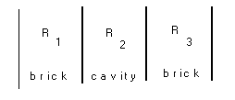THERMAL CONDUCTIVITY:- a measurement of heat flow through a body. It is the heat transmitted in unit time, across a unit temperature difference, per unit distance.

UNITS:- Wm-3oC-1 or Wm-3K-1
(analogous to electrical conductivity or hydraulic permeability).

THERMAL RESISTIVITY:- reciprocal of conductivity.

THERMAL RESISTANCE:- takes into account resistivity and geometry of the system.

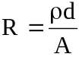
where R is the resistance
d is the thickness
A is the area
ρ is the resistivity

often we use the UNIT AREA THERMAL RESISTANCE - i.e. the thickness is included but not the area.

UNIT AREA THERMAL CONDUCTANCE or 'U' - Value is the reciprocal of UNIT AREA THERMAL RESISTANCE.

6.2 Conduction
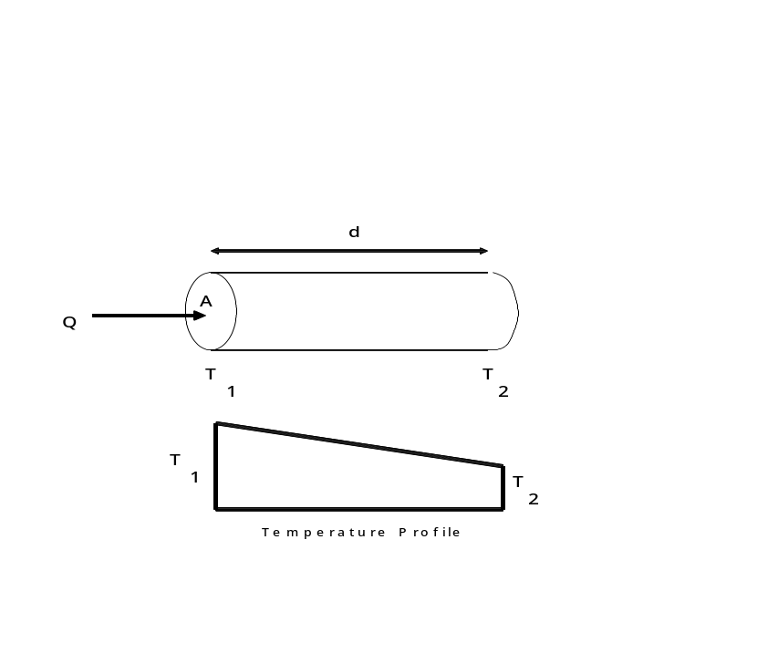
Fig, 6.1 sumulation of conductive Heat flow

- the larger A is, the larger will be the heat flow.
- the larger d is, the smaller will be the heat flow.

Heat Flow, 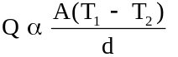

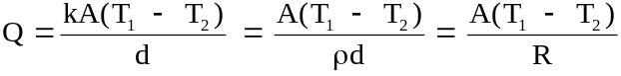
Direct analogy with electricity:-

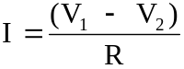 where I is the electric current and V is the voltage.

Water flow through soils is yet another analogy.

----------------------------------------------------------------------
In most situations we have composite materials to deal with - e.g. a wall consisting of an outer skin, a cavity, an inner skin, and then plaster as a minimum.
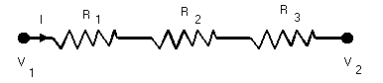Fig. 6.2 Simulation of simple brick

Total UNIT AREA THERMAL RESISTANCE is given by:-

R = R1 + R2 + R3 + ........ i.e. resistances in series

Electrical Analogue

Fig. 6.3 Electrical Analagoue of series heat flow

Current (I) is equivalent to Heat Flow,

Potential Difference (V1 - V2) or voltage is equivalent to temperature difference

Components in Parallel:
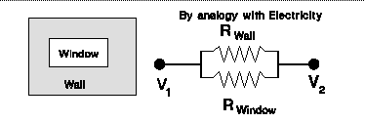Fig. 6.4 Components is parallel

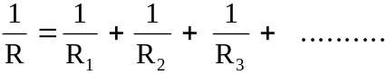

U - value is 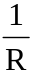 where R is resistance per unit area

Simple Example:-

Brick wall 105 mm thick
plaster 15 mm thick on inside

Internal temperature = 20oC
External Temperature= 0oC

kbrick = 0.84 W m-3 K -1
kplaster = 0.50 W m-3 K -1

What is the U - value of the construction and also the temperature at the interface between the brick and the plaster?

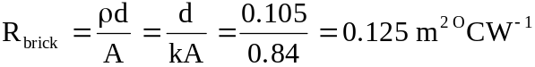

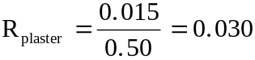

Total resistance = 0.125 + 0.030 = 0.155 m2 oC W-1

and U-value = 1/0.155 = 6.45 W m-2 oC-1
==============

Heat flow per square metre = 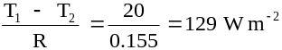

Now heat flow in plaster = heat flow in brick

So if Tbp is temperature at interface

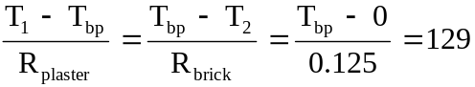

Hence Tbp = 129 * 0.125 = 16 . 1oC
=========
We need to be able to evaluate temperatures like these particularly when we wish to estimate the surface temperatures of components (e.g. for thermal comfort)
-----------------------------------------------------------
Surface Resistance

Simple example does not allow for radiation and convection across a boundary layer of air on both surfaces of wall/window etc.

This boundary layer, while involving complex radiative and convective losses, may be approximated in most situations involving heat loss from a building to an additional effective resistance of both layers.
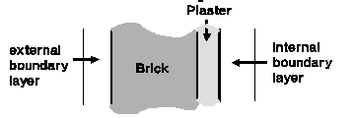Fig. 6.5 Inclusion of internal and External Surface resistances
This boundary layer, while involving complex radiative and convective losses, may be approximated in most situations involving heat loss from a building to an additional effective resistance of both layers.

The Internal Surface of EXTERNAL walls/windows below room temperature.
The external surface is above the external temperature

The internal surface temperature plays an important part in determining thermal environment comfort levels. The external surface temperature is important in poor quality bricks in determining how well they stand up to weathering.

6.3 Radiation

Heat lost by radiation (qr) obeys the Stefan-Boltzmann Law -
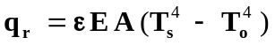
where ε = Stefan-Boltzmann constant

= 5.7 x 10-8 W m-2 K-1

E = emissivity of the object (see below)
A = surface area of object

Ts and To are temperatures of two objects - in the case of heat loss calculations
Ts = temperature of surface, and To = temperature of ambient air.

Note Ts and To are in degrees absolute (Kelvin).

Emissivity is defined as the ratio of the radiation from unit area of the surface to the radiation from unit area of a full black body radiator at the same temperature. For most building materials E ~ 0.9.

The above equation may be written as

For most of the situations with which we shall be concerned qs and qo will differ by less than 10oK. For such differences, the term (qs- qo) will have significantly more effect on qr than the remaining terms, and we can take the term:-
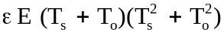 = f

to be a constant (f) so that the equation is written as
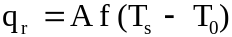
___________________________

Let us examine the values fr may take:

For Ts = 278, To = 277K, E = 0.9 fr = 4.38 Wm-2K-4

Ts = 297K, To = 277K, E = 0.9 fr = 4.86 Wm-2K-4
i.e. fr does not change much for a substantial change in temperature.
fr is normally taken to be 4.5 - 4.6 for E = 0.9.

Radiative Heat flow is more complex that conductive heat flow, but we can make the approximation (see box above)
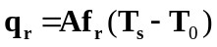
Note:
- The reason for this approximation is to make radiant heat flow approximately equal to temperature difference (as conductive heat flow is). Calculations are simplified considerably if this transformation is employed.
- For aluminium foil, emissivity = 0.05 and fr : 0.5 Wm-2K-4. iii)

6.4 Convection

6.4.1 Free Convection

Heat loss from a plane surface is given by:-

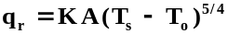
where K is the coefficient of free convection and depends on roughness of surface and orientation.

Horizontal surface facing up K = 2.6
horizontal surface facing down K = 1.3
vertical surface K = 2.0
putting equation in a similar form to that for radiation

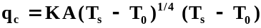

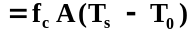

where 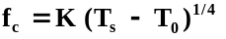 and is assumed to be constant over range of interest.

For Ts - To = 5, K = 2.0, fc = 3.0
Ts - To = 10, K = 2.0, fc = 3.6
fc is normally taken to be about 3.4 W m-2K-1

6.4.2 forced convection

various empirical formulae have been proposed, e.g.

fc = 5.7 + 4.1v for v , 5 ms-1
fc = 7.8v0.8 for V > 5 ms-1

6.5 Internal and External Surface Resitances

From sections 6.3 and 6.4.1 above, convective and radiative heat losses can be added to determine total heat loss,

i.e. q = qr + qc = frA (T1 - T2 ) + fcA (T1 - T2)

= f A (T1 - T2) where f = fr + fc and is equivalent to a thermal conductance.

We may therefore speak of a surface resistance
1
Rs = --- = 1/ (Fr + fc)
f
but its actual value will depend on exposure (i.e. wind velocity etc.).

Typical values for surface resistances are:-

Rint = 0.123 for vertical internal surfaces
0.11 for upward flow through floors/roof
0.15 for downward flow through floors

Rext = 0.08 sheltered
0.06 normal
0.03 severe
Note:
the orientation of windows is important in heat loss calculations as the external resistance is a significant proportion of the total resistance,

the effect of exposure/orientation of walls on overall heat loss is very small as external resistance is usually less than 10% of total resistance.

6.6 Resistances of Air-spaces

- thermal conductivity of air-spaces is very small, and heat transfer is mostly by radiation and convection,

- values are given in tables, but can be divided generally into two categories:-

- unventilated air spaces (or low ventilation) - resistance is about 0.18

examples are:- air-space in modern cavity walls,
air-space in double glazing
air-space between ceiling and underside of felt (post-war 2 houses),
- ventilated air spaces for which the resistance is about 0.12.
This category includes:- older cavity walls and air-space between ceiling and underside of tiles (pre--war 2 houses).

6.7 Derivation of 'U'-values for 3 types of wall

For most standard types of wall construction, there are tables giving the appropriate U-value. However, any non-standard walls including those with cavity insulation will require the U-value to be derived from first principles.

Example 1

The resistance to heat flow in this case arises from 6 components:-

1) external surface layer
2) outer brick layer
3) cavity
4) inner brick layer
5) plaster
6) internal surface layer

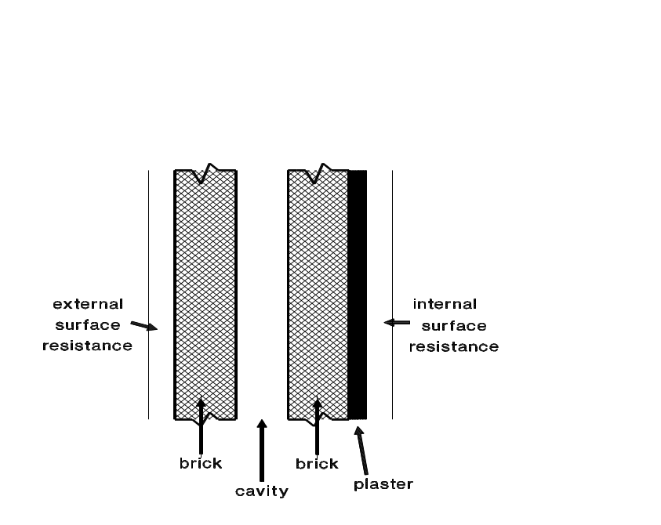 Fig. 6.6 Heat flow a wall of 1950's construction

conductivity of brick = 1.0 Wm-1 oC-1

conductivity of plaster = 0.7 Wm-1 oC-1

New resistance = 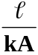

where k = conductivity
l = length of heat flow paths (thickness in this case)
A = cross section Area (which we take as 1m2)

So resistance of brick = 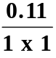 = 0.11 m2 oC W-1

resistance of plaster = 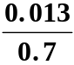 = 0.02 m2 oC W-1

Now effective resistances of air spaces are:-

internal boundary 0.123 m2 oC W-1
external boundary 0.055 m2 oC W-1
air-cavity 0.18 m2 oC W-1

So total resistance

= 0.055 + 0.11 + 0.18 + 0.11 + 0.02 + 0.123

= 0.598 m2 oC W-1
==================
and since U = 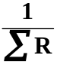 , U = 1.67 W m-2 oC -1

[Note: that the external resistance is relatively small, and thus the U value for walls varies little with exposure normally only a few per cent at most].

Example 2

As example 1 except that the inner brick leaf is replaced by an aerated block wall i.e. construction used from mid-1960's.

conductivity for aerated block = 0.14 Wm-1 oC-1

and resistance of such a block = 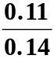 = 0.76 m oC W-1

and since this replaces the inner brick of 0.11 m2 oC W-1 of the original wall, the new resistance

= 0.598 + 0.76 - 0.11

= 1.248 m2 oC W-1

so U-value = = 0.80 Wm-1 oC-1

i.e. this is half the value of example 1 and represents a 50% saving in the heat lost through the walls of a house.

Example 3

- As example 2 except that cavity is filled with insulation
- As example 2 except that cavity is filled with polystyrene
- conductivity of polystyrene = 0.04 Wm-1 oC-1
- resistance of cavity fill = 0.05 /0.04 = 1.25 m2 oC W-1

and this replaces the resistance of 0.18 from the air-cavity

Thus the new resistance = 1.248 - 0.18 + 1.25

= 2.318 m2 oC W-1

and U-value = = 0.43 Wm-2 oC-1

i.e. this is approximately half of the value in example 2 and one quarter of the value in example 1.
[the U-value for a wall with two brick leaves and cavity insulation is 0.60 Wm-2 oC-1. Thus the reduction from cavity insulation is much more noticeable for this type of wall].

6.8 Calculation of Other U - Values - and temperature distribution

Example 4

Single glazing

conductivity of glass = 1 Wm-1 0C-1

i.e. resistance = 0.003 m2 oC W-1

internal surface resistance = 0.123

external surface resistance = 0.055

Thus total resistance = 0.123 + 0.003 + 0.055

= 0.181 m2 oC W-1

and U-value = 5.5 Wm-2 oC-1

Note

- that the resistance of glass makes very little contribution to the overall resistance

- that if the external resistance changes then the U-value will also be affected significantly. Thus as the external boundary layer varies significantly with wind speed and orientation, the U-value will also be affected. [Compare this with the situation for the walls (see note to example 1)].

Example 5 [ for you to in your own time].
What is the temperature distribution across the cavity wall shown in Fig. 6.6 if the thermal properties of the components of the wall are as follows?:

External leaf is brick k1 = 1.00 Wm-1oC-1
Inner Leaf is aerated block k2 = 0.14 Wm-1oC-1
plaster k3 = 0.7 Wm-1oC-1
expanded polystyrene k 4 = 0.04 Wm-1o

internal surface resistance = RINT = 0.123 m2 oCW-1
external surface resistance = REXT = 0.08m2 oCW-1
air space resistance = Ra = 0.18m2oCW-1
(cavity)

A knowledge of the temperature distribution can be important as if some components (e.g. windows) have their insulation performance improved, it can cause condensation elsewhere. Equally, over insulation of the loft space by placing fibre-glass between the joist can lead to freeze of the water tanks in the loft space when previously this was not a problem.

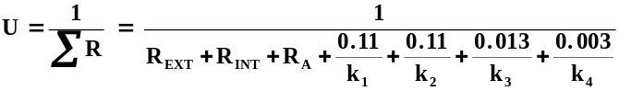

Total heat flow q = U(T2 - T1) = 20 x 0.73 = 14.6 Wm-2
=======
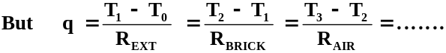

Hence T1 = q REXT + T0 = 1.17 oC

and T2 = q R brick + q1 = 1.17 + 1.60 = 2.77 oC

similarly T3 = 5.40 oC
T4 = 16.87 oC
T5 = 17.14 oC
T6 = 18.24 oC
T7 = 20.00 oC

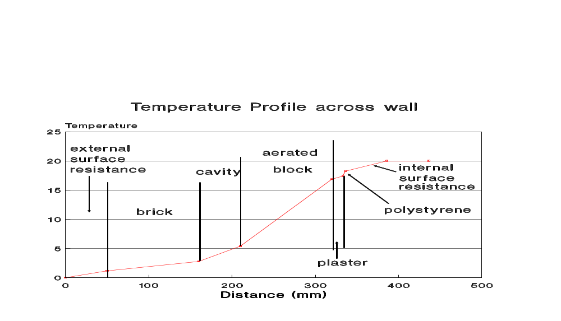
Fig. 6.7 Temperature profile through wall in example 5

Note:
- the greatest temperature gradient occurs in the thin layer of polystyrene, but the greatest temperature change across a single component is across the aerated block.

- the internal surface temperature which affects thermal comfort is 1.76oC below air temperature.

- the external surface temperature is 1.170C. If this falls below 00C, and the components are of poor quality, then ice formation may cause brick to deteriorate.
Example 6 [Another example for you – we shall be doing this on Field Course]
Pitched roof - estimation of U- Value

ceiling - plasterboard (+ loft insulation)
roof - tiles lined with felt on battens
Component | Resistance ( m2 oC W -1)
internal surface resistance | 0.11
plasterboard | 0.06
fibre glass (25mm) | 0.72
fibre glass (50mm) | 1.43
fibre glass (100mm) | 2.86
fibre glass (150mm) | 4.29
air-space to underside of felt | 0.18
felt (4mm) | 0.11
air-space between felt and tiles | 0.12
tiles | 0.04
external surface resistance) | 0.04

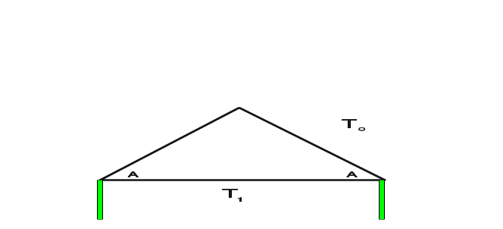

Fig. 6.8 Heat flows through a pitched roof

1
U = --------------------------------------------------------------------
(internal resistance+resistance of plasterboard and insulation)+
(resistance of air space) + RcosA

where R = resistance of felt+felt-tileairspace+external resistance,
and A = the slope angle which is required as the area of sloping parts is increased by 1/cosA and hence the resistance is reduced to RcosA.

For a 45o slope and no loft insulation,
1
Hence U = ------------------------------------------------------------
( 0.06+0.11+0 ) + 0.18 + 0.12+0.11+0.04+0.04]cos45

1
= ------------------------------------------------------------
0.57 + resistance of insulation

For no insulation 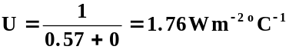
For 25mm insulation 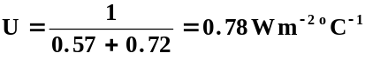
For 50mm insulation 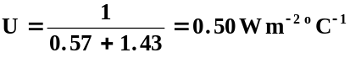
For 100mm insulation 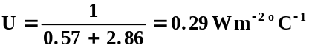
For 150mm insulation 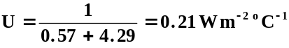

Notice that there is a quick way to estimate improvements in a roof. One only has to evaluate the instrinsic resistance (in this case the figure 0.57) as this remains constant no matter what the insulation level is.

Hence the reductions in the heat flow through the roof in the four cases are 56%, 74%, 85%, and 88% respectively. Note: in older properties, there is no felt on batten lining, and in this case U may be as high as 2.98 Wm-2oC-1 if no insulation is present.

Example 7 Double Glazing
 | m2 0C W -1
3mm single pane - resistance | 0.003
4mm single pane - resistance | 0.004
internal surface resistance | 0.123
external surface resistance | 0.055
air-space resistance | 0.18

U values 3mm glass = 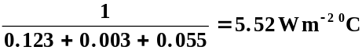
4mm glass = 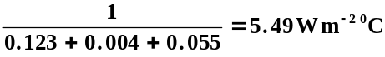

i.e. there is little difference irrespective of what thickness of glass is used. The U-value is entirely dependant on the internal and external surface resistances. The latter varies significantly with exposure and hence the U-value also varies (unlike that of walls).

Double glazing: U value (3mm glass) = 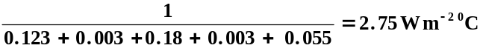

Note the U value does depend on the thickness of the air-space, which is optimum at about 18-20mm.

6.9 Problems associated with thermal bridging

While the U-Value for any construction type may be computed, things are often a little more complex. For instance around windows and doors, if it not possible to have the full cavity insulation in a wall. The building regulations give information on ways to minimise the problem.

Whenever bridging is present, this can lead to cold spots on the internal surfaces leading to condensation, and ultimately a discolouration where the presence of bridges can be seen. A thermal imaging camera can be used to identify such bridges, but these are often expensive.

In traditional UK houses the normal way of adding insulation in the loft is to put fibre glass between the joists. As the thickness of insulation has increased problems of thermal bridging can appear as the timber joists (despite a relative good performance in normal circumstances), can show thermal bridging problems. Fig. 6.9 illustrates the problem

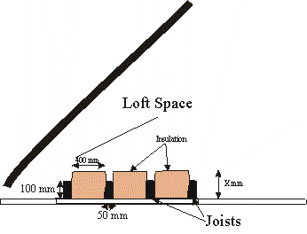
Fig. 6.9 - Placing insulation between joists.

What is the effective U - value for heat loss through the roof if X = 150 mm. Does this conform to the regulations?

Strictly speaking we should split the calculation into three parts - the heat loss from the loft space to the outside, the heat loss through the full insulation path from inside to the loft space and the heat loss through the full timber path from inside to loft space. In reality we can get a good approximation very much quicker, and usually within 1-2% by noting that without any insulation, the total resistance path including the internal and external resistances, the plasterboard ceiling, the loft space and tiles as 0.57 m2oC W-1 as shown in example 6 above. We note that the heat can flow through two parallel paths - i.e. either through the insulation or through the timber, son in this case we use the parallel resistance formula: -

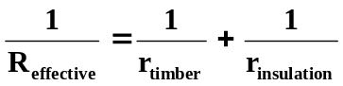

The resistance in the timber and insulation must take account of the different areas. i.e.

- taking the conductivity of timber to be 0.14 W m-1oC-1 and that of insulation to be 0.04 W m-1oC-1

- also we note that in a 450 mm length, 400 mm is insulation and 50 mm is joist - i.e. 50/450 or 1/9 is joist and 8/9ths is insulation.

The resistance of a single component is given by:-
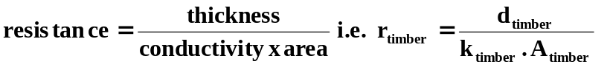

If we normalise the Area of timber as a fraction i.e. 1/9th as shown above and repeat for the insulation, then
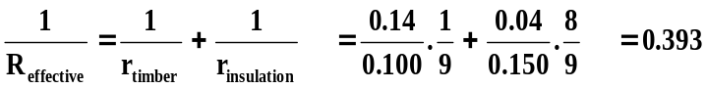

[ the 0.100 and 0.150 in this equation are the thicknesses of wood and insulation respectively] - i.e. R = 1/0.393 = 2.547

Thus the total resistance to heat loss through the roof is 2.547 + 0.57 = 3.117 giving an effective U - value of 1/3.117 = 0.32 W m-2 oC-1 and thus does not conform to the regulations.

In the example shown where the insulation is thicker than the joist height, then it is likely that the insulation would in reality cover the space above the timbers and thus the regulation would be met.

A similar situation with potential bridging can arise when insulation is placed on solid walls. The construction here would be for the creation of a thin cavity followed by plywood followed by a timber frame about 90 - 100 mm into the room with the space between timbers filled with insulation. On the inside of the room would be plasterboard as show in Fig. 6.10.

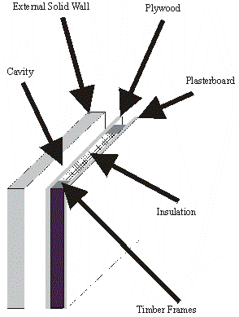
Fig. 6.10 Components in a solid brick wall improved by adding studding to inner wall. The timber frame acts as a short circuit bridge across the inner layer.

HEAT LOSS CALCULATIONS

FIVE COMPONENT PARTS:-

- lossess through the walls
- lossess through the windows
- losses througfh the roof
- losses through the floor
- ventilation losses

7.1 U - values

for the first four we need

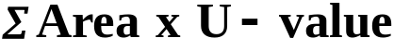

The value obtained is the Heat Loss Rate or the heat loss per unit temperature difference.

An intrinsic factor for a particular building - may be changed by varying the insulation of one or more components.

While there will be typically 4 factors in the summation equation (one for roof etc), more can be used (e.g. walls of different construction, partial double glazing etc).

7.2 Ventilation

Ventilation is treated differently

We talk in terms of air-change rate (usually per hour).

An air change rate of 1.0 means that the whole volume of air within a building is replaced each hour by cold air from outside which then has to be heated.

It is convenient to work in terms of an equivalent U - value
i.e. to obtain a factor which is dependant on temperarure difference.

The specific heat of air is about 1300 J m-3 oC-1

So the total energy required to heat incoming air will be

volume x air change rate x temperature difference x specific heat

This will be energy required per hour, so dividing by 3600 to bring to Watts gives:-

volume x ( air change rate 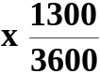 ) x temp diff.

The quantity in brackets is equivalent to a U - value.

The factor 1300/3600 = 0.361

7.3 Heat Loss Calculations

H = ΣArea x U - Value + Volume x ach x 0.361

H is heat loss rate per degree

In a steady State condition, heat lost must be replaced by heat supplied by heating system. The sizing of system depends on

- the heat loss rate

- the design internal temperature

- the design external temperature

Typically in UK the internal temperature is taken as 20 oC or 21oC for residential properties while external temperature may be varied according to external conditions - e.g. -1oC for UK.

e.g. for house with H = 250 WoC-1, and a design temperature difference of 20 - -1 (i.e. 21), the heating appliance must be able to supply 21 x 250 W = 5250 W.

The heating device must be capable of supplying this amount of heat.

7.4 Notes on Sizing of Heating Appliances

1) the design cannot assume incidental gains are present for sizing purpose (we take then into account in overall consumption).

2) boiler sizes typically come in increments of 3 kW (some makes 6 kW), and size must also be capable of supplying hot water.

3) if temperature falls below -1oC (or external design temperature), heating sytem will not be capable of coping with heat demand and internal temperature will start to fall.

4) basic heat loss calaculations assume a steady state

5) most houses have a significant heat storage, and this can help when temperature initially falls to a low temperature.

6) storage lags of 12 hours or more are not uncommon in houses.

7) hot water requirements can be signficant at certain times of day, so boiler must be able to cope with this demand as well (additional 3 kW).

8) At times of low hot water demand, this additional capacity can be used to boost heating supply.

7.5 Annual Consumption of Energy for Heating

Energy used in heating varies

- with external temperature
- incidental gains
- dynamic considerations

Need to evaluate overall consumption to judge effectiveness of savings etc.

Detailed way:-

Assess incidental gains and temperature variations throughout year and then estimate annual consumption.

Tedious - requires much record keeping

Approximate way:-

Adequate for judging savings as assumptions are consistent.

7.5.1 Degree - Day Method – simple formula

Heat requirement is proportional to temperature difference

Each day when there is1 degree temperature difference we add 1, each day when there are 2 degrees temperature difference we add 2 and so on.
i.e. Each day when there are n degrees temperature difference diff we add n

Degree-Days is sum of these numbers
- East Anglia annual figure is 2430

Note: the Dgree-days assumes some incidental gains.

There is a "free" temperature rise from the incidental gains.
The temperature at which no heating is required is call the neutral or balance temperature and is taken as 15.5oC.

This means that the effective internal temperature is taken as 15.5ºC.

If the external temperature is 14.5ºC we add 1 and so on.

However, if the temperature is greater than or equal to the balance temperature we add zero.

7.5.2 Degree – Day Method – more exact formula

This formula was introduced as in spring and summer, there are many days when the temperature is partly above the balance temperature and partly below it. The consequence is often that a small amount of heating may be required, even though the balance temperature is below the mean daily external temperature.

The improved method proceeds as follows.

During the Heating Period:

T_{max} - maximum external temperature
T_{min} - minimum external temperature
T_{neutral} - neutral or base temperature.

Approximate Formula as above may be formalised as

For each day

DegreeDays = T_{neutral} - 0.5 * (T_{max} + T_{min}) if 0.5 *(T_{max} – T_{min}) < T_{neutral}
Or = 0 if 0.5* (T_{max} – T_{min}) >= T_{neutral}

More Accurate Formula

For each day

If T_{neutral} < t_{min}

DegreeDays = 0

If T_{neutral} > t_{max}

DegreeDays = T_{neutral} - 0.5 * (T_{max} + T_{min})

If T_{neutral} < t_{max}

Then if T_{neutral} > 0.5 * (T_{max} + T_{min})
DegreeDays
= 0.5* (T_{neutral} – T_{min}) - 0.25 * (T_{max} – T_{neutral})
Or if T_{neutral} < 0.5 * (T_{max} + T_{min})
DegreeDays = 0.25 * (T_{neutral} - T_{min})
In both methods DegreeDays are summed over number of days in period = e.g. week, month, quarter, year.

There was an example of using the two Degree Methods in the examination in 2004.

The same procedure may be used for determining amount of energy used for cooling. In this case there will be a cooling neutral temperature which will normally be different from the heating one and currently in the UK is set at 22ºC.

Cooling Formula

Approximate Formula

For each day

DegreeDays = 0.5 * (T_{max} – T_{min}) - T_{neutral}
if 0.5* (T_{max} – T_{min}) > T_{neutral}
Or = 0
if 0.5* (T_{max} – T_{min}) <= T_{neutral}

DegreeDays are summed over number of days in period = e.g. week, month, quarter, year

The formula follows the same general format as the simple Heating formula. There is a more accurate cooling formula similar to the more accurate Heating formula. However, unlike the Heating situation the differences between the estimates from the simplied and more exact formulae in the case of cooling are much less, and the extra time needed for the more accurate formula is not usually justified.

In the UK, the default neutral temperature for heating is 15.5⁰C, for cooling the neutral temperature is usually taken as 22ºC.

7.5.3 Degree Day Table

20-year average heating degree days for the UK 1979 - 1998
 |  |  | Jan | Feb | Mar | Apr | May | Jun | Jul | Aug | Sep | Oct | Nov | Dec
1 | Thames Valley |  | 337 | 303 | 256 | 190 | 111 | 47 | 19 | 22 | 51 | 130 | 234 | 302
2 | South Eastern |  | 356 | 323 | 280 | 217 | 136 | 66 | 32 | 38 | 75 | 155 | 255 | 321
3 | Southern |  | 342 | 310 | 277 | 221 | 138 | 68 | 37 | 42 | 77 | 150 | 244 | 309
4 | South Western |  | 289 | 268 | 250 | 198 | 124 | 59 | 24 | 26 | 51 | 116 | 199 | 255
5 | Severn Valley |  | 320 | 288 | 250 | 190 | 114 | 47 | 18 | 20 | 47 | 128 | 215 | 284
6 | Midlands |  | 373 | 333 | 290 | 230 | 152 | 76 | 39 | 43 | 83 | 176 | 269 | 342
7 | West Pennines |  | 360 | 317 | 286 | 219 | 139 | 73 | 35 | 40 | 78 | 165 | 259 | 330
8 | North Western |  | 370 | 323 | 303 | 239 | 162 | 90 | 47 | 53 | 98 | 183 | 272 | 346
9 | Borders |  | 363 | 319 | 306 | 258 | 199 | 112 | 58 | 60 | 101 | 182 | 267 | 333
10 | North Eastern |  | 380 | 328 | 298 | 234 | 163 | 83 | 41 | 46 | 87 | 178 | 274 | 346
11 | East Pennines |  | 371 | 327 | 287 | 225 | 152 | 77 | 39 | 41 | 80 | 170 | 267 | 340
12 | East Anglia |  | 374 | 336 | 291 | 228 | 145 | 72 | 36 | 36 | 69 | 157 | 266 | 341
13 | West Scotland |  | 376 | 327 | 311 | 239 | 164 | 92 | 54 | 62 | 111 | 200 | 285 | 358
14 | East Scotland |  | 386 | 332 | 314 | 252 | 189 | 103 | 57 | 63 | 110 | 199 | 289 | 362
15 | NE Scotland |  | 389 | 336 | 324 | 264 | 197 | 115 | 63 | 70 | 119 | 211 | 294 | 364
16 | Wales |  | 329 | 303 | 285 | 232 | 159 | 88 | 44 | 43 | 74 | 150 | 230 | 294
17 | Northern Ireland |  | 358 | 314 | 298 | 234 | 162 | 88 | 47 | 54 | 98 | 179 | 268 | 329
18 | NW Scotland |  | 323 | 291 | 313 | 256 | 208 | 129 | 84 | 77 | 118 | 206 | 254 | 328

Neutral/Base Temperature in above table taken as 15.5ºC.

7.5.4 Example using Degree-days
(see also previous exam questions)

A house has a heat loss rate 0f 450 W m-2 oc-1 and incidental gains of 2025 Watts. If there are 1100 degree days in a 3 month period and the thermostat is set at 20oC, what is the balance temperature and what is the consumption?

Free temperature rise is 2025/450 = 4.5 oC
Thus balance temperature = 20 - 4.5 = 15.5 oC
(i.e. the standard value)

So consumption is 1100 x 450 x 86400 = 42.8 GJ

7.6 Dynamic Heating

• Calculations are more complex
- Need to account for heat stored and work out loss/gain of heat from/to heat store during a specific time period (e.g. each hour) as well as the normal calculations.
- A knowledge of dynamic behaviour is needed to appraise situations where time switching is used. The approach taken in the lectures is a simple block model to illustrate the basic principle. In the practical a much more refined model is used which calculates changes each minute, and also divides the various components e.g. wall etc. into 5 mm thicknesses.
- An an initial assumption must be made as to what the temperature profile is though the walls etc. (see section 6.7). The profile shown in Fig. 5 is only true when steady state conditions have been reached which in the case of a house would represent several days heating when the outside temperature was constant.
- In a dynamic situation, the internal temperature will fall once the boiler is turned off. The trend is one of exponential decay. Alternatively if the internal temperature is constant and the boiler is kept on, then the heat output from the boiler will reduce in response of changes in the external temperature.
- In a heavy weight house, then the heat flows will lag the changes in temperature by many hours - typically up to 6 - 9 house in a typical brick construction. In a lightweight insulated structure of timber, the lag can be a short as 1 hour.

7.6.1 Response of typical house to external temperature variations in summer.
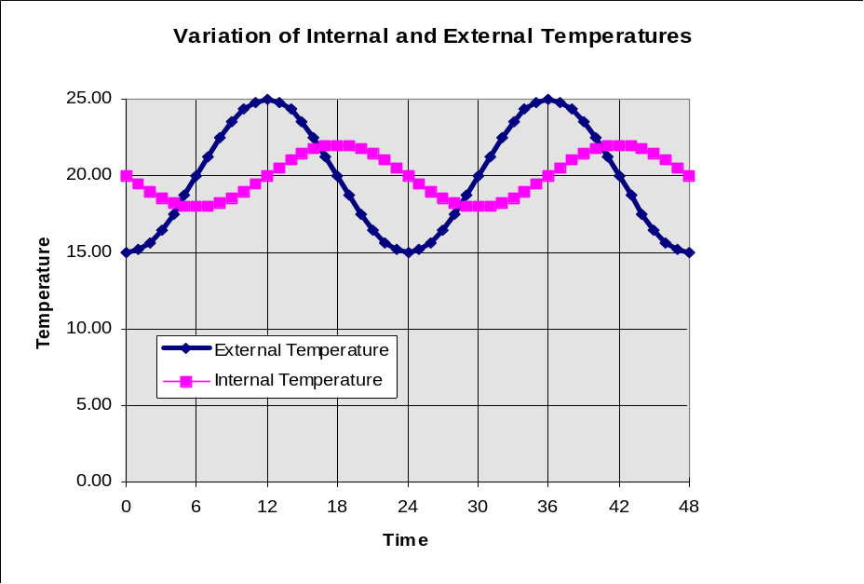
Fig. 7.9 Internal and external temperature variations in an unheated house

The graph shows a sinusoidally varying external temperature. The internal temperature also varies sinusoidally, but with lower amplitude and with the peaks shifted. The heavier the construction the lower will be the amplitude of the internal temperature and the greater the shift. In light weight buildings - e.g. sainsbury centre, the amplitude of the internal temperature can be quite high, although less than the external temperature.

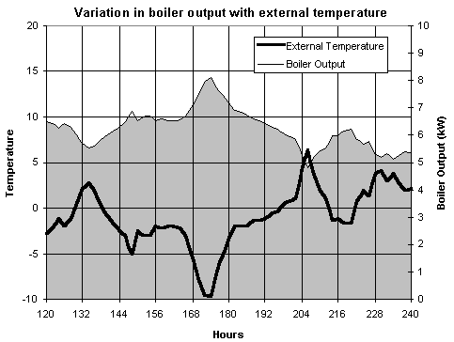
Fig. 7.10 Variation in Boiler Output with external temperature for a house. The thermostat temperature is 20oC. The climatic data refer to the period 5th - 10th January 1985 in Norwich

In winter, the temperature will always be below the thermostat setting and the boiler will cut in to supply heat as required. Fig. 10 shows the situation for a non-time switched case for a house in Norwich in a particularly cold spell in January 1985. It is noticed that the boiler output peaks when the temperature is at its lowest and is at a minimum when the temperature is a maximum. Note though, because of the storage of the building the amplitude of variation in the boiler output is once again much less than the temperature. The temperature ranges over 50%, but the boiler by only about half that.

The shaded area beneath the boiler curve represents the total energy consumed during the period. If the outside temperature had been constant at 0oC, then the output of the boiler would have been constant at around 5.9 kW through out..

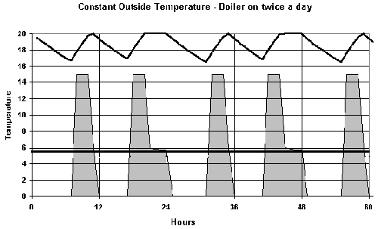
Fig. 7.11 Effect of time switching - constant external temperature. on periods 07:00 - 11:00 and 17:00 - 24:00.

Fig. 7.11 shows the effects of time switching on a boiler. Here the boiler is on for a four period in the morning,, and a longer period in the evening. The temperature falls from 20oC overnight and at 7am, the boiler cuts in and is under full power as the temperature rises - eventually reaching the thermostat level shortly before it cuts out in the late morning. In the evening a similar thing happens, but after about 4 hours, the boiler throttles back as the thermostat level is reached. However, the boiler output continues to drop with time as the heat storage of the house is replenished. The solid line show the situation had the boiler been on constantly - with an output of 5.9 kW. Thus even at the end of the day, the boiler output is still significantly above the steady state level.

A consequence of time switching is thus to require a larger boiler. If an even larger boiler than the 15 kW shown had been used then the temperature would have risen more quickly to the thermostat level and its output would have declined at an earlier stage.

If the boiler had been on constantly, then the total energy consumed could be estimated from the total area beneath the solid line. With time switching the output is as shown shaded, and in this case represents a saving of just over 13%. even though the heating was on for only 11 hours in the period of 24. With a larger boiler, the saving would have been less because the temperature reaches thermostat level more quickly.

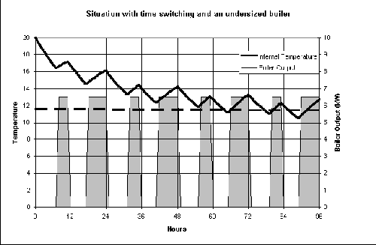
Fig. 7.12 Effect of time switching with an under-sized boiler.

The key thing to remember about saving with time switching is that the energy required is directly proportional to the mean internal temperature, and if this is kept higher - with a larger boiler or better insulation, then the saving will be proportionally less. Obviously one consequence of too small a boiler is the fact that the temperature may never quite make thermostat level and will continue to decline with time. This is illustrated in Fig. 7.12. Clearly this is a non-viable option and the theoretical saving of 50% has no meaning.

While the above graphs illustrate the situation with "idealised" boilers, i.e. the boilers throttle back in output once the thermostat temperature is reached, this is not how a domestic boiler works. Large industrial boilers, e.g. the UEA boilers have some scope in reducing output to a certain level, but domestic boilers are either on or off. Consequently, the actual mode of operation of a domestic boiler is to see it firing continuously for a period when it first comes on. Then when it reaches temperature it will cut out - perhaps for just a minute or so, and then cut back in again. With time the on period to off period decreases so that even on a cold winters day, the boiler will be on for perhaps 50% - 60% of the time. The longer the boiler is on the shorter will be the on periods, and the longer the off periods. If the output of zero in off is averaged with the rated output when it is on, then the computed result will be as indicated in the graphs shown.

A further complication arises from the fact that there is no - single thermostat level. A setting of 20oC implies a range of temperatures which might be from 19oC to 21oC.
heating continues by the boiler until the upper temperature is reached when it will cut out. The temperature will slowly drop until the lower temperature is reached when it will cut back in again. As a result the actual temperature profile will show a slight saw tooth form even in the apparently flat sections of the curve shown in Figs. 7 and 8.

Because o the thermal lag in buildings, the actual energy supplied by the boiler will reflect the external temperature some hours before hand. If the external temperature rises rapidly, the control on the boiler will not be aware of this and will continue to pump out heat relevant to the temperature a few hours beforehand, and this is potentially wasteful. The most sophisticated controls provide for a boiler energy manager which monitors outside temperature as well as inside, and will prematurely throttle back the boiler in such cases. equally, it will temporarily increase the water flow temperature when the external temperature falls to ensure the boiler is working at its optimum efficiency for as long as possible, and avoid unnecessary cycling of the thermostat.

Few domestic properties has such systems installed, although they are common in commercial and industrial premises. Indeed the installers of central heating systems have little experience of them - and are prone to install them incorrectly.

7.7 Dynamic Heat Loss - a worked example.

To properly analyse the dynamic situation required splitting the components of the buildings into numerous sub-components, each with its own thermal capacity. Thus a 100 mm thick brick would be divided into layers 5mm thick and each layer would be treated as being of uniform temperature and thermal capacity. Clearly, the thinner the layer the better, but without the aid of finite element computer modelling it becomes an impossible manual task. The practical in week 7 uses a program written by a former ENV student and analyses the situation with such fine layers. However, an idea of the method can be judged from the following which is sufficient to give an idea of what is involved. Indeed precisely this method (albeit on a time scale of 30 minutes was used by Dr N.K. Tovey when appraising the proposed UEA Heat Pump scheme in 1981 - see practical in week 9.

As an example we shall use Waveney terrace which has a thermal capacity of around 4 GJ per degree Celsius, and a heat loss rate of about 45 kW per degree Celsius. &00 students live there and if we assume an average body heat output of 100 W, that means that there is an output of 700 x 100 = 70 kW in useful gains.

In the example we shall use a time span of 2 hours (which would be adequate in any exam question. Shorter periods would give slightly more accurate results but at a much increase time.

We start by assuming that the heating goes off at midnight, the thermostat temperature is 20oC, the external temperature is 0oC, and the maximum heat supply to Waveney is 2000 kW.

The heat loss from the building at midnight will be (20 - 0 ) * 45 = 900 kW. The (20 - 0) refers to the temperature difference. However, there is a gain of 70, so the net heat loss will be 900 - 70 = 830 kW. Over a period of 2 hours this will mean a total heat loss of 830 * 2 * 3600 /1000000 = 5.98 GJ.

Knowing this we can thus estimate the drop in the temperature in the building =
5.98/4 = -1.49oC [the 4 is the thermal capacity of the building].

We can thus work out the temperature at the end of 2 hours to be 20 - 1.49 = 18.51oC.

We can repeat this procedure, but it is much more efficient to do in tabular form, and also much less prone to error. A suitable table layout is shown with the first row of data entered as calculated above.

Time | Internal Temp (oC) | External Temp (oC) | Heat loss  (kW) | Body Heat (kW) | Heat from boiler (kW) | Net Heat (kW) | Heat gain/loss (GJ) | Temp change (oC)
24:00 | 20.00 | 0.00 | 900 | 70 |  | -830 | -5.98 | -1.49
02:00 | 18.51 | 0.00 |  | 70
04:00 | 17.13 | 0.00 |  | 70
06:00 | 15.87 | 0.00 |  | 70 | 2000
08:00 | 18.31 | 0.00 |  | 70 | 2000 | 1246 | 8.97 | 2.24
10:00 | 20.55 | 0.00 |  | 70 | 2000 | 1145 | 0.32 | 0.08

The revised temperature (18.51oC) at 2 am is entered in column 2 of row 2. A new heat loss is calculated. This will be less than in the previous 2 hour period because the internal temperature is lower. We can proceed in a similar manner working through the rows until 6 am is reached when the boiler cuts in. We enter the boiler rating output in column 6 (i.e. 2000 kW) and that means that for the first time the Net Heat is positive, and consequently we will see a rise in temperature. Ultimately we would find that the temperature has come up to thermostat level a little before 10 am as the computed temperature is now above the thermostat level.

We see that at 8 am the temperature is 18.31 and 20.55 at 10, so we can estimate the time to reach thermostat level as (20.0-18.31)/(20.55-18.31)*2 = 1.508 hours after 8 am or 9:31.

After that time the boiler output would reduce to match the actual requirement.

The example shown here kept the external temperature constant, but the same procedure is used with a varying temperature.

  - Energy issues with radiator on outside wall – only for those who are interested.
Heat loss behind a radiator on an outside wall can be quite considerable because of the high surface temperature of the outside wall [ remember heat loss is proportional to the temperature difference].

In this example we will take the radiator temperature to be 570C which is slightly on the cool side, but it makes it slightly easier as in absolute terms, the temperature is 273+57 = 330 K.

We shall assume that the walls are built to the 1976 Building regulations and also the 1994 regulations.

The respective U-values of the walls are

1976 - 1.00 W m-2oC-1
1994 - 0.45 W-2oC-1

The Mean external temperature over the heating season of 8 months is 7oC or 280 K.

The Stefan Boltzman Constant (σ) is 5.7 x 10-9 W m-2oC-1

the emissivity of the wall (ε) is 0.9

while the emissivity of wall with insulated foil is 0.2

the U-value of 1976 wall with insulated foil is 0.93 W m-oC-1
and of 1994 wall is 0.435 W m-oC-1

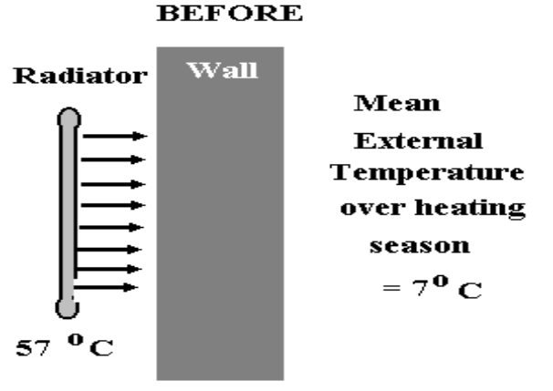

Fig. 7.13 Situation without foil
By Continuity:-

Heat absorbed by wall on radiator side must equal heat conducted through the wall.

Heat from radiator is by radiation. and let Ts be the internal surface temperature of the wall.

σ ε (Tr4 - Ts4) = (Ts - To) . U
where Tr is the radiator temperature and To is the outside temperature.
In 1976 case
radiation transfer conduction through wall
| |
5.7 x 10-8 x 0.9 (3304 - Ts4) = (Ts - 280) x 1
or 5.18 x 10-8 x Ts4 + Ts - 888 = 0
To solve such equations requires trial and error by inserting a guessed value for Ts and see if the two sides of the equation balance. Obvious Ts will be between the room temperature and that of the radiator, and using a spread sheet makes it easy to solve.
However, manually, we can make a guess say that the temperature is 320, If we did that we would find that the value of the left hand side of the euqtion is -30.46 - suggesting that the value is too low. Choosing 325 gives a value of 8.96 [too high], while 324 gives a residual of 0.95 - almost correct.

In the case of the above equation for 1976, Ts = 324 K or 51oC.
For 1994, the equation is slightly different because of the different U - Values, but the value of Ts becomes 327 K or 54oC. Note in the case of the better insulated wall, the internal surface temperature will be higher.
Thus the actual heat lost per square meters behind the radiator on the 1976 wall will be

(51 - 7 ) 1.0 = 44 W m-2 on an average day, compared to
(20 - 7) . 1.0 = 13 W m-2 through other parts of the wall

For the 1994 wall the flows will be
(54 - 7 ) . 0.45 = 21 W m-2 behind the radiator and
(20 - 7) . 0.45 = 5.9 W m-2 for other walls
As a comparison the surface temperature for a solid wall with a U-Value of 2.1 W m-2 oC-1 is 318.5 giving a heatloss of just under 80 m-2.

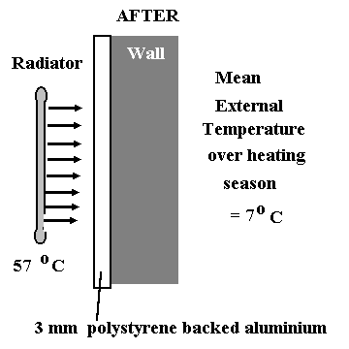
Fig 7.14 Situation after installation of insulating foil

With the foil in place, the reduced emissivity changes the equation above to
or 5.7 x 10-9 x Ts4 + 0.93. Ts = 868

[ remember that the U-value also changes slightly]

In the 1976 house the internal surface temperature now becomes 29oC, and the heat loss is 20.5 W m-2

For the 1994 construction, the new heat loss is 13.9 W m-2 while for a solid wall the heat loss is 25.3 Wm-2.

Thus the improvement is much greater with older construction as ismuch smaller with newer constructions.

The saving for the 1976 construction is 24 W m-2, and over the heating season of 8 months this represents a saving [assuming 12 hours heating a day] of
24 x 3600 x 12 x 240 = 0.25 GJ m-2

Allowing for a typical boiler efficiency of 75%, this represents a saving of around 0.3 GJ per radiator. At a cost of £3.925 per GJ [current 1998 British Gas Tariff], and a cost of £2 per square meter, the capital cost is paid back -[simple pay back] in a little over a year. This of course assumes a DIY installation.

For a pre-war solid wall where the U-values are 2.1 [without] and 1.81 [with], the savings are more dramatic with a reduction from 80 Wm-2
to 25 wm-2 representing an annual saving of around. 0.76 GJ per square metre, and a pay back in less than a year.

7.9 A Method to determine Air-exchange rate

As indicated previously it is difficult to measure the true air-exchange rate, bit one method where this may be done is to provide supplementary heating to the room in question, If the rise in temperature above normal is measured then it is possible to estimate the exchange rate using basic heat loss calculations.

In this case we have to consider not only heat loss to the outside, but also heat lost to adjoining rooms.

A room in a single storey building is 4m x 4m in plan and 2.4m high. It has one external wall with a single glazed window 2.4m2 in area. On a day when the external temperature is 0oC, the rest of the building is heated uniformally to 20oC. In an experiment the determine the intrinsic structural ventilation rate, the gaps at the edges of the windows and doors were sealed and supplementary heating of 1494 W was supplied to the room. After two hours the room temperature stabilised at 25oC. Estimate the intrinsic ventilation rate in air changes per hour if the specific heat of air is 1305 J m-3 oc-1. U-value data are given in Table 2.
U-Values (W m-2 oC-1)
External Walls | 1.0 | Floor | 1.0
Internal Walls | 2.5 | Window | 5.0
Roof | 0.2

Assume radiator is turned off in room in question:

Then by Continuity

supplementary heat - heat losses to outside + heat losses across internal walls = ventilation losses

The solution is best in tabluar form
 | Area (m2) | U-value  (W m-2 oc-1) | Temperature difference | heat lost  (W)
internal heat transfers - 3 walls 4 x 2.4 m | 28.8 | 2.5 | 5 | 360
external wall transfer | 7.2 | 1.0 | 25 | 180
window transfer | 2.4 | 5.0 | 25 | 300
roof transfer | 16.0 | 0.2 | 25 | 80
floor transfer | 16.0 | 1.0 | 25 | 400
Total conductive losses | 1320

So ventilation losses = 1494-1320 = 174 W

volume of room is 4 x 4 x 2.4 = (38.4 cum), and temperature difference = 25oC

so ventilation loss = 39.4 x 25 x 1305 / 3600 x ach = 174
|
seconds in an hour
so number of air changes per hour = 0.500

- ENERGY MANAGEMENT

[Please Note: in 2006, this section is being taught before the section on Building Regulations as the latter have been recently modified and extra time is needed to prepare an up to date handout].

8.1. Introduction

Good Energy Management is the key to Energy Efficiency and Energy Conservation.

An Energy Manager should:-
ASSESS
current energy demand - record keeping
ANALYSE
energy requirements
ADVISE
on technical improvements
ADVERTISE
ways to save energy
ACCOUNT
for energy consumption

8.2 ASSESSING ENERGY DEMAND

• keep records
• consumption
• time of readings
• temperature
• other factors affecting demand
e.g.
weekday/weekend
special events

Frequency of readings:-

• every quarter is usually too long
• every month is often too long
• every week is a useful frequency

every day can be helpful (as long as difference between
weekend and weekday is recognised - if relevant)

If readings are not a exactly the same time each day, week, month or quarter, then scale readings to standard interval before presentation.

8.3 ANALYSING ENERGY RECORDS

Frequently not done, but it is a important step in energy management..

Need to allow for key variables:-

Heating:-

- external temperature
- wind speed
- humidity
- solar gain

Lighting:-

• hours of darkness

For a centrally heated building:-
Wind speed, humidity, and solar gain are minor effects as far as heating goes and rarely contribute more than 10% of variation in total. External temperature is dominant effect.

8.3.1 Analysis of heating requirements:-

- Degree day Method - quicker method
- Mean temperature method - more accurate method

8.3.2 Degree Day Method – Case 1

for assessing energy requirement in buildings NOT
heated with electricity (e.g. gas, oil, coal).

Using oil or coal makes analysis difficult as only general estimates of consumption can be made over a period of time - based of frequency of delivery or approximate reading of dipstick in oil tank.

There are two component parts to consumption

1) A temperature related part
2) A part which is largely independent of temperature
(i.e. hot water and cooking if by gas)

Let W be amount needed for hot water, and cooking if by gas and let H be the heat loss rate for the house.

then total energy consumed over a period (E)

E = W + H x DegreeDays x 86400

W is approximately constant for a given house and averages around 7 - 10 GJ a quarter.

We have two unknowns:- W and H, so if we know number of Degree-days in two successive quarters and also the energy consumption we can estimate both the heat loss rate and the steady energy requirement.

8.3.3 Example - Degree Day Method (Non-electric heating)

In two successive quarters the consumption is 31.76 GJ and 18.80 GJ while the corresponding Degree Days are 1100 and 500 respectively. What is the heat loss rate and the steady continuous energy requirement.

1100 x H x 86400 + W = 31.76

500 x H x 86400 + W = 18.80

solve simultaneous equations in normal way to get H and W
(in this case subtract equation 2 from equation 1)

i.e. H = 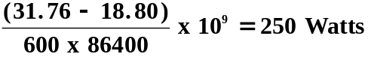

substitute for H in either equation to get W

e.g. W = 31.76 x 109 - 1100 x 250 x 86400

= 8 x 109 = 8 GJ
=====
Once both H and W have been obtained, performance in subsequent quarters may be assessed.
Thus if in third quarter degree-days = 400, then we would predict consumption to be

400 x 250 x 86400 + 8 x 109 = 16.64 GJ

If actual consumption is 17.5 GJ we can see that organisation has been wasting energy in this last quarter (17.5 - 16.64 GJ)

8.3.4 Mean Temperature Method - (Non-electric heating)

In this method we plot the mean consumption over a specified period against mean external temperature.

Normally we will be dealing with periods of 1 week or 1 day (i.e. much shorter than Degree Day Method) and thus give more rapid indication if things are deviating from norm.
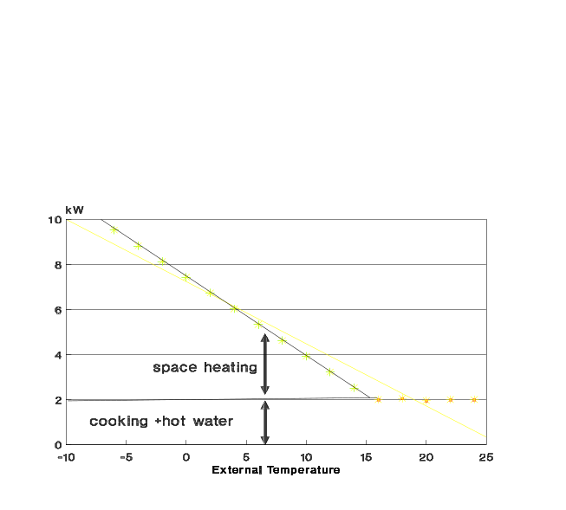
Fig. 8.1 Energy Consumption against mean external temperature

NOTE: Two sections to graph
DO NOT simply do a regression analysis on all data -
split into two parts.

Kink in line corresponds to balance temperature.

8.3.5 Analysis of Lighting (Non-Electrically Heated)

Lighting varies throughout the year with hours of darkness.
To make sense of the data we need to assess a realistic time for lighting.

If for example, a family goes to bed around midnight, it is easy to assess the number of lighting hours in a particular day by subtracting lighting up time from midnight (assuming no lighting requirement in the morning).

A typical plot is shown below.
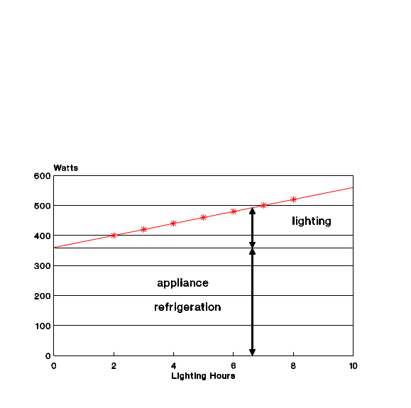
Fig. 8.2 Electricity Consumption against lighting hours
There is constant load (A) arising from appliance and refrigeration use, and an increasing amount from lighting.

The increase in the lighting hours L can be used in same way as H to obtain both L and A in same way as for H and W in heating example.

8.3.6 Analysis of Heating/Lighting in Electrically heated house

Situation is more complex than in previous examples as both H and L are unknown. We can combine A and W to an overall appliance + hot water etc. load (A)

Energy Consumption (E) becomes:-

E = (degreedays x H + lighting hours x L) x 86400 + A

Note; the units of L are Watts per hour - one of the very few occasions when such a unit is permissible.

We now have three unknowns and if we have data from three separate quarters then we can estimate values for H, L , and A by solving the three simultaneous equations.

- becomes more complex, but methods are standard.

If appliance load is known, then computation is easier e.g. steady total appliance load of 15GJ for hot water etc.

Degree Days | Lighting Hours | Consumption (GJ)
1100 | 500 | 36.1680
480 | 200 | 24.1584

As in example we can write the two equations:-

(1100 x H + 500 x L) x 86400/1x109 + 15 = 36.1680

(480 x H + 200 x L) x 86400/1x109 + 15 = 24.1584

Note: the divisor by 1x109 is to bring all units to GJ

Simplifying both equations:-

1100xH + 500 x L = = .....(1)

480xH + 200 x L = = …..(2)

Multiply (1) by 2 and (2) by 5

Subtract (2) from (1)

-200 x H =

Hence H = ====== 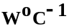

Now substitute for H in either (1) or (2) to get L

i.e. 1100 x 200 + 500 x L = 245000

or L = 50 W hr-1
============

If at the end of the second quarter, low energy lighting (which uses only 20% of normal energy for lighting) is installed, we may predict the actual consumptions provided that we know the Degree Days and the Lighting Hours.

If these are 200 (degree days) and 100 (lighting hours),

then we can predict the quarter's consumption as:-

(200 x 200 + 100 x 10)*86400/1x109 + 15 = 18.5424 GJ

If the actual consumption is above this figure, then we can
presume that we have been wasteful in our use of energy. If the value is less than we have been active in awareness in conservation.

Normal predictions will be OK to about 5% so anything
above 19.5GJ (in this example) should indicate cause for concern.

Continuing the example, and assuming that additional insulation is added in the third quarter so that the heat loss rate is now 180 WoC-1, we can also predict what the consumption would be (say for instance if the number of degree days is 700, and the lighting hours are 450):-

Predicted Consumption is

(700*180+10*450)*86400/1x109 + 15 = 26.2752 GJ

Once again we can check this against actual consumption.

Clearly if in the example shown here, the consumption in the third quarter was above that expected, then this would suggest a less than predicted performance of the low energy lighting. We could if we wished use a corrected version to assess the performance of the insulation measures separately.

The example given here assumes that the appliance load is constant and known. If the appliance load is unknown, then we can replace the 15 in equations (1) and (2) by A, and include an equation for a further quarter to allow the three unknowns (i.e. H, L, and A) to be determined. This makes computation more complex, and will not be expected in this years course.

8.4 Cumulative Deviation Method

This method combines the predictions obtained by one of the methods described in 8.3. to show the cumulative savings over time.

Evaluate deviation from ORIGINAL consumption line for each time period.

- If no energy conservation ,measures have been implemented, then graph should remain horizontal.

- Period (2) - Winter following improved insulation

- Period (3) - Summer - graph is horizontal as conservation measure only affected heating.

- Period (4) - Winter - line is parallel to period (2)

- Period (5) - Improved management of hot water produces savings in summer month

6) Period (6) - Expected gradient would be sum of gradient in period (4) + that in period (5). Gradient is less suggesting that energy conservation performance is slacking.

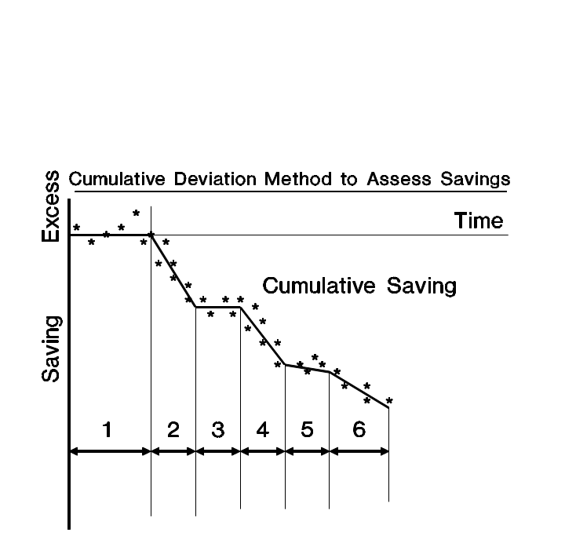

Fig. 8.3 Cumulative Deviation method to Assess Savings.

8.5 ADVISE ON ENERGY MANAGEMENT

Most firms are more interested in saving money than saving energy. Thus performance of Energy Manager will usually be judged not on how much energy saved, but how much money.

Similar graphs to above could be drawn, but problems arise with changes in fuel prices (tendency for them to reduce in real terms, and VAT on fuel can make situation confused.

It is best to show in terms of energy, but with rider of monetary saving.

However, recommendations as to strategies will normally be related to cost of fuel. Thus though UEA uses much less electricity than gas, it is the electricity price which is greatest, and so the University will be more interested in measures to save electricity than gas even though latter may result in larger energy savings.

Recommendations will fall into four categories:-

1. Technical
a) insulation, draft exclusion, (thermostatic radiator valves (TRVs), heating control etc.
b) low energy lighting, efficient refrigeration etc.
c) power factor correction
d) relocation of switches, PIR/movement sensing etc

2. Energy Management
a) checking performance
b) record keeping

3. Financial:-
Make sub-sections accountable for their own energy budget - with carrots for those who save energy.

4. Other Factors
Changing patterns of working/ working practices/use of space

8.6 ADVERTISE WAYS TO SAVE ENERGY

• Rarely are savings predicted from technical solutions to energy conservation realised.

• New technology often requires a change in attitude by the user. In other cases, user should be educated into correct use.

• Advertising Campaigns should encourage users to save energy - closing doors, switching off lights etc. However, such campaigns are only effective for a few months. New slogans or a change in emphasis is required.

8.7 ACCOUNT FOR ENERGY USE

An Energy Manager should account for the energy use in a firm and analyse improvements using a technique as described in section 8.3.

It is essential that allowance is made for key variables and the effectiveness of awareness/advertising campaigns must be constantly appraised. This can only be done once the predicted technical performance changes have be made.

