New low energy multi-residential
accommodation

Constable Terrace, University of East Anglia

- Monitored annual fuel use 174 kWh/m2/yr.

- Fuel costs of £5.90/m2/yr

- Energy efficient lighting
- High levels of insulation and airtightness.

- Mechanical ventilation and heat recovery (MVHR).

- All-electric heating offset by
internal heat gains.

- Carbon dioxide emissions
84 kg/m2/yr

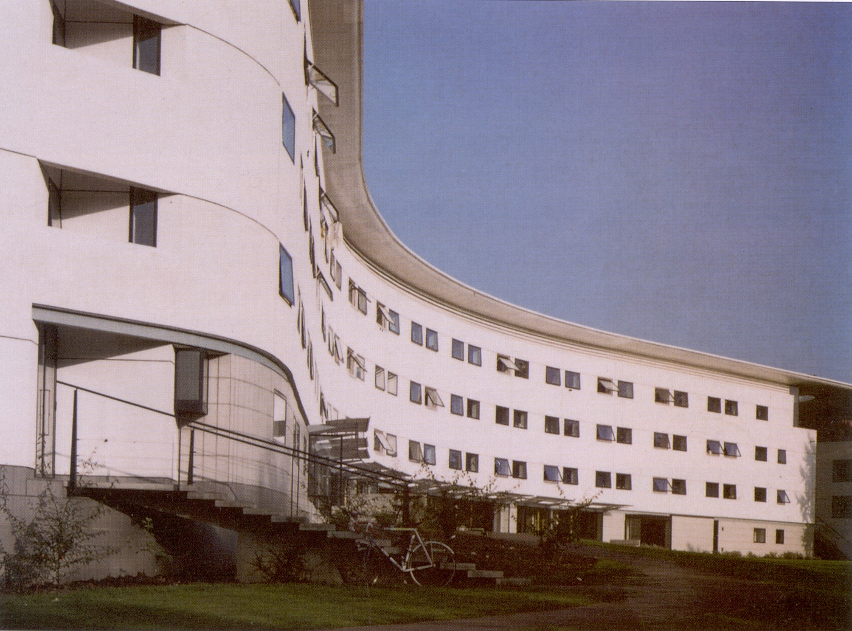

Constable Terrace seen from the south-west

Fig.1 A typical study bedroom
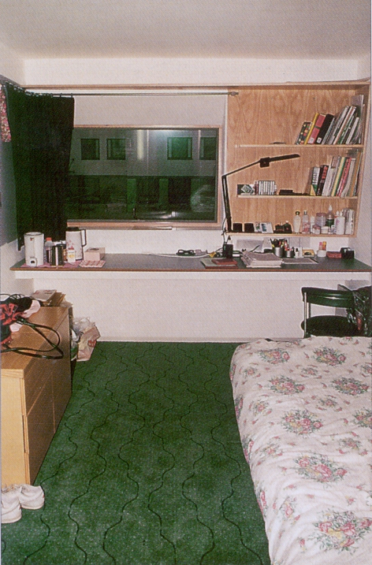
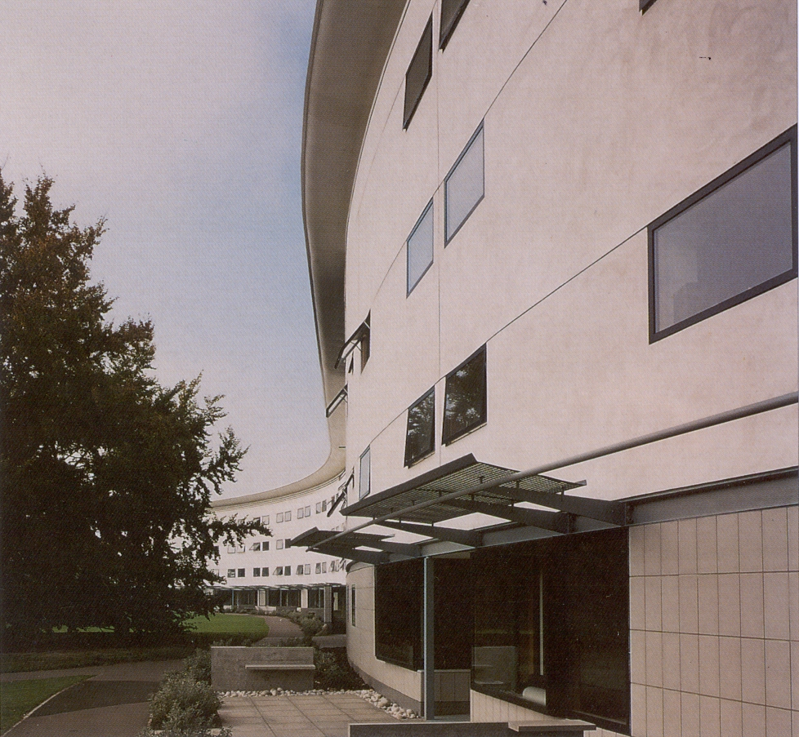
General description and
energy strategy
Constable Terrace is a residential building located at Norwich on the campus of the University of East Anglia (UEA). The building was completed in September 1993, and provides accommodation for 393 students and staff. The energy efficiency strategy adopted in the design of the building combines high standards of insulation and air-tightness with mechanical ventilation and heat recovery (MVHR). This reduces heat losses and provides continuous, adequate ventilation. A substantial proportion of the space heating demand is satisfied by internal heat gains from occupants and from the use of lights and appliances.
Fig. 2 Part of southern façade, showing external sunshades.

Constable Terrace consists of a double-curved, four-storey terrace in two connected blocks (see page 1 ). The lower three floors provide accommodation for undergraduate students in 26, ten-person houses. The top floor and the ends of the blocks provide a variety of flats, study bedrooms (see figure 1) and visitors' apartments (accessed via a central corridor on the top floor). Each house has ten study bedrooms with en-suite toilets and shower rooms, and a communal kitchen and lounge area. A large common room is located at the gap between the two linked blocks, at ground floor level.
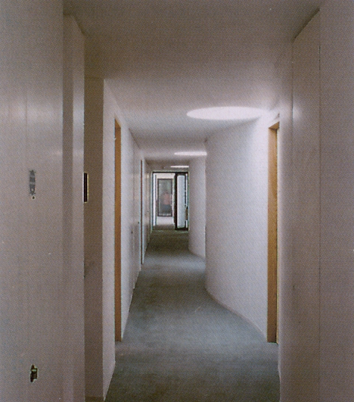
Fig. 3 The third floor access corridor which is daylit via rooflights.
Construction
The ground floor of Constable Terrace is constructed from precast concrete planks laid on 100 mm expanded polystyrene insulation and a ground bearing concrete slab; this has a calculated U-value of 0.18 W/m2K. The external
walls consist of two leaves of 100 mm lightweight concrete blocks separated by a 150 mm wide cavity which is insulated with 100 mm mineral fibre insulation. The walls are finished externally with render and internally with plaster, and have a calculated U-value of 0.22 W/m2K. The precast concrete plank roof construction is finished with steel panels and includes 200 mm thick mineral fibre insulation, with a calculated U-value of 0.15 W/m2K.

Windows and external doors are double glazed and weatherstripped. The large windows serving the kitchen and lounge areas on the south sides of the houses incorporate low emissivity glass and are protected from high-angle summer insolation by external metal sunshades (see figure 2). The construction around windows and door openings includes cavity closers, and is detailed to reduce thermal bridging and improve airtightness. The building was designed to achieve a high standard of airtightness. The specified air change rate at 50 pascals internal air pressure was 1 ach (air change per hour), which implies an average air infiltration rate equivalent to 0.05 ach at normal pressure.

Pressure tests have indicated that the actual air change rate at 50 pascals is approximately 2 ach. Although higher than that specified this is substantially more airtight than conventionally constructed buildings.

Services
Each MVHR system installed at Constable Terrace serves one ten-person house and two top-floor flats. The systems operate continuously, extracting moist, stale air from the k!tchens and shower rooms at a rate of 6 ach, and supplying fresh air to lounges and study bedrooms at 1 ach.

The MVHR systems incorporate heat exchangers which recover heat from the exhaust air and deliver it to the supply air. The heat exchangers may be by-passed outside the heating season in order to avoid summertime overheating.

Each unit incorporates approximately 450 W of fan power and 5 kW of electric heating for heating the incoming air to the supply temperature (15-16°C). This is controlled by a thermostat in the supply air duct and is the primary heating source. The systems have been designed to operate at low air velocities, and incorporate attenuators within the ductwork to minimise noise levels.

The large ground-floor common room at the centre of Constable Terrace is served by its own MVHR system which operates continuously. This system is controlled by a carbon dioxide sensor which adjusts the ventilation rate in response to the variable occupancy of the space.

Secondary heating is provided by electric ceiling heating in the kitchen and lounge areas, and by 250 W electric panel heaters in all study bedrooms, both of which are thermostatically controlled. The panel heaters are governed to a maximum temperature of 23°C and are intended for warming up the rooms after they have been unoccupied.

Hot water is provided by a pair of gas-fired boilers which supply heat to individual hot water storage tanks in the ten-person houses and flats. The tanks incorporate electric immersion heaters which are intended for back-up purposes only. The choice of electric space heating was influenced by capacity of the existing gas main to the site which was only able to meet the hot water requirement.
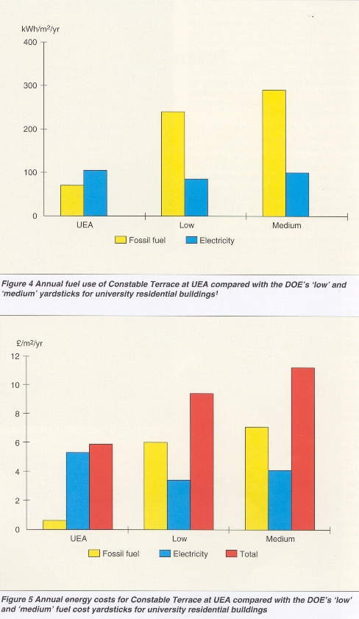
Energy efficient lighting was specified throughout Constable Terrace. All areas have tubular or compact fluorescent lamps, all with high frequency ballasts. The study bedrooms have a low level of background lighting supplemented by task lighting at the desk or bedside.

The demand for artificial lighting has been reduced by daylighting in most of the communal areas (see figure 3), and by the use of splayed window reveals to improve daylight distribution in study bedrooms.
Electricity use (kWh/m2/yr) | 104
Gas use (kWh/m2/yr) | 70
Total fuel cost (£!m2/yr) | 5.90
Carbon dioxide emissions (kg/m2/yr) | 84
Table 1 Summary of annual fuel use and
carbon dioxide emissions

The monitoring programme
Performance monitoring of Constable Terrace was carried out throughout the first academic year in which the building was occupied, ie September 1993 to August 1994. The monitoring programme focused on five features of the performance of the building: overall fuel use and costs, electricity use, internal temperatures and humidities, maintenance costs,
and occupant behaviour and satisfaction.

Overall fuel use, fuel costs and carbon dioxide emissions
During the monitoring period, the use of electricity and gas for Constable Terrace was measured by the University. Analysis of this data suggests that fuel use was 174 kWh/m2/yr , split between gas and electricity in the ratio 2:3. This compares well with current 'energy consumption yardsticks' for university residential buildings (see figure 4).

These yardsticks suggest that 'low' fuel use is less than 325 kWh/m2/yr (240 kWh/m2/yr for fossil fuels plus 85 kWh/m2/yr for electricity), and 'medium' fuel use is less than 390 kWh/m2/yr (290 kWh/m2/yr for fossil fuels and 100 kWh/m2/yr for electricity), anything larger being 'high'.

The fuel cost for the building over the year was calculated as £5.90/m2/yr, which may be compared with 'typical energy costs' (at 1992 prices) for university residential buildings1 (see figure 5). These suggest a figure of less than £9.40/m2/yr for a 'low cost' building, and less than £11.20/m2/yr for a 'medium cost' building, split between gas and electricity in the ratio 4:7. Carbon dioxide emissions associated with the use of fuel at Constable Terrace were approximately 770 tonnes per year, or 84 kg/m²/yr ( see table 1). This figure may be compared with the Department of the Environment's (DOE's) 'carbon dioxide yardsticks' for university residential buildings1, which suggest that 'low' emissions are less than 110 kg/m²/yr and 'medium' emissions are less than 130 kg/m²/yr .

Maintenance costs
Maintenance costs for Constable Terrace, as reported by UEA, are difficult to compare with those of other university residential buildings because for most of the monitoring period the building contractor was responsible for the 'making good' of defects in the building. Consequently, the maintenance costs during the monitoring period were considerably lower than they are expected to be in future years.

Maintenance costs associated with the energy efficient lighting installed at Constable Terrace 'are lower than those associated with the conventional tungsten lighting in the University's other residential buildings. The longer life of the energy efficient lamps significantly reduced first-year costs associated with lamp replacement. In future years, the higher replacement cost of the CFLs is likely to offset the initial saving to some extent.

The University anticipates significant maintenance costs arising from seasonal by-passing of the heat exchangers and regular cleaning of the filters in the MVHR systems installed. The filters require cleaning and/or replacement at approximately six month intervals. In order to achieve this, each system must be switched off while the filter unit is removed, dismantled and serviced in the University's workshop, and then replaced. The appropriate service interval may be longer than six months in practice, although, initially, the filters have been affected by dust and dirt from building activities on adjacent sites.

With hindsight, one conclusion which may be drawn from this is that a smaller number of larger MVHR units, each serving more than one house, might have resulted in lower maintenance costs associated with the cleaning of filters. It should be noted that this approach would exacerbate the problem of maintaining acceptable internal temperature~ during periods

of reduced occupancy such as the University's Christmas vacation.
Electricity use  Four typical houses were used for monitoring the electricity use, and end uses. This was achieved by sub-metering the power supplies for the MVHR systems, the backup water heaters, the panel heaters and for lighting and small power, in each house.  The total electricity used in the four monitored houses averaged approximately 98 kWh/m2/yr, of which approximately 34 kWh/m2/yr was for the MVHR units. The average percentage breakdown of total electricity use by end uses was as shown in figure 6. The designers of Constable Terrace did not intend electricity to be used for water heating (except for trace have. | heating of pipework). The individual electric immersion heaters were specified only as backup for the central gas-fired system. However, premature disintegration of sacrificial anodes caused a build up of sludge in the hot water storage tanks, effectively insulated the heating coils, and restricted the supply of hot water. Consequently, the electric immersion heaters were switched on during parts of the monitoring period, in order to increase the quantity and temperature of hot water. In the four monitored houses this procedure appears to increased the use of electricity slightly and reduced the demand for gas by a thermally equivalent amount. | 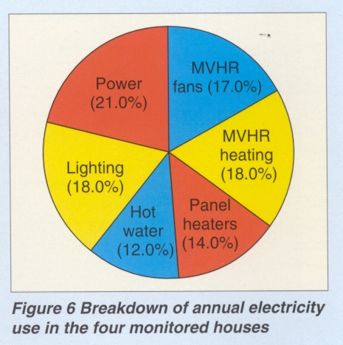

Occupant behaviour and satisfaction
In order to determine how the occupants of Constable Terrace used the building, and to establish their level of satisfaction with the environment provided, a questionnaire was circulated to all occupants during May 1994. For comparison, a similar questionnaire was circulated to all occupants of Waveney Terrace, another residential building on the UEA campus, built in the 1960s. (Waveney Terrace is substantially less well insulated than Constable Terrace.

It is heated from the campus heat main, and does not have en-suite shower facilities for residents.) At the time of the questionnaire survey, most occupants of both buildings had been in residence for eight out of the previous ten months. Nearly 50% of the residents of both buildings returned completed questionnaires, the high response rate being attributed in part to residents' general support for energy efficiency.

The responses to the questionnaires revealed that most occupants spent between 14 and 18 hours per day in the building. Nearly all occupants remained in residence at weekends, but very few remained in residence during university vacations. Most occupants of both buildings 'always' or 'often' cooked meals in their residence. A wide variety of electrical appliances were in use in the Constable Terrace.
Fifty per cent of respondents had kettles, 76% had hi-fi systems, 46% had television sets, 34% had personal computers and 32% had imported extra lamps. Refrigerators and video recorders were present in the buildings as well as many smaller items.

The number of electrical appliances imported by residents was larger than anticipated, and in Constable Terrace they will have contributed significantly to useful internal heat gains. The reported level of satisfaction was high for both buildings: nearly all respondents from Constable
Terrace (95%) and most respondents from Waveney Terrace (85%) reported that their residences 'always' or 'mostly' provided a comfortable environment in winter.

Similarly, 90% of respondents from Constable Terrace and 76% of respondents from Waveney Terrace reported that their residences 'always' or 'mostly' provided a comfortable environment in summer. Overall, the response from Constable Terrace residents was slightly more positive than
that from Waveney Terrace residents.

Some residents of Constable Terrace reported that on winter days with the windows closed (the designers' preferred mode of operation) their accommodation was 'too stuffy', but overall the responses suggested that in winter Constable Terrace had provided a slightly cooler and less draughty environment, with better air quality, than Waveney Terrace. Nearly half the respondents from Constable Terrace reported that in winter they had opened windows 'every day' (21%) or 'frequently' (25%), and approximately 60% reported use of the panel heaters 'every day' or 'frequently'.

An earlier survey of a smaller sample of residents of Constable Terrace suggested that panel heaters were rarely used at the same time as the windows were open. It seems likely that the most frequent use of the panel heaters was to warm rooms immediately after a period when the window had been left open. As defects In the MVHR system are rectified (to eliminate the distribution of cooking odours) and residents are guided on the best way to operate the building, this problem will be reduced.

Conclusions
The monitored performance of Constable Terrace demonstrates that an integrated energy efficiency strategy which combines high levels of insulation and airtightness with MVHR can be effective in multi-residential accommodation. Such a strategy may be used to provide accommodation of good internal environmental quality, and offers significant savings in fuel use, fuel costs and carbon dioxide emissions when compared with typical, existing student residences.

When such a strategy is adopted, it is important that the occupancy pattern of the building is carefully assessed. Occupants may import large numbers of electrical appliances into small spaces such as study bedrooms, and the heat gains from these appliances may be utilised within the building. However, if internal heat gains are expected to contribute a significant proportion of the space heating demand, then provision should be made for periods of partial occupancy, such as university vacations, when the heat available from internal gains will be reduced.
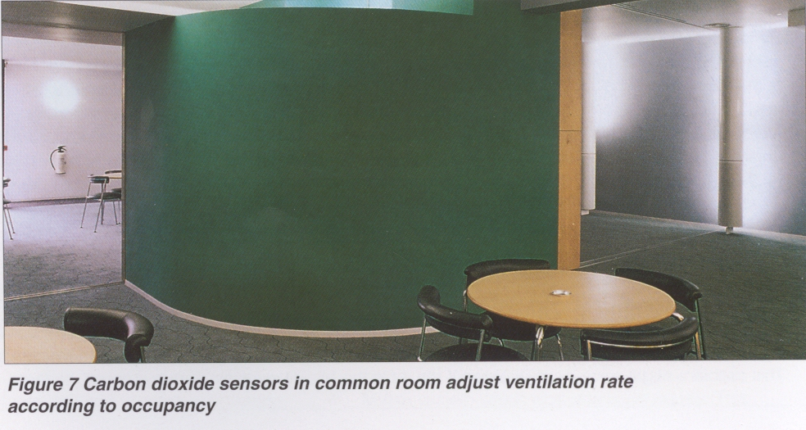

Both winter and summer operation should be considered during the development of designs of this sort. Heat recovery systems should be bypassed in summer, but in a well insulated and airtight building it may be necessary for both extract and supply ventilation systems to continue to operate. In summer, there is a risk of overheating arising from a combination of internal and solar gains. In order to avoid this, south-facing glazing should be of limited extent and provided with shading. Provision should be made for secure, natural ventilation when the building is unattended.

When mechanical ventilation systems are specified, the maintenance costs associated with large numbers of small systems (eg for cleaning filters) may offset fuel cost savings. In some cases fewer, larger systems may be more economical overall, so the number and size of installations should be carefully considered. It seems likely that the overall fuel use, fuel costs and carbon dioxide emissions associated with Constable Terrace will be reduced, in future, when defects in the MVHR and hot water systems (see above) have been rectified. Correction of these problems is expected to result in less window opening (and therefore reduced heat losses) and to permit water heating to be entirely by means of the gas-fired boilers rather than the electric immersion heaters.

Careful consideration should also be given to fuel choice. An all-electric approach may be appropriate where overall fuel demand is low, especially if the capital cost of obtaining supplies of other fuels is high. However, if the design is innovative, or mechanical systems are specified, then an all-electric strategy may not be economically robust against unexpected technical problems or patterns of occupant behaviour. In some cases the use of a cheaper fuel at higher capital cost (eg a new gas supply or a campus heat main connection) may be more
economical over the planned life of the building.

Internal Temperatures and Humidities in autumn and winter.

Temperatures were monitored In the kitchen and lounge area and in eight study bedrooms in each of four typical ten-person houses. In two of the houses, relative humidities in the kitchen and lounge areas were also monitored.

Monitoring commenced when the building was being completed and occupied for the first time. During the first three months of occupation average relative humidities in the kitchen and lounge areas fell from about 70% to 50%, as the building dried out. This long drying out period is thought to be due to the high level of insulation, and airtightness of {he building fabric. During the autumn and winter period, when the building was fully occupied, temperatures in the kitchen and lounge areas remained between 17°C and 25°C, and temperatures in the study bedrooms remained between 16°C and 24°C.
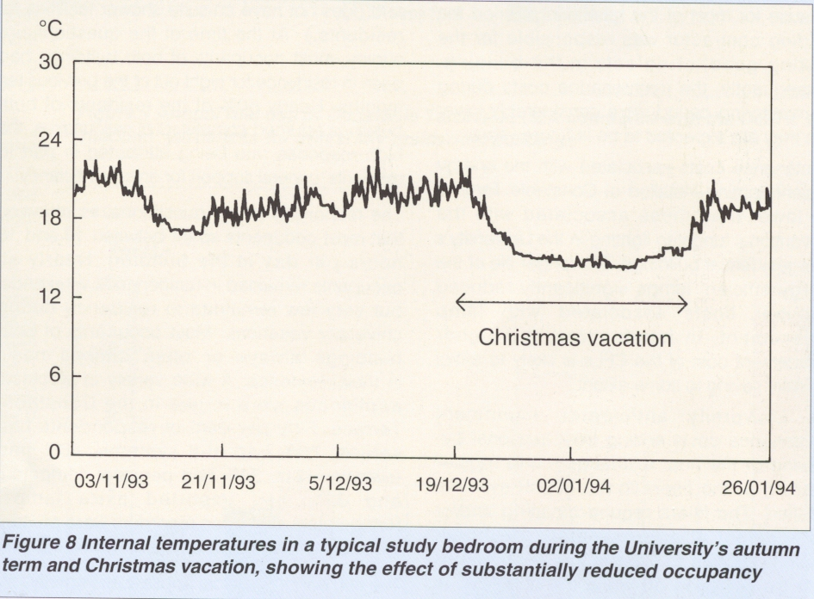
Frequent swings in internal temperatures appear to have been the result of occupants leaving the windows of their study bedrooms open and subsequently reheating the rooms using the panel heaters. The limited capacities of the heating systems (which are designed to be supplemented by internal heat gains) resulted in rooms which had been allowed to fall below 17°C requiring two or three hours of heating and occupancy to return them to 21°C. This effect was exacerbated by initial defects in the MVHR
systems, which caused some intermittent shut-downs. Also, stale air extracted from kitchens, and foul air from soil and vent pipes, was frequently reingested by the MVHR systems and redistributed around the buildings. Cons-equently, the occupants opened windows more frequently and for longer than had been anticipated. This problem was traced to the proximity of supply and extract air grilles at roof level, and the poor construction of separating panels.

During the UEA Christmas vacation most occupants of Constable Terrace left the campus, but some remained in residence. Where only one or two occupants remained in a ten-person house, the internal temperatures fell to approximately 17°C, resulting in complaints. This was caused by there being insufficient jnternal heat gains (from occupants, cooking, and the use of lights and appliances) to raise the internal temperature above that of the air supplied by the MVHR systems, and by the fact that any h.eat recovered from the extracted air was redistributed evenly throughout each house.

Thus, internal temperatures fell towards the supply air temperature, which under normal occupancy is controlled to approximately 17°C (see figure 8). Experiments with a Tas computer-based thermal simulation model suggested that, when the building is fully occupied, increasing the supply air temperature above 17°C reduces overall energy efficiency (see note). In this situation, more of the heat required to reach the demand temperature of 21°C is provided by deliberate heating, instead of by internal heat gains. It was concluded that during periods of full occupancy the supply air temperature should remain at approximately 17°C, but when partial occupancy occurs during the heating season (ie during the Christmas vacation), the supply air temperature should be temporarily increased towards 21°C.

Note. The Tas thermal analysis system is a fully dynamic multi-zone thermal simulation model which makes use of the response factor calculation procedure.

Internal temperatures in spring and summer

During the spring and early summer. Internal temperatures in the four monitored houses rose steadily, reflecting the increase in external temperatures.

By late July. temperatures in the rooms at the front of Constable Terrace (ie on the south side of the building) were typically in the range 24°C
to 30°C, and the kitchen and lounge areas were warmer than the study bedrooms. By contrast. the rooms at the rear of the building (ie those on the north side) were slightly cooler, with temperatures in the range 24°C to 26°C.

On some occasions. particularly in the kitchen and lounge areas. internal temperatures reached the upper limit of acceptability. These circumstances usually occurred between mid-day and early evening, when the houses were unoccupied and left with the windows closed. This problem might have been avoided if the windows of the kitchen and lounge areas had been smaller, or provision had been made for secure, unattended, natural ventilation during the summer. The University is now considering the fitting of opening restrictors, which will provide this facility.

Average external temperatures were highest in mid-July, reaching 26°C, but a mid-month peak does not appear in the monitored temperature data, which typically show a steady rise, subject to 3°C variations from day to day. This suggests that the internal temperatures are more responsive to internal and solar heat gains than to external air temperature, as might be expected of this highly insulated and sealed building.

From early May until the end of the monitoring period in September, the heat recovery units in the MVHR systems were bypassed, so that heat in extracted stale air was rejected rather than returned to the interior of the building. Initially, this 'summer mode' of operation also included the isolation of the supply air systems; the extract systems remained in operation and it was expected that fresh air would be obtained via open windows. The supply ventilation was reinstated within seven days, after numerous complaints of poor air quality. This requirement was reinforced by noise from an adjacent building site, which caused students to keep their windows closed while revising for their examinations.

Despite these special circumstances it seems unlikely that acceptable internal conditions can be achieved in this very airtight building by means of extract ventilation only, even in summertime (although this approach has been successful elsewhere when combined with trickle ventilators).

Acknowledgements
The monitoring of Constable Terrace was carried out by Rickaby Thompson Associates, with the assistance of the architects Rick Mather Architects, the services engineers Fulcrum Engineering Partnership, energy consultants Halcrow Gilbert Associates and the host organisation (the University of East Anglia). Thermal simulation modelling was carried out for the monitoring contractors by the Applied Energy Department of Cranfield University. The performance monitoring of Constable Terrace would not have been possible without the generous assistance and co-operation of the University of East AngJia's Premises Division and Accommodation Office, and of the residents of Constable Terrace during the academic year 1993/1994.

Suppliers

There may be other suppliers of similar energy efficient equipment in the market Please consult your supply directories or, contact BRECSU who may be able to provide more details upon request

References
1 ENERGY EFFICIENCY OFFICE (1994)
Introduction to Energy Efficiency in Further
and Higher Education, Department of the
Environment, London. Copy available from
BRECSU Enquiries Bureau.

